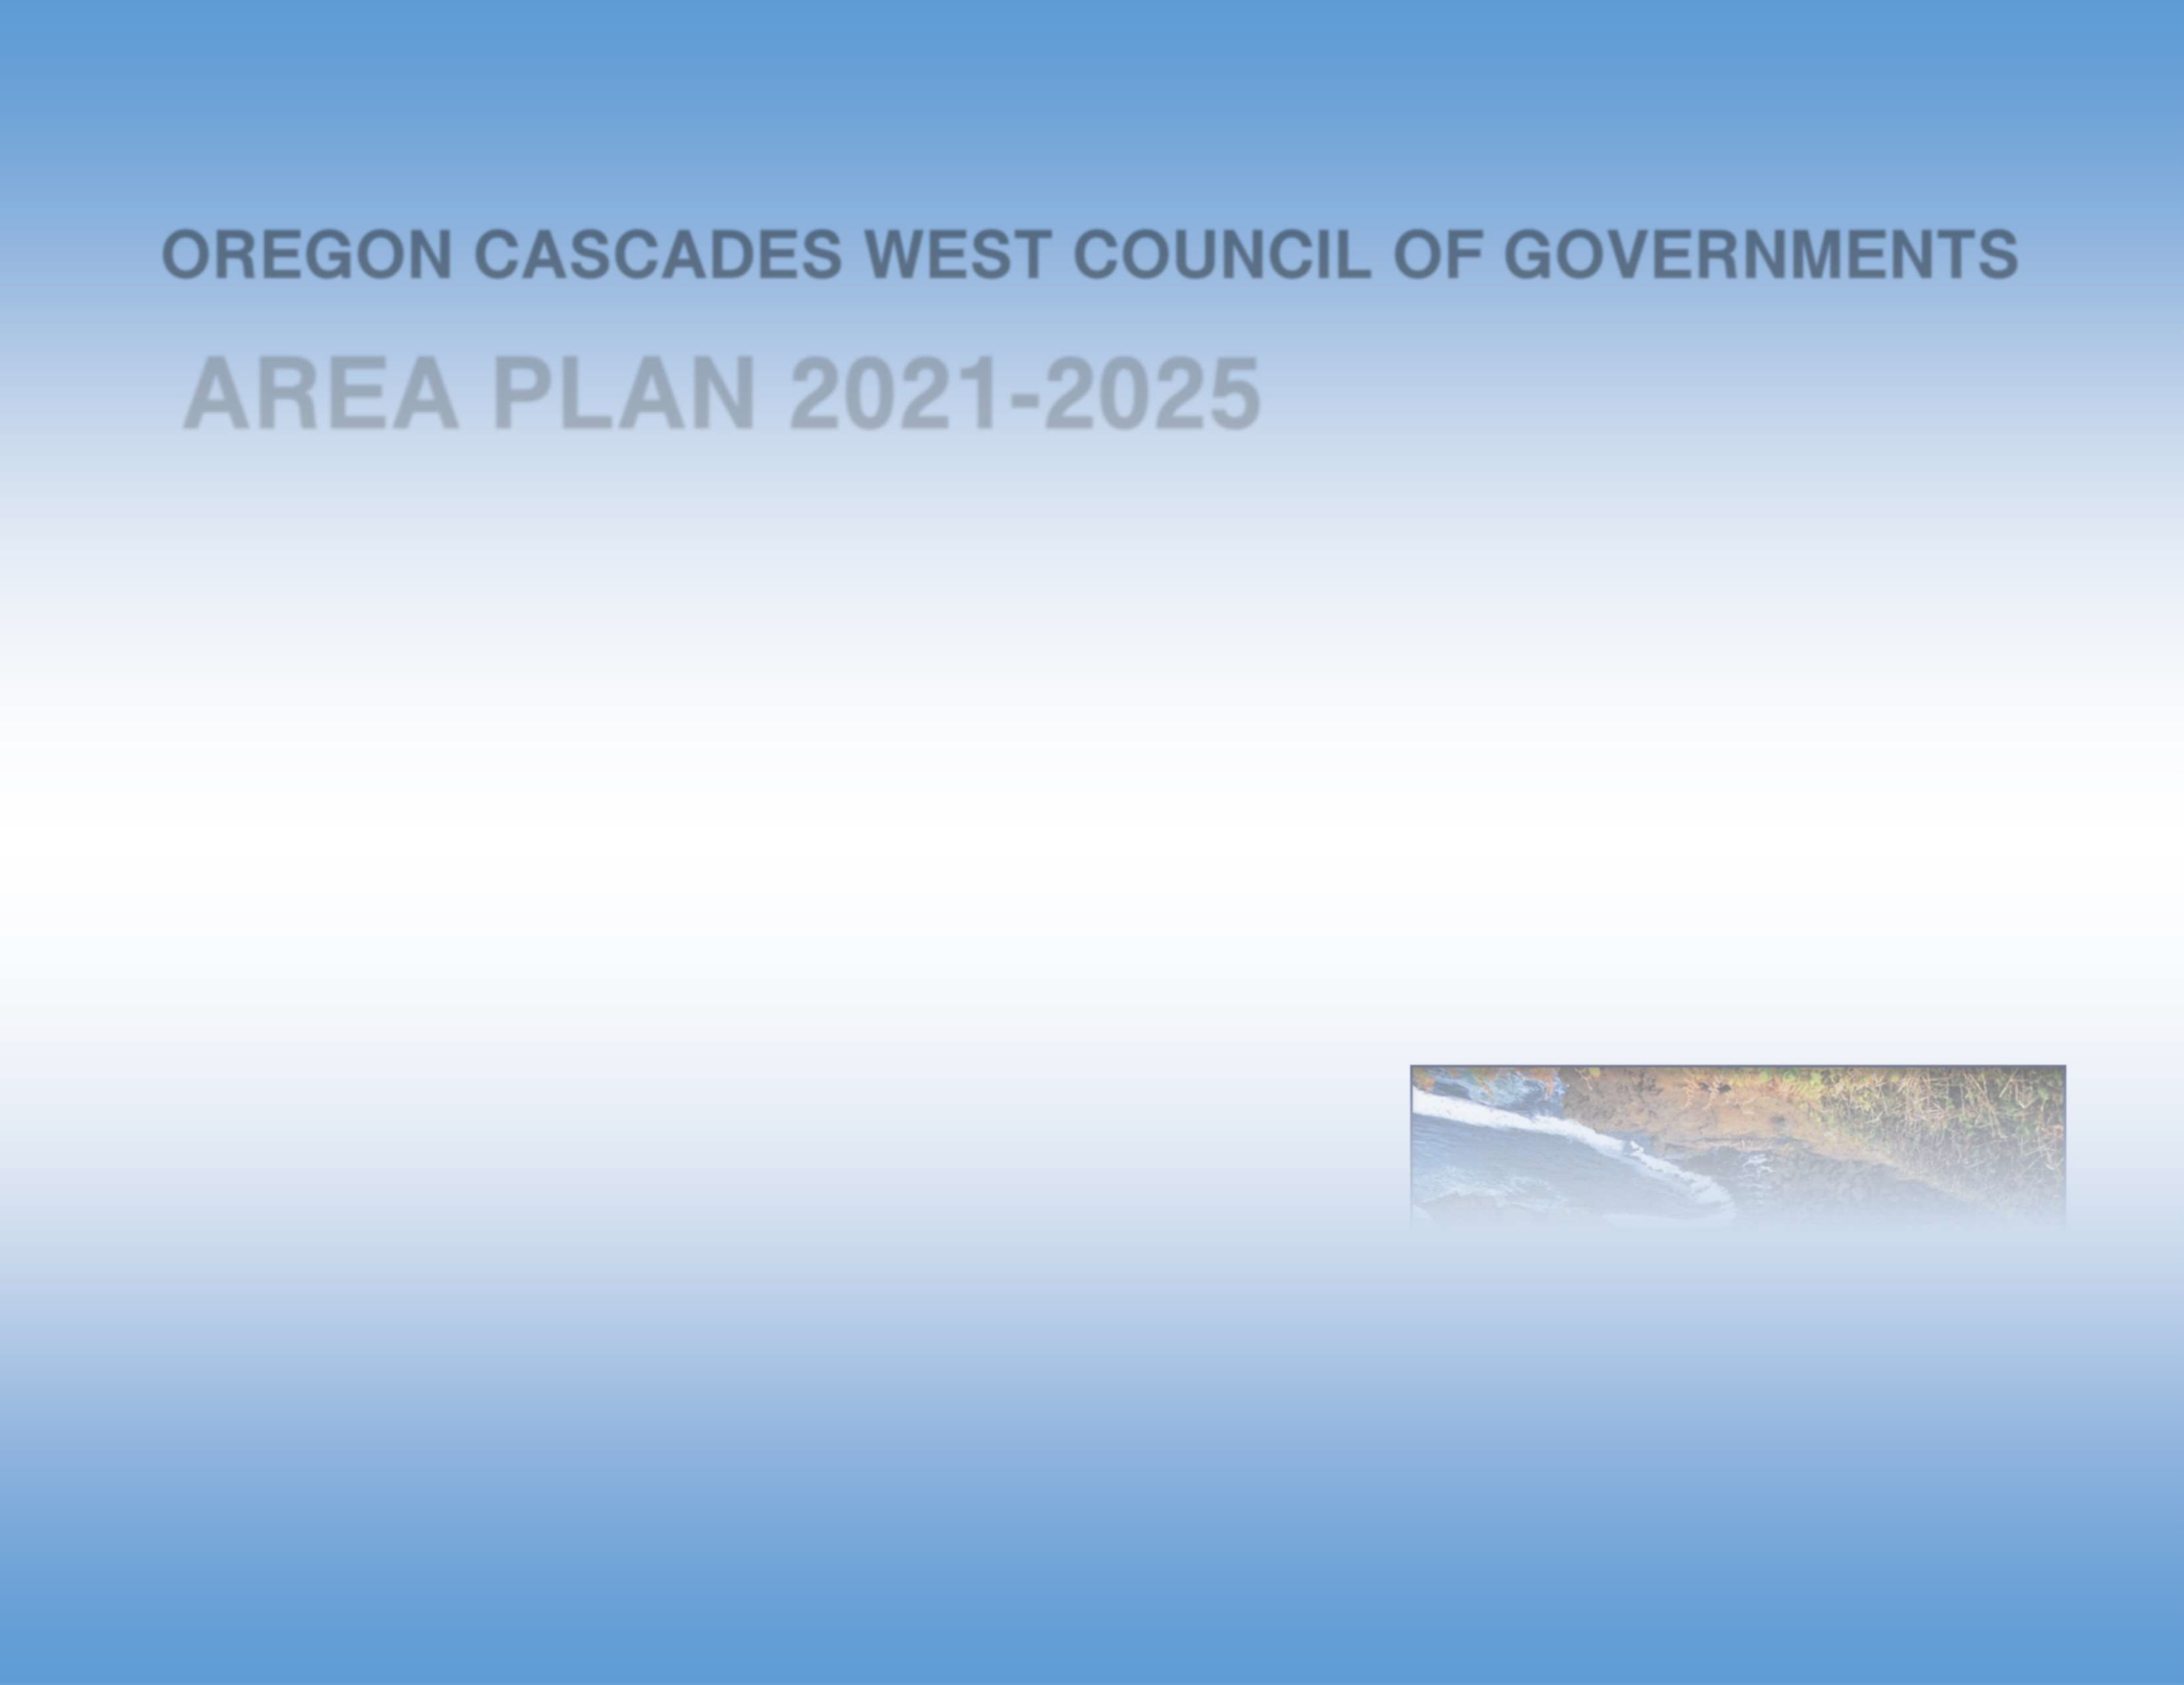


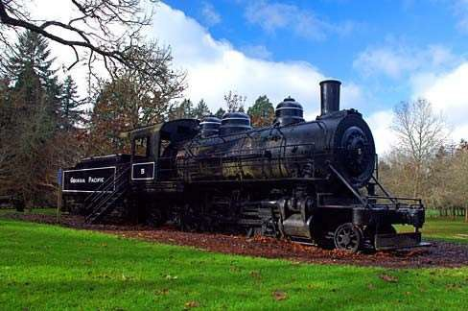

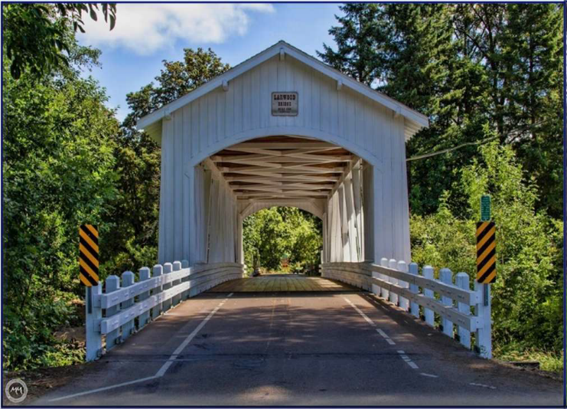
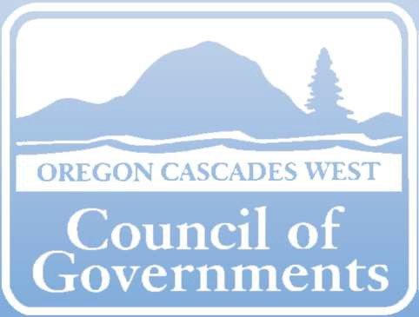
OREGON CASCADES WEST COUNCIL OF GOVERNMENTS

AREA PLAN 2021-2025

SERVING LINN, BENTON, AND LINCOLN COUNTIES
DISTRICT 4

OREGON CASCADES WEST COUNCIL OF GOVERNMENTS
2021-2025 AREA PLAN

TABLE OF CONTENTS

Section A Area Agency Planning and Priorities Page
  - Introduction 1
  - Mission, Vision, Values 3
  - Planning and Review Process 4
  - Prioritization of Discretionary Funding 6

Section B Planning and Service Area Profile
  - Population Profile 7
  - Target Populations 12
  - AAA Services and Administration 18
  - Non-AAA Services, Services Not Provided by the AAA 23

Section C Focus Areas, Goals and Objectives
  - Information and Referral Services and Aging and
Disability Resource Connection 24
  - Nutrition Service 30
  - Health Promotion 36
  - Family Caregivers 45
  - Legal Assistance and Elder Rights Protection 51
  - Older Native Americans 58
  - Financial Wellness 63
  - Transportation 68

Section D OAA/OPI Services and Method of Service Delivery
  - Administration of Oregon Project Independence (OPI) 75
  - Services provided to OAA and/or OPI consumers 78
– Attachment A

Section E Area Plan Budget 89

Appendices
    - Organizational Chart 95
    - OCWCOG Board of Directors and Advisory Councils 96
    - Public Process 99
    - Final Update on Accomplishments from 2017-2020 Area Plan 100
    - Emergency Preparedness Plan 103
    - List of Designated Focal Points 135
    - Partner Memorandums of Understanding 136
    - Statement of Assurances and Verification of Intent
    - OPI Waitlist Policy 137

Attachments
- Community Surveys 77
- Non-OAA Services 139
- OAA/OPI Services 140
- Medicaid Consumer Survey 143
- OPI Survey 145
- Public Hearing Ad – Linn and Benton County 148
- Public Hearing Ad – Lincoln City 149
- Public Hearing Ad – Newport 150

Section A: Area Agency Planning and Priorities
A. 1 - INTRODUCTION
Oregon Cascades West Council of Governments (OCWCOG) is designated by the Oregon Department of Human Services (ODHS) as the Area Agency on Aging (AAA) and Aging and Disability Resource Connection (ADRC) lead for Linn, Benton, and Lincoln Counties.
OCWCOG is a voluntary intergovernmental entity which on behalf of its member governments, carries out a variety of local, State, and Federal Long-Term Services and Support (LTSS) programs which help older adults, people with disabilities, Veterans, and caregivers in our region. OCWCOG is led by a Board of Directors (BOD) which consists of local elected officials who represent the associated member governments. The Senior Services Advisory Council (SSAC) and Disability Services Advisory Council (DSAC) consists of a representative from the OCWCOG Board and stakeholders from the community that advise and advocate regarding policies, quality of services, program delivery, budget, and spending. The Advisory Councils were integral in developing the 2021-2025 Area Plan and outlining the priorities the agency will work on over the next four years.
OCWCOG houses three outward facing programs which serve seniors and people with disabilities:
Senior and Disability Services (SDS) – issues and administers medical, prescription, nutrition, and cash benefits that are provided to Oregonians through the Medicaid program. Case Managers coordinate the Long-Term Services and Supports provided by Medicaid that people over 65 and adults with physical disabilities receive in their homes or care facilities. In addition, OCWCOG Adult Protective Services Specialists (APSS) screen and investigate reports of abuse of people over 65 and adults with disabilities (18 to 64 years).
Community Services Programs (CSP) – facilitates the coordinated operation of programs serving older adults, individuals with long-term physical disabilities, and Veteran populations. CSP uses Older Americans Act (OAA), State general funds, and other non-Medicaid funds to assist residents and program participants to maintain their health, wellness, independence and dignity, and reduce social isolation by maintaining connection to the community. Several CSP programs offer volunteer and advocacy opportunities to area residents.
Community and Economic Development (CED) – engages in a variety of programs that support the region and member communities to improve overall economic health, mobility, access, and resiliency. Cascades West RideLine, which is housed in CED, coordinates Non Emergent Medical Transportation (NEMT) services, providing much needed transportation options for Medicaid consumers including older adults and people with disabilities. While the RideLine program directly supports clients the Area Plan addresses, the CED Department staffs a number of additional programs that can offer support to seniors and people with disabilities and have a particular emphasis on insuring people of all ages

and abilities can safely travel through the region to access jobs, goods, and services. Relating to this plan, CED has a focus on training older adults and people with disabilities on how to use transit and supporting regional transit initiatives that support this population.
In order to ensure that OCWCOG meets the needs of the entire region effectively, OCWCOG has three offices, one in each, Linn, Benton, and Lincoln Counties. All offices provide full access for persons with disabilities.

Linn County
Our offices provide information and/or services to all adults aged 60 and older, and people with disabilities under the age of 65. Consumers and potential consumers, can access all of the information and resources via a phone call to the Aging and Disability Resource Connection (ADRC), which serves as the front door for resources in the region.
To reach the ADRC call 541-967-8630 (for Benton and Linn Counties) and 541- 336-2289 (for Lincoln County).
1400 Queen Avenue SE, Suite 206
Albany, OR 97322
541-967-8630 Voice and ADRC
800-638-0510 Toll free
541-924-8402 TTY

Benton County
777 NW 9th Street, Suite 202 C Corvallis, OR 97330
541-758-1595 Voice
800-508-1698 Toll free
541-758-3126 TTY

Lincoln County
203 North Main Street Toledo, OR 97391 541-336-2289 Voice and ADRC
800-282-6194 Toll free
541-336-8103 TTY

Copies of the Area Plan, in its entirety, may be found on our website at www.ocwcog.org. Questions and comments on the Area Plan may be addressed to Randi Moore, Senior, Disability, and Community Services Director, 541-967-8630, or rmoore@ocwcog.org.

A. 2 – MISSION AND VALUES
Oregon Cascades West Council of Governments strives to enhance the independence, dignity, choice, and individual well-being of all aging people and people with disabilities. To serve and protect individuals and families, and to expand consumers’ opportunities for self-sufficiency, health, and wellness.
OCWCOG embraces these key values:
- Service Equity: Providing fair and unbiased support to all people regardless of race, gender, sexual orientation, or culture.
- Customer Service: To treat consumers with courtesy, respect, and dignity while providing exceptional customer service.
- Innovation: To embrace an ever changing culture which creates and cultivates new programs, opportunities, and resources.
- Community Collaboration: To build strong alliances with community partners in order to better leverage resources and increase impact.
- Rewarding Work Environment: To encourage a work space where creativity, critical thinking, and innovation are valued and where staff feel their contribution and performance are recognized and appreciated.
These key values are operationalized in our region by providing stakeholders such as consumers, caregivers, community partners, and staff with quality and up to date information, listening to each person’s unique perspective, and encouraging the advocacy and involvement of all.

A. 3 – PLANNING AND REVIEW
The needs assessment for this Area Plan, conducted over the last four years, is based on a combination of community outreach, input from direct services staff, OCWCOG management, advisory councils, and a statistical analysis of our region’s demographic and population data. A multi-faceted approach was used to gain input from the community.
DEVELOPING A PLAN THAT IS INCLUSIVE
Staff at OCWCOG work to ensure that our services are inclusive of all residents in our region and partner with multiple community partners across the three counties to ensure we maintain a focus on how to support consumers from minority groups and with limited English proficiency. Groups and committees that include OCWCOG staff representation are: The District 4 Equity and Inclusion Coalition, The Lincoln County Equity and Inclusion Coalition, Casa Latinos Unidos, The Hispanic Advisory Committee, The Confederated Tribe of the Siletz Indians Elders Group, The Disability Equity Center, and The OSU Pride Center. By representing and presenting information to these groups we hear of the specific barriers faced by aging adults and people with disabilities from minority populations. Program outreach materials are shared (in Spanish when appropriate). Input gained from being involved is brought back to the agency for service planning discussions. Additionally, OCWCOG has several bilingual staff who are deployed to support Spanish speaking consumers who are accessing benefits and services through our agency.
PARTNER AND STAKEHOLDER FORUMS
Stakeholder forums were organized to solicit opinions from selected community partners. SSAC and DSAC members also participated. Attendees were asked to help provide specific ideas and suggestions related to service equity, working with underserved populations, and services for older adults and people with disabilities.
- Nutrition Forum: Community agency participants included Meals on Wheels Advisory Council, Community Services Consortium, Gleaners, Linn-Benton Food Share, Community Outreach, Philomath Community Services, South Corvallis Food Program, and Food Share of Lincoln County. Topics discussed: community nutrition service gaps, developing greater collaboration to reduce overlap of services, ADRC and 211 utilization. Outcome: Develop a stakeholder group to meet regularly to continue the conversation.

- Transportation Forum: Community agency participants included Samaritan Health, OCWCOG Community and Economic Development, and staff from the City of Albany, City of Lebanon, City of Philomath, City of Corvallis, and Linn and Benton County offices. Topics discussed: Duplication of services and how to streamline processes to be more effective as a community. Outcome: Form a workgroup to meet quarterly and collectively strategize how to utilize current agency services and serving rural areas.

- Elder Justice Forum: Stakeholders at the table included Adult Protective Services (APS), Long-Term Care

Ombudsman Fred Steele, Legal Aid representatives Tomas Hernandez, Richard Montgomery, Blair Bobier, and retired Legal Aid representative Mitzi Naucler. ADRC members included Dawn Rustrum and Sandy Potter. Topics discussed: Identifying service gaps, tracking trends, behavioral health, financial abuse and scams, and utilizing opportunities to educate the elderly on their rights. Outcome: Follow up meetings to be scheduled with Long-Term Care Ombudsman about future ways to partner.

- Senior/Community Center Staff Forum: For the first time, SSAC and DSAC members hosted a forum with directors and staff of regional senior centers/60 plus centers. Topics discussed: The future of aging in our communities, what the “new normal” in aging looks like, barriers and gaps that must be addressed, and how to work together to better leverage resources. Outcome: We plan on this being a biennial event.

SURVEYS
In order to develop goals and objectives for this Area Plan, four individual surveys were completed.
Family Caregiver Support Program (FCSP) Consumer Survey: Completed telephonically in 2019 the FCSP surveys purpose was to find out from participants if services they receive are beneficial and increases their success as a family caregiver. Of 152 FCSP open case consumers, 13% of the program participants completed the phone interview.
Medicaid Consumer Survey: Developed by SSAC and DSAC and distributed to 6009 Medicaid Service and Non-Service consumers. The purpose of the Medicaid Consumer Survey was to receive feedback on consumers’ experiences and identify areas in which the programs can improve its service delivery. There was a 20% return rate of surveys with overall responses being positive. Trends identified consumers experiencing an improved quality of life, and maintaining the ability to live in their own home. For the first time, the option of completing the survey online was available. Only a handful of participants took advantage of this option. The vast majority returned the handwritten survey in a provided pre-paid postage envelope. Consumers who identified urgent issues in the comment section of the survey were called back by agency staff to problem solve or support.
Oregon Project Independence (OPI) Consumer Survey: An OPI Consumer Survey was mailed to 201 consumers with 53 participants completing the survey with a return rate of 25%. Participants included consumers of the more traditional age 60+ group as well as younger people with disabilities. Respondents were asked to provide input about their benefits, staff communication, and additional services or equipment needed.
Community Partners Cluster Surveys: Sent to organizations in the region which serve aging LGBTQ, Native American Elders and their families, and Latino populations. The purpose of this survey was to identify unmet needs and the most effective way for OCWCOG to outreach to these populations to promote service equity and inclusion. Though return rates were small, trends identified were a need to create a greater awareness of programs available through advertising, printed brochures, and online presence.
All consumer surveys included representation of individuals who are low income, living in rural areas, and/or ethnic and cultural minorities.
See Attachment D and E for survey text.
“HOW ARE WE DOING?” CARDS Consumer satisfaction cards are provided to all consumers who receive a visit from one of our workers at their home and are displayed in our office lobbies. These cards are available in Spanish and English Languages.

REGIONAL DATA

Using a GIS Specialist housed at OCWCOG, staff reviewed and analyzed multiple data sets in order to identify need, highlight specific areas of concern, and ascertain ways that funds used to support the community would be most impactful over the next four years. Data about the region is contained throughout this document.

- 4 – PRIORITIZATION OF DISCRETIONARY FUNDING
A small amount of funding provided to OCWCOG through its allocation from ODHS is considered discretionary. This means that once minimal service and contractual requirements are met, OCWCOG has the discretion to use any remaining funds to pilot new programs or enhance existing services.
SSAC and DSAC members, staff, consumers, and other stakeholders provided critical input on prioritizing how discretionary funds are to be spent in our region, and chose to support programs that have a focus on:
  - Serving populations that have been underserved, disadvantaged, and lacked equity in accessing services.
  - Positively impacting the Social Determinants of Health (SDoH) for our consumers and communities, specifically focusing on food security, housing, financial empowerment, and transportation.
  - Maintaining current service levels for Meals on Wheels (MOW), and assuring long-term program sustainability.
  - Leveraging resources and reducing program duplication in our communities so regional funds stretch as far as possible.
  - Supporting family caregivers by providing respite, supplemental services, training, and recognition.
  - Reducing social isolation for older adults and people with disabilities in Linn, Benton, and Lincoln Counties.
  - Breaking down barriers between Behavioral Health and Long-Term Service and Support programs allowing us to support physical care needs and mental health needs simultaneously.
  - Providing inclusive and equitable support to all of our community members, but especially working with those at the greatest social and economic risk.
OCWCOG has not changed service priority levels or implemented a waiting list for any services provided to older adults and people with disabilities. If a future decrease in funding requires altering program models, prioritization will be given to keeping services to current consumers as stable as possible. In the event of a waitlist – a risk tool will be used to identify and prioritize consumers most in need. ADRC call center and Options Counseling staff will work with waitlisted consumers to access other benefits and resources.

Section B: Area Agency Planning and Service Area Profile
- 1 – POPULATION PROFILE
As an Area Agency on Aging (AAA), OCWCOG needs to bear in mind current demographics and emerging trends in order to serve the region’s population in an effective and efficient manner over the next four years. The following information is intended to create a profile of the region, the demographics, and potential needs.
OVERVIEW

The service area for Oregon Cascades West Council of Governments spans approximately 3,946 square miles. The region is primarily rural, with the majority (83.5%) of its 269,170 residents concentrated in small and mid-sized towns and cities. The rural nature of the communities in the service area magnifies the issues older adults and people with disabilities face when trying to age in place or remain independent, such as a lack of transportation options, access to nutrition, healthcare, social services, and affordable and accessible housing.

Three very diverse and distinct counties each with their own unique strengths and challenges are represented in the area.

LINN | BENTON | LINCOLN
Population 127,320 | Population 94,665 | Population 48,305
Area 2,292 Sq. Miles | Area 676 Sq. Miles | Area 980 Sq. Miles
People over age 65 22,859, 18.3% | People over age 65 14,145, 15.5% | People over age 65 13,534, 27.9%
31.3% Live in Rural Areas | 22% Live in Rural Areas | 41.7% Live in Rural Areas
Median Household Income  $55,893 | Median Household Income  $62,077 | Median Household Income  $47,882

Approximately 11% of Oregonians are between 138% and 200% of the Federal Poverty Level. NW Portland and Lake Oswego have the lowest rates in the State at between 5 and 6%.The highest rate, with over a quarter of the population living in


















poverty is in OCWCOG’s services area, Blodgett-Eddyville. In fact, other than the exception of the areas of Benton County surrounding Corvallis, Adair Village, and North Albany the majority of the cities in OCWCOG’s service area fall at a higher rate than the State average.
.7%

AGE OF THE REGION

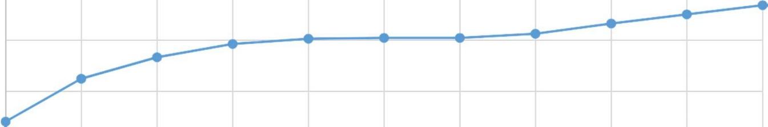
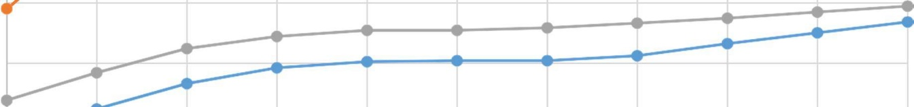





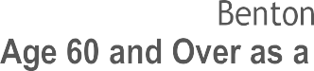






Approximately 20.5% of OCWCOG’s population is age 65 and over. This is slightly higher than Oregon’s 18.1%. According to long-range population forecasts prepared in 2017 by the Population Research Center at Portland State University (PSU), the 60 and older population in the OCWCOG tri-county region is forecast to grow from about 74,769 in 2020 (27.4% of the total population) to 81,828 (28.5% of total) by 2025 – a growth rate of over 9%. Across the region, the age distribution looks quite different from county to county. As expected, Benton County, home of Oregon State University (OSU), has a large college-age population. In Lincoln County, almost the reverse is true, and baby boomers are the largest segment of the population.
.3%
4%

 |  | 38.8% | 39.9% | 39.6% | 38.5% | 37.8% | 37.5% | 37.6% | 37.2%  37
36.0%

29.5% 27.9% 28.3% 28.7% 29.2% 29
26.2% 27.2% 27.7% 27.7% 28.
24.2% 27.5%
25.6% 26.6%
21.9%  17.0% | 21.2% | 23.3% | 24.6% | 25.1% | 25.2% | 25.2%

GENDER AND SEXUAL IDENTITY OF THE REGION
In all three counties, 60+ females outnumber their male counterparts by at least 10%. The number of residents in the region who identify as Lesbian, Gay, Bisexual, Transgender, and Queer (LGBTQ) is approximately 15,000 assuming the national average of 5.6% (LGBT Demographic Data (January 2019); The Williams Institute, UCLA School of Law) of the population holds as a constant.

RACE AND ETHNICITY
The U.S. Census Bureau categorizes “minority” as any person who identifies as African American, Hispanic or Latino, Asian American, Native Hawaiian or Pacific Islander, American Indian or Native Alaskan, Some Other Race, or Two or More Races. According to this definition, the 2010-2014 American Community Survey reported that 5.6% of our tri-county area’s 65+ population is categorized as minority. Of those, the largest percentage by a significant amount (8.4%) identify as Hispanic or Latino.

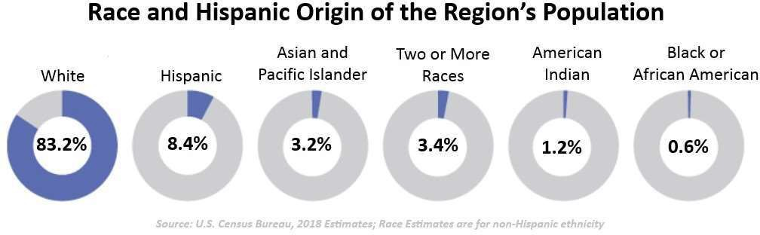

The Confederated Tribes of Siletz Indians are an important presence in the area and possess a rich history. The Confederated Tribes of the Siletz Indians is headquartered in Siletz in Lincoln County. The Tribe lists 5,547 members in its registry. This includes 1,231 members living on the reservation and elsewhere in Lincoln County. Approximately 67% of the Siletz Tribal members live in Oregon.

PEOPLE WITH DISABILITIES
According to U.S. Census Bureau estimates on disability, the OCWCOG region has 42,989 residents with a disability, a higher percentage of total residents (16.3%) than the State (14.4%) and the nation overall (12.6%). People over the age of 65 have a much higher rate of disability than their younger counterparts with 27.4% of 65-74 year olds and 52.6% of people 75 years old and older being affected.

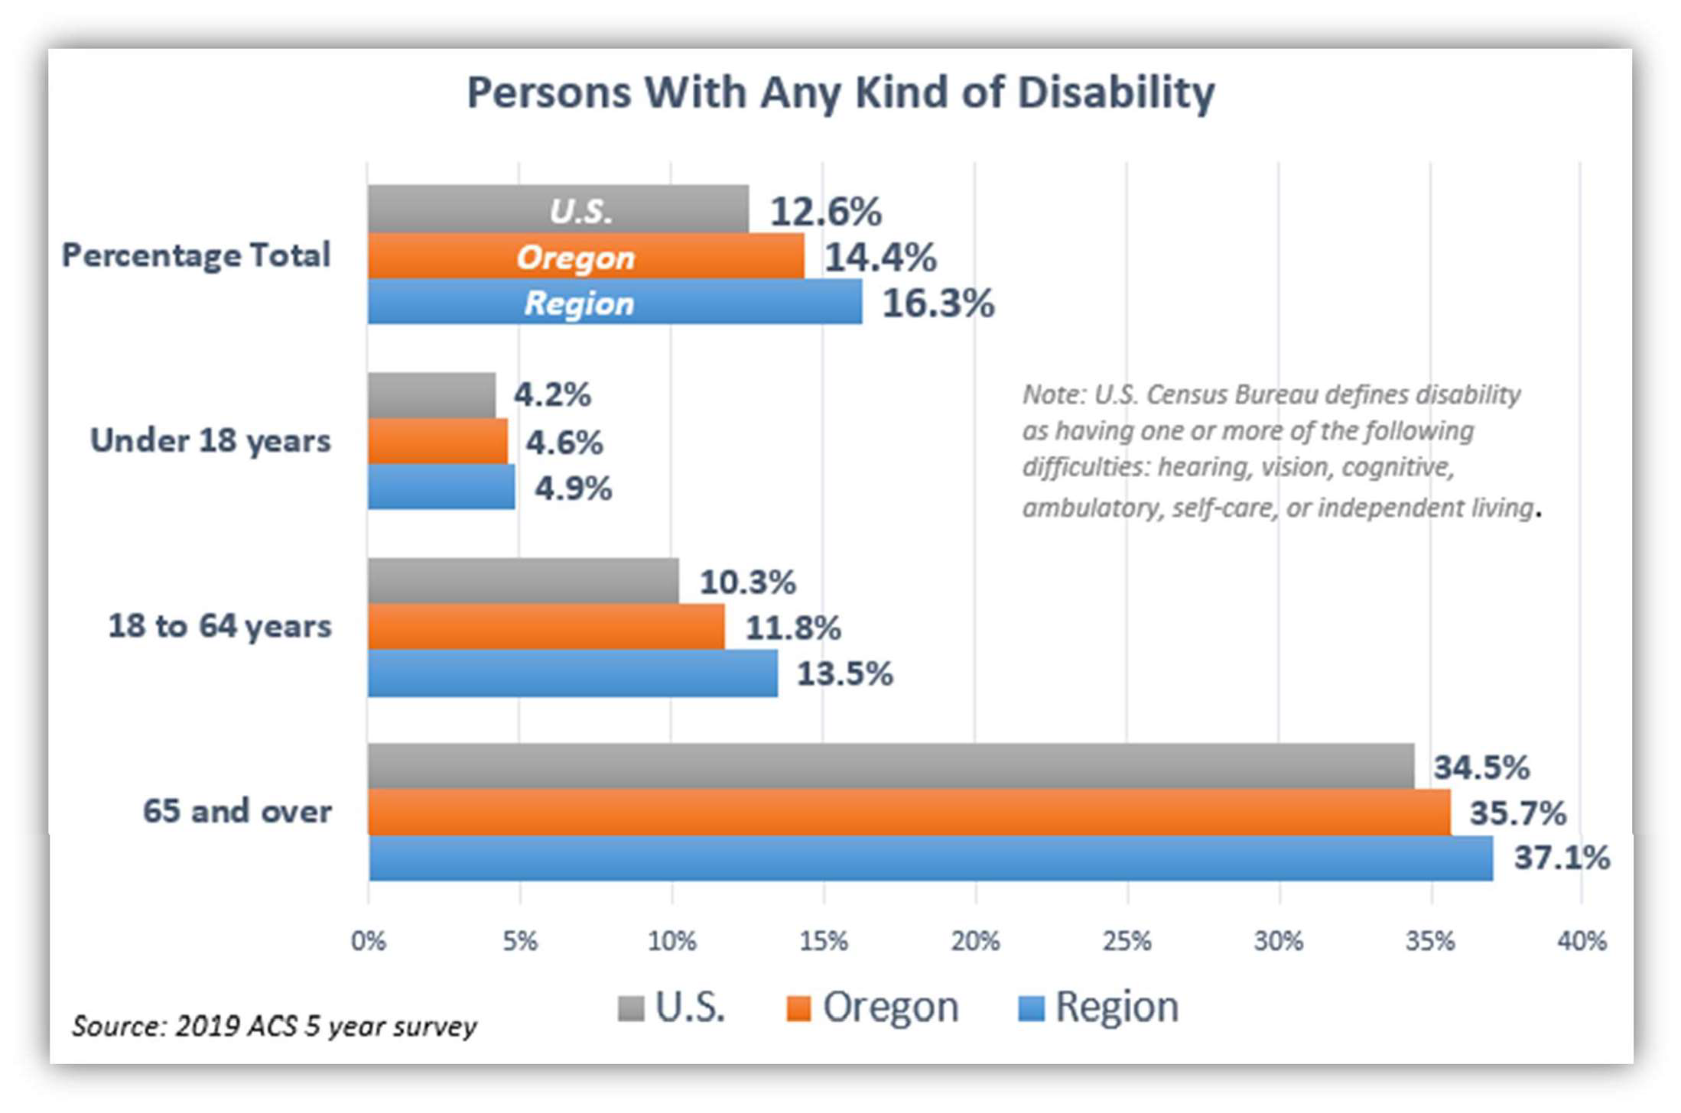

VETERANS
OCWCOG is proud and thankful for the service of the 21,869 (10.5% of adult population) Veterans who call Linn, Benton, and Lincoln Counties home. Though Veterans are better off financially than their non-veteran counterparts with only 8.5% living in poverty, their higher average age (over 45% are age 65 and older) and higher percentage of members experiencing disability (36.5%) make them a population group that OCWCOG considers when assessing LTSS delivery.

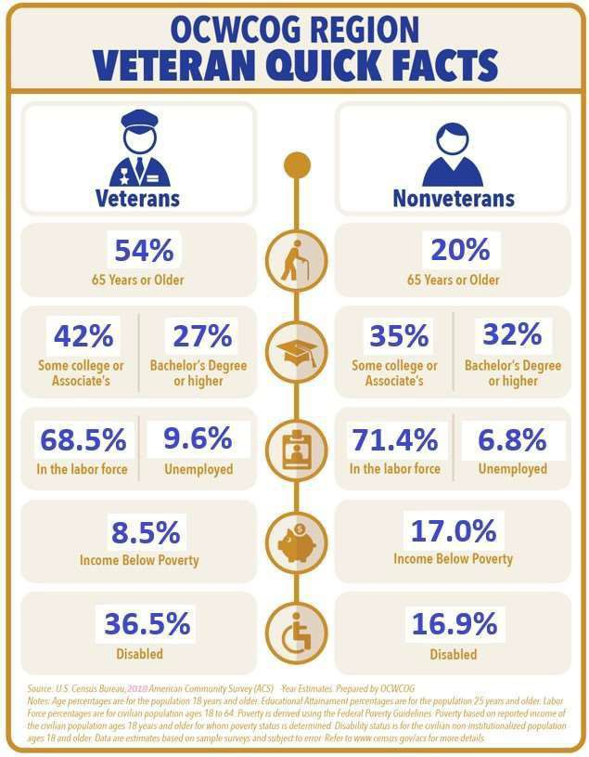

B. 2 – TARGET POPULATION

While our region celebrates diversity, understanding our most common traits is helpful to making long-lasting and impactful decisions that strengthen our communities and the individuals living in them.

A region’s diversity cannot be summed up in any one person, but averages can tell us a story.

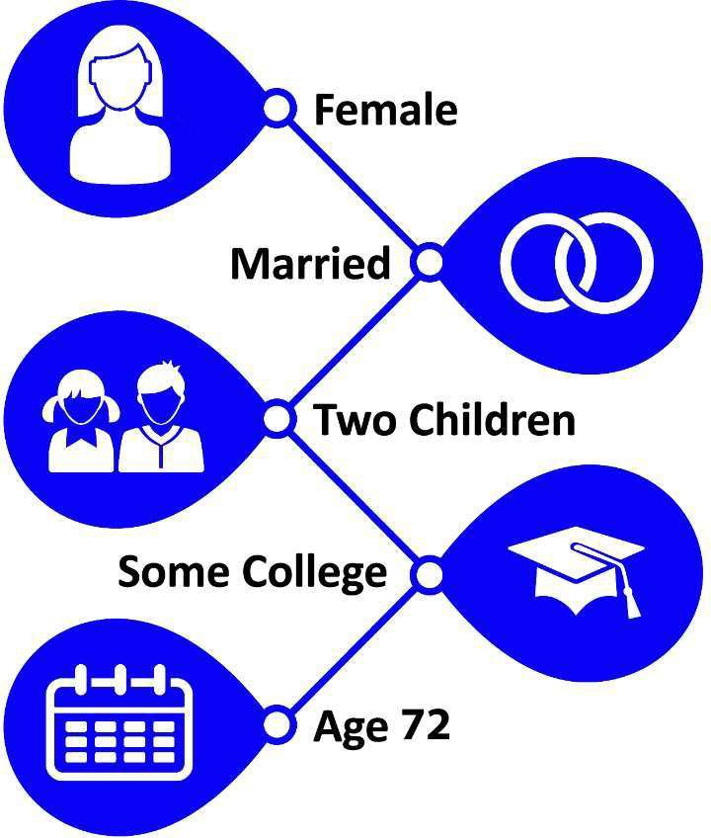
Our region’s “typical” senior citizen resident is named Linda. She is 72.5 years old, white, is married, has two children (but not in the household), and has some college education. Her husband “James” is a veteran. She lives in a house built in 1975 (valued at $261,692), and (with a mortgage) has average monthly housing costs of $1,376 (if no mortgage then monthly housing costs of $497). Nearly one in five of her neighbors is also elderly. She likely has no disability of any kind, although one in three of her age group friends does. She is not in the labor force, and has an annual household Social Security income of $22,104, and possibly an additional household retirement income of $30,790.

How did we go about determining the traits of this typical senior person?
Data about the economic and demographic makeup of a region can provide a broad overview of the commonalities among our region’s residents. Taking several factors into consideration, and using the U.S. Census American Community Survey (2015-2019 5-year) data for our region, the profile of an “average” senior resident emerges. For example, we know that over 50% of our region’s residents age 65 and over are married. We also know from the U.S. Social Security Administration that “Linda” was the most common name given to females born in Oregon in 1948 (as was “James” for men), since 72.5 is the average age of senior residents in our region, 1948 is her birth year. Why a female and not a male? Because there are more senior women than men in the region (54% of the 65+ age group is female).

Thirty-seven percent of the senior age group in the region have a disability. Of the 75+ age group nearly 53% are disabled in some way.

Again, according to U.S. Census (ACS 2015-2019 5-year) 80% of regional seniors live in owner-occupied housing that, as a regional average, was built about 45 years ago and has a median value of $261,692 (contrasted with the Oregon median value of $312,200). Although 31% of the 65-69 age group is in the labor force, the overall 65+ age group drops to 18% participation.

Why is Linda important?

By understanding similar attributes, OCWCOG can use this information, and similar data to make decisions regarding funding priorities and program focus. This information assists in answering questions about OCWCOG’s consumers and our region’s residents.

Though it’s important to understand who OCWCOG’s typical older consumer is, as an Area Agency on Aging our services must prioritize those in the greatest social and economic needs. This list of priority target populations has been developed by combining State required focal populations and those identified by the needs assessment process. Each of the groups identified below represent individuals with unique needs and barriers that may prevent them from accessing services and will require focused efforts to assist them in getting their needs met. This list is not intended to provide a ranking priority. The target populations include:
- Individuals who are low-income
- Older adults and adults with disabilities who live in rural areas and are at-risk for isolation
- Hispanic and limited English speaking
- Adults, age 18 and older, with disabilities
- Older adults who identify as LGBTQ
- Native Americans
- Individuals with behavioral health challenges, including dementia-related diseases
- Older and disabled Veterans
- Those at risk for meeting basic needs such as food and housing

In order to meet the needs of the target populations in our service area OCWCOG will employ three strategies: focusing outreach efforts, developing relationships with community partners, and being present in the communities we serve.
FOCUSED OUTREACH
OCWCOG will provide outreach materials such as brochures and posters outlining services and programs to community partners that serve targeted populations to be posted where consumers and the public can freely access the information. In order to adapt to the lack of people visiting agency and office locations due to COVID, program information will also be created in electronic formats to be shared and posted on community partner web and Facebook pages. Outreach materials will be developed that embrace and are representative of the culture and language, including art and pictures, of the populations we are working to serve. Hiring a Diversity, Equity, and Inclusion Officer is one of OCWCOG’s top priorities in 2021. The role of this position will be to help assure materials are culturally appropriate. The following graph shows organization and agencies where we will focus our outreach efforts.

Agencies For Targeted Outreach
Latino, Hispanic, Spanish Speaking | Centro de Ayuda - a cultural help center for the Hispanic population in the region’s coastal service area  Casa Latinos Unidos
Rural Consumers | Strengthening Rural Families Rural clinics and doctor offices  Coastal Range Food Bank - Blodgett
Low Income | County Health Departments Food Pantries  Community Services Consortium – Community Action Agency
Tribal Community | Tribal Health Centers

LGBTQ | Local Parents and Families of Lesbians and Gays (PFLAG) groups OSU Pride Center  Basic Rights Oregon  Valley AIDS Information Network (VAIN) Lavender Womyn  Mid-Willamette Trans Support Network  Aging Wisely with Heartfelt Hands - Newport
Veterans | County Veteran Services Offices  Samaritan Health Services Veteran Coordinator Community Services Consortium  Veterans of Foreign Wars (VFW) American Legion  Vets Helping Vets  OSU Veterans Services  Oregon Veterans Home - Lebanon
General | Faith Based Organizations Other Social Services Offices Self Sufficiency Offices Disability Equity Center  Samaritan Health Services

RELATIONSHIPS WITH COMMUNITY PARTNERS
OCWCOG participates in planning efforts, workgroups, community forums, and coalitions that represent and develop programs and policy for target populations. Through these partnerships, staff identify individuals in our region who are vulnerable, isolated, and financially in need. Some of these groups include the local county Multi-Disciplinary Teams (MDT), the Vulnerable Adult Services Team (VAST), self-sufficiency, local senior centers, the Linn-Benton Senior Resource Network, the Homeless Connect program, and the Heart-to-Heart Homeless Coalition, which plans a homeless fair annually with community service groups. This homeless fair is cosponsored and attended by OCWCOG staff to provide information and assistance.

Cross training and making connections with partner agencies, attending meetings, and providing programmatic information so staff at these agencies know about the resources and services we can provide will allow them to share the info with their clients. A focus will be placed on attending staff meetings at organizations who work with the identified underserved populations we hope to reach.
Through Memorandums of Understanding (MOU) and contracts with partner and volunteer agencies, these organizations agree to refer consumers who are identified as low income, minority, at-risk for isolation, or whom are generally underserved due to their socio-economic status to our ADRC for information and assistance.

A PRESENCE IN THE COMMUNITY
Staff will attend speaking engagements at local service clubs, churches, business and civic organizations and share information about the services we provide. Identifying groups that have ties to the underserved populations we want to focus on will be a priority. In addition, while out in the community, Older Americans Act (OAA) staff (Case Managers and Options Counselors) will stop at local businesses such as rural stores and introduce themselves and provide information about the agency and programs. Both strategies are necessary for meeting people where they are at in their communities.
OCWCOG staff regularly man tables at events and festivals geared toward specific populations such as local Latino and Pride Celebrations, Veterans Stand Down, the annual Elder Native Caring Conference, and the Senior Fair at the Chinook Winds Casino.
OCWCOG’s Corvallis office functions as the Benton County Veterans Service Office. Due to the proximity to Oregon State University, the Corvallis SDS staff is able to engage and increase its visibility with younger disabled adults. Additionally, the relationships we have developed with the university because of our proximity to the main campus has allowed us to collaborate more with university cultural resource centers like the Pride Center and the Centro Cultural César Chávez.
The Confederated Tribes of Siletz has a major presence in Lincoln County and has Tribal members living in Benton and Linn Counties. Lincoln County is also home to Tribal members of the Coos, Lower Umpqua, and Siuslaw Tribes. A primary focus of our organization is to partner in activities with the Confederated Tribes of Siletz through the ADRC, Family Caregiver Support Program, and the Meals on Wheels Program.
Additionally, OCWCOG will advertise its services and programs through press releases, newspapers, and radio advertising including ones that reach rural and Spanish speaking communities.

INTERNAL FOCUS ON EQUITY AND INCLUSION
As an agency, OCWCOG is engaged and dedicated to completing our work with a social justice, equity, and inclusion lens. Besides the creation of a Diversity, Equity and Inclusion Officer position, this involves ramping up efforts to hire a more diverse work force that is representative of the communities we serve, and providing meaningful and regular training to our staff.

B. 3 - AAA SERVICES AND ADMINISTRATION
OCWCOG’s SDS, CSP, and CED Programs ensure access to a wide spectrum of Long-Term Services and Supports (LTSS) provided through a variety of funding streams. The following identifies the individual services, or service components, that our AAA provides.
NON-MEDICAID SUPPORT SERVICES, INCLUDING OLDER AMERICANS ACT
Information and Assistance/Referral - Call Center Agents are the doorway to connect individuals, families, and community members to needed services that are housed at OCWCOG. These Call Center Agents, who are an integral part of the Aging and Disability Resource Connection (ADRC), also provide information and referral to external programs and supportsprovided by community partners across the region. More Information about OCWCOG’s call center and the ADRC can be found in Section C of this document.
Options Counseling - Options Counselors help to facilitate planning for individuals and families so they are aware of all service options available to meet their unique situation. This program focuses on those at risk for having to leave their home related to a healthcare crisis or on-going care needs. The Options Counselors complete an assessment of need, provide resource education and counseling, and facilitate client-centered action planning with consumers and their families during a face-to-face visit, usually in the home. Options Counselors provide short-term assistance and follow-up with individuals and families. During the COVID-19 pandemic options counseling appointments are being completed telephonically.
Meals on Wheels (MOW) - Offers hot, nutritious meals to homebound, aging adults, and adults with disabilities who often live alone, and have limited resources or ability to care for themselves. A volunteer base of 350 serve in meal site kitchens and as delivery drivers-providing a daily well-check for homebound clients, opportunity for socialization, and reducing isolation. More information about MOW can be found in Section C – Nutrition Services.
Elder Abuse Prevention - Preventing and raising awareness about abuse and neglect before it occurs allows information to be distributed widely and reach even the most remote and isolated community members.
Adult protective service staff participate in a monthly Multidisciplinary Team (MDT) meeting in each of the respective counties. This team consists of each counties District Attorney’s Office, local law enforcement agencies, legal aid attorneys, and other critical community partners. Time is spent staffing critical individual cases, reviewing adult protective service referrals for prosecution, discussing community concerns, and strategizing abuse prevention options.

Advocacy - OCWCOG provides opportunities for consumer advocates to work with staff, and local and State policymakers, on public policy and program issues. The AAA also works with policy issues and represents the interests of older adults and people with disabilities, as well as their caregivers at local, State, and National levels.
Stand By Me - A duplication of a financial empowerment program started in the State of Delaware. Stand By Me ($BM)uses coaches embedded in community programs to work with participants on financial goals such as creating a budget, reducing debt, improving credit, and increasing savings. Stand By Me – Oregon is a pilot program started with seed money provided by Benton County.
AmeriCorps Seniors Programs (formally Senior Corps Programs) - OCWCOG serves as the region’s sponsor to the cost-effective AmeriCorps Seniors Programs, whose national mission is to utilize seniors 55+ to “improve lives, strengthen communities, and foster civic engagement through service and volunteering.” The Programs expand a simple volunteer assignment into credentialed National Service activities, which span across the entire OCWCOG region and include:
The Retired and Senior Volunteer Program (RSVP): Medicare counseling, tax preparations, and friendly visiting programs;
Foster Grandparent Program (FGP): Tutor and mentoring of youth ages 3-18; and
Senior Companion Program (SCP): Helping homebound seniors age in place by assisting with daily living tasks, transportation, and companionship.

Transportation - The AAA provides access to medical and non-emergency medical transportation for low-income seniors and consumers with disabilities. Special Transportation Grant Funding in Linn and Benton Counties is applied for on an annual basis to offer bus tickets to use for those without access to a car and vouchers for gasoline to travel to medical appointments. Rideline provides safe and timely rides to medical appointments through approved transportation providers.
Family Caregiver Support Program (FCSP) - assists unpaid family caregivers by providing supports to ease family caregiver stress and increase coping skills stabilizing care given within the home through continued support, while forestalling placement in a higher level of community care. More information about the FCSP can be found in Section C of this document in the area focusing on “Family Caregivers”.

Employer Resource Connection (ERC) - is free for individuals who have been approved to receive in-home services through Medicaid or Oregon Project Independence. Consultants guide and provide a variety of services and tools that allow consumers (who are the employers) with the skills needed to be successful. These include helping to create interview questions, holding mock interviews to build interviewer skills, helping to create a back-up plan in case a worker is unable to come to work, and understanding how to keep professional boundaries with a worker.
Oregon Project Independence (OPI) - provides case management and in-home care services for individuals who are not Medicaid eligible (except for food stamps and the Qualified Medicare Beneficiary program), and are 60 years or older, or younger adults with a physical disability. Services are authorized based on individual consumer needs and may include in- home care, adult day care services, respite, and nursing services. More information about how OPI is administered at OCWCOG can be found in Section D.
Benton County Veterans Services - is staffed by the Oregon Cascades West Council of Governments in partnership with Benton County Commissioners. Veterans Services Officers are accredited by the Oregon Department of Veterans Affairs (ODVA) and the National Association of County Veterans Services Officers (NACVSO) and provide guidance and information to assist Veterans, ensuring the maximum payment of claims and providing other resources and supports to meet each family’s specific needs.

Money Management Program (MMP) - provides free assistance to eligible individuals, with personal money management tasks through specially trained volunteers to people over age 60 and adults with a disability. Service is personalized, confidential, and safe. Services provided by the MMP include assistance with budgeting, organizing financial papers, paying bills, banking, and help filling out forms. MMP staff can also provide Rep Payee services, assisting individuals who do not have the capacity to manage their Federal benefits, such as Social Security.

SUPPORT SERVICES PROVIDED BY OCWCOG USING MEDICAID FUNDS
The following services are provided to residents of Linn, Benton, and Lincoln Counties. A variety of factors such as age, income, resource levels, and type and amount of assistance required to accomplish Activities of Daily Living (ADL) are factors that can affect program eligibility.
Program Coordination and Development - OCWCOG staff provides the administrative function support required to implement planned services, negotiate and maintain required contracts, and maintains records for all agency contracts and funding obligations.
Adult Protective Services (APS) - investigates complaints of abuse, neglect, and exploitation of older adults and people with disabilities in the community and in long-term care facilities. APS screeners triage calls and refer to other resources and supports when a complaint does not rise to the level of being investigated. If a complaint does rise to the level of being referred to the APS team, the assigned worker determines what occurred, if there was wrong doing, and takes action to provide protection if needed. A report is completed for all investigations. The APS team works closely with law enforcement, district attorney offices, and other groups such as hospital social workers to keep vulnerable community members safe.

Pre-admission Screening and Diversion/Transition - Trained professionals work across the region to assess the needs of older adults and people with disabilities determining if there is a need for nursing facility care. These workers take an active role in identifying options and resources needed to divert and transition older adults and people with disabilities from nursing facility placement to lower levels of care. Individuals and their families are assisted in obtaining the service level that is most appropriate while taking into account each consumers wishes, goals, and personal supports and needs.
Case Management - Using person centered planning, OCWCOG provides assistance to Medicaid eligible consumers in obtaining services, assessing need, and developing a service plan. These services can be provided in a consumer’s own home with the support of a Home Care Worker (HCW) or in a community based facility such as an Assisted Living Facility, Residential Care Facility, or Adult Foster Home. Case Managers connect and check in with service clients regularly, monitor change of condition, and support consumers and families in making sure the care meets the individuals need.
Eligibility Services - Eligibility Specialists determine eligibility for enrollment for multiple State and Federal programs that provide consumers with nutrition, medical, and/or cash assistance. Previously, OCWCOG Eligibility Specialist’s managed these benefits only for older adults and people with disabilities, but since the roll out of the Integrated Eligibility (IE) System in 2020, workers are now able to support any Oregonian who meets qualifying income and resource requirements.

Adult Foster Home (AFH) Licensing - OCWCOG is responsible for the licensing and oversight of AFHs operated in Linn, Benton, and Lincoln Counties. Licensors monitor these small (less than 5 resident) home-like settings frequently, making sure they are following all rules and guidelines of the State. ODHS has overarching authority of AFH licensure and are responsible for imposing penalties and terminating licenses if a home is not compliant with State rule.
Consumer Employed Provider Support - Consumers in Oregon can use Home Care Workers (HCW) to provide the assistance with daily living tasks that they need to remain independent. Though these HCWs are hired, fired, and trained by the consumer, OCWCOG provides administrative support in the form of collecting and processing the application, completing a criminal history check, providing a HCW number, and managing payroll for these workers.
SUPPORT SERVICES PROVIDED BY OCWCOG MANAGED BY CONTRACTS
Health Promotion - OCWCOG contracts with community partners to provide Evidence-Based Programs in our area. Classes help to improve quality of life and reduce healthcare expenditures.
Legal Assistance - Utilizing OAA funding, OCWCOG contracts to provide up to 539 hours of legal aid services to persons 60 years of age and older. Consumers call Legal Aid Services of Oregon to make appointments with an attorney. These legal services are provided to the most vulnerable persons to protect their health, welfare, independence, and security. Service priorities include persons who reside in facilities, Medicaid and SSI recipients, and defense of guardianship or conservatorship. Additionally, Legal Aid provides support to Senior and Disability Services staff, Ombudsman Outreach Specialists, and Case Managers participating on the Multi-Disciplinary Elder Abuse Task Force and performs community education and public outreach activities to bring awareness of services available to the public.
Adult Day Services - Family Caregivers and OPI consumers can receive respite services because of contracts OCWCOG has with two adult day services providers - the Grace Center located in Corvallis and the North End Senior Solutions (NESS Club) in Lincoln County.

B. 4 – NON-AAA SERVICES, SERVICE GAPS AND PARTNERSHIPS TO ENSURE AVAILABILITY OF SERVICES NOT PROVIDED BY AAA
As an AAA it is impossible for OCWCOG to fill the diverse and complex needs of every consumer in the three county area. Instead, our role as the Aging and Disability Resource Connection lead is to assess the resources in our communities that serve older adults and people with disabilities, support and partner with other agencies that are providing programs and resources, bring community groups together to collaborate and create efficiencies, improve awareness about the resources available to consumers, and if possible to fill any service gaps. We do not look to compete, but supplement, support, and round out the Long-Term Services and Support network in our region.
The ADRC call center assisted consumers by making over 6,600 referrals to services during the 2019-2020 fiscal year. Of the referrals made, about half were to services provided by OCWCOG and the other half to services provided by other social services agencies. The list below shows the type of referrals that were made for services not provided by OCWCOG and the types of agencies referred to:
Housing: Housing Authority offices, low income housing communities, DevNW, and Community Services Consortium.
Energy Assistance: Community Services Consortium and faith based organizations which provide cash support for utility payments.
Legal Assistance: Legal Aid of Linn, Benton, and Lincoln Counties, and private Elder Law attorneys.
Transportation: Dial-a-Bus and community organizations.

Because of OCWCOG’s dedication to maintaining and updating the resources for our service area in the ADRC database, it remains up-to-date for use by consumers and ADRC specialists. We strive to have over 95% of resources updated at any point in time and a plan to make sure all resources are updated annually. Searching the database allows anyone to access the community organizations in our region which provide services beyond those provided by OCWCOG.
Despite the work of OCWCOG and our community partners there are three high profile service gaps that impact the consumers we serve in Linn, Benton, and Lincoln Counties – housing, transportation, and the intersection of behavioral health and long term care systems. Because of the gaps that still exist in these areas they are subjects that are addressed more in the goals and objectives section of this plan.
See Attachment C.

Section C: Focus Areas, Goals and Objectives
C.1 - INFORMATION AND REFERRAL SERVICES: AGING AND DISABILITY RESOURCE CONNECTION (ADRC)
The Aging and Disability Resource Connection (ADRC) is a hub of information and support provided by a collaboration of community agencies. Through the ADRC, trained professional staff help individuals and families connect to programs, services, and community resources that address aging and/or disability needs. OCWCOG oversees the ADRC work for the tri-county area and houses call center staff which provide free information and referral services. Community members can access this service regardless of income.
Information and Referral staff are certified by the Assistance and Information Resources System (AIRS), the Nationally recognized accreditation for Information and Assistance work. ADRC staff help assess level of need and provide eligible program options that can include support for health and wellness, nutrition, legal services, transportation, counseling, family caregivers, and needs related to performing activities of daily living such as bathing or dressing.
Often consumers who receive information and assistance may need a more in-depth exploration into their specific situation. In this case, they are referred to an Options Counselor. Options Counselors are knowledgeable individuals available for face-to-face sessions, either in a community member’s home or in one of our offices. These qualified professionals use person centered planning to help individuals and family members identify and determine what care options best fit to meet their goals, needs, and desires.
OCWCOG has an interagency agreement with the 211 info program. The 211 info program refers callers from Linn, Benton, and Lincoln Counties who call 211 and are looking for resources or services related to aging or disability services to local Information and Referral call center agents at OCWCOG for expert help and in-depth assistance.
Without a “No Wrong Door”, easily accessible entry point to the complicated world of Long-Term Services and Supports many individuals and families would struggle to find the resources necessary to meet the unique challenges they may be facing. OCWCOG is dedicated to and recognizes the importance of providing comprehensive information and assistance when a consumer first makes contact with our agency.
One of OCWCOG’s most integral regional partners is Community Services Consortium (CSC), a State-designated Community Action Agency. The close partnership of the two agencies is a natural fit given the shared service areas of Linn, Benton, and Lincoln Counties. There are a large number of residents that utilize programs in both agencies, and that each agency is equally invested in working to overcome poverty and helping community members live better lives. Specifically, at the program level both agencies support our region in the areas of food security, providing safe and accessible housing, improving financial wellness, and serving Veterans. Given this, in 2019 local elected officials, the CSC, the OCWCOG Board, and leadership of the two organizations started considering ways the two agencies could be better aligned in order to reduce duplication, be more efficient, and break down barriers for residents accessing support. Ongoing joint team meetings are being held on multiple levels to assess the future of this collaboration and partnership.

Continuing to staff ADRC functions without dedicated funding to support the work continues to be a challenge, especially during high stress times such as during the CVOID pandemic or during wildfire season when calls increased dramatically. OCWCOG works with ADRC core partners and other entities with the hope of decreasing duplication of efforts, leveraging community resources, and identifying and capturing additional funding streams to maintain and expand ADRC services. OCWCOG leverages existing Medicaid funding for the ADRC which has helped augment ADRC call staff. We continue to review work flow for efficiencies and process improvements to maximize resources and staff availability and provide information and data supporting the value of the ADRC to local elected officials.

Goals and Objectives: Information and Referral Services: Aging and Disability Resource Connection (ADRC)

Goal #1: Improve “No Wrong Door” entry point access.
MEASURABLE OBJECTIVES | KEY TASKS | LEAD POSITION & ENTITY | TIMEFRAME FOR 2021-2025  START DATE / END DATE
1. Create a “warm | A. Develop a list of partners that serve a  large number of the same consumers. | Program Director and | A. 7/1/2021 – 9/30/21
handoff” process |  | Program Manager.
between OCWCOG and
community partners |  |  | B. 7/1/2021 – 9/30/21
which serve a large | B. Develop a work group for each community partner to discuss warm handoffs.
cross section of the
same consumer base.
 |  |  | C. 7/1/2021 – 11/30/2021
 | C. Develop a process.
 |  |  | D. 10/30/2021, 1/30/2021,
 | D. Revisit quarterly in the beginning to address any issues. |  | D. 10/30/2021, 1/30/2021,
 | D. Revisit quarterly in the beginning to address any issues. |  | 4/30/2021, 7/31,2021
2. Reduce barriers and | A. Develop a streamlined application process for consumers that utilize OCWCOG and CSC programs. | Program Director and | 1/1/2022 – 6/30/2022
simplify the process |  | Eligibility Supervisor.
for consumers that
utilize both CSC and
OCWCOG program.
 | B. Work with CSC leadership to make sure both agencies have up to date and accurate information about programs. | ADRC Supervisor. | Annual team meetings
 |  |  | beginning fall
 |  |  | 11/15/2022.
Goal #2: Provide Information and Referral and Options Counseling staff with the tools and resources they need to do their job.

1. Regular training will be provided on topics that are especially relevant to Information and  Referral specialists. | A. Training on Person Centered Planning will be offered once every two years. | Training unit, Professional Development Committee, and ADRC Supervisor. | Staff will have an opportunity to attend training on all four topics by 6/30/2025.
 | B. Training on the meaning of Service Equity and how to be inclusive and culturally competent  will be offered every two years. |  | B. – E. 7/1/2021 –  6/30/2023 and 7/1/2021 –  6/30/2025
C. Training on De- escalation tactics
will be offered every two years.
D. Training on how to be Trauma Informed
will happen every two years.
E. Staff from key partners such as CSC will be invited to participate allowing the agencies to share the cost of training
resources and build relationships.
2. Information about | A. 100% of the resources in the RTZ  database will be updated annually. | ADRC Supervisor and Data | Annually rolling timeframe
regional resources will |  | Committee Representative | with QA done every
be up to date and |  | from the call center. | December. 12/2021,
accurate. |  |  | 12/2022, 12/2023 & 12/2024
3. OCWCOG will encourage staff’s professional development. | A. All Staff of Information and Referral workers at COG will be Association of Information and  Referral Specialists | ADRC Supervisor. | 50% trained by 6/30/2023. 100% trained by 6/30/2025.

(AIRS) certified.

Goal #3: Provide exceptional customer service to Information and Referral consumers.
1. Answer calls live. Respond to referrals, emails and voicemails within 1 work day during a normal work week. | A. Monitor average wait, call back timeframe and abandonment of calls weekly for  staff problem solving and triage. | ADRC Supervisor. | A. Start monitoring quarterly 7/1/2021 – 6/30/2025
B. – D. 7/1/2021 &
Ongoing through 6/30/2025.
 | B. Implement corrective action by agent and/or unit when timely call backs or live answered calls  drop below 90% for 60 days. |  | B. – D. 7/1/2021 &  Ongoing through 6/30/2025.
C. Monitor call volume data to determine
peak call times.
D. Fully staff call
center during peak times.
2. Conduct annual ADRC Secret Shopping for phone and resource directory feedback. | A. Recruit council  members for Secret Shopper study. | Program Director and Advisory Councils. | 4/1/2023 4/30/202  B. 4/1/2023 – 4/30/2023  C. – D. compile annually and share annually. 4/1/, 2024 & 2025.
 | B. Develop script and rating tool. | Program Director and Advisory Councils.
 | C. Compile data. | Program Director and Advisory Councils.
 | D. Share data with Councils and staff. | Program Director and Advisory Councils.

 | E. Complete corrective action for any issues. |  | E. Annually, 5/1/2024-6/30/2024 & 5/1/2025-4630/2025
Goal #4: Promote awareness of the ADRC and its purpose.
1. Quarterly outreach to | A. Assign completing quarterly outreach  to ADRC Supervisor. | ADRC Supervisor and | A. – E. Starting
underserved | A. Assign completing quarterly outreach  to ADRC Supervisor. | Program Director. | 2/1/2023 and
populations, including | A. Assign completing quarterly outreach  to ADRC Supervisor. |  | ongoing quarterly.
outreach to Tribal and | A. Assign completing quarterly outreach  to ADRC Supervisor.
Spanish speaking | A. Assign completing quarterly outreach  to ADRC Supervisor.
Spanish speaking | B. Identify target  audiences, locations, events.
populations as well as | B. Identify target  audiences, locations, events.
LGBTQ consumers. | B. Identify target  audiences, locations, events.
C. Utilize culturally
appropriate materials.
 | D. Conduct outreach quarterly.
 | E. Report out to Councils quarterly about outreach activities.
2. Outreach to local businesses. | A. Outreach quarterly  will be to at least one local business. | ADRC Supervisor. | Starting 2/1/2023 and ongoing quarterly.
 | B. Report out to Councils quarterly about outreach activities. |  | B. 4/2023, 7/2023, 10/2023, 1/2024
Goal #5: Expand and strengthen ADRC partnerships.

1. Improve communication and working relationships between core partners. | A. Provide training to key community partners about the work information and referral staff  perform. | Program Directors, Program Managers, and ADRC Supervisor. | Twice annually starting in fall of 2021 and ongoing.

 | B. Streamline referral process for community partners. |  | 10/2021 – 6/30/2023  C. 10/2021 & 4/2022
 | C. Conduct semi- annual check-ins with key partners  and improve referral forms and pathways. |  | 10/2021 – 6/30/2023  C. 10/2021 & 4/2022
ACCOMPLISHMENTS- UPDATES 2022 | - Three community partners were identified as being our priority for streamlining support when working with joint consumers this year – IHN CCO, Community Services Consortium, and regional homeless shelters. Regular meetings have been scheduled with these groups to discuss how to support No Wrong Door work.  - A process has been developed where consumers applying for SNAP with OCWCOG will be warm transferred to CSC if they are interested in utility assistance (UA) (if eligible for SNAP consumers are categorically eligible for UA). CSC will call all people warm transferred to them. In addition, a list was pulled of all people in the region who are SNAP eligible which was shared with CSC. This allowed them to send UA information to more than 7000 families they were not serving.  - The next step is to start talking about how CSC and OCWCOG have some kind of joint call center.  - OCWCOG and Self Sufficiency staff are cohousing across the three-county region for cross training and building relationships. The work is being done to support No Wrong Door point of entry work.  - ADRC staff received training this year on working with people affected by trauma. Mental Health First Aid classes are also scheduled.  - Two staff have been identified as the staff that will take the AIRS certification test in the Fall of 2022 and are actively studying to accomplish this task.  - The RTZ database is up to date and all resources have been updated in the last year.  - A new supervisor has been hired to lead the ADRC. She has implemented weekly huddles for training and is starting to learn and understand the role of call center agents. She is also developing understanding of how to pull QA data about call volume, timeframes, and follow up.  - The new ADRC supervisor is working on an outreach plan and calendar for getting info about the ADRC into community businesses, doctor offices, clinics, and pharmacies. Rural areas and agencies that serve underserved individuals will be the priority.  - OCWCOG has hired a new communications officer. Creating marketing materials that advertising the call center and its purpose is one of her top priorities.  - OCWCOG attended over 15 events over the last year that focused on underserved communities and shared ADRC information. Most of the events were focused on outreach to Latino families. A tribal event and Pride (LGBTQ) event were also in the mix.
ACCOMPLISHMENTS- UPDATES 2023 | - Local radio and movie theaters in all three counties ran ads purchased to highlight the services OCWCOG provides and inform people of our ARDC call center.  - Warm transfer hand offs, process improvement, and info sharing was expanded to involve new partnerships with community agencies this year: Trillium Health Services, Linn Benton Housing Authority, and Community Services Consortium Veteran Services. All involve regular (at least monthly) meetings and streamlined systems to better serve joint consumers.  - A new Program Manager was hired that will have oversight of the ADRC, OPI, Options counseling and OAA teams, her previous experience will bring a lot of stability and clarity to those programs.  - Program staff are working closely with agency tech services to identify how call center metrics and data can be pulled despite the implementation of a new phone system. Reports will start being pulled monthly to support providing better customer service.  - OCWCOG attended 112 tabling events, resource fairs and conferences this year, sharing information about our programs and services. Thirty nine were held in rural areas, in addition to 19 Latinx events and 5 serving Pride/LGBTQ+ population.  - One OAA staff member has been named as our designated Tribal Liaison for the agency. She works closely with the Siletz Tribe and has long standing history with the Siletz Tribal Elders Programs. This relationship has led to a meeting being scheduled with Siletz Tribal staff and State Tribal Liaison staff in the hopes of a contract being created between the Siletz Tribe and APD.  - Turnover and staffing shortages in the Tribal Elders program has still made getting the Tribe to regularly participate in our Advisory Councils difficult.  - All OCWCOG staff, including ADRC call center agents, recently participated in Active Threat training and consumer facing staff will soon be attending De-escalation training to help support them when they are working with frustrated consumers. An annual rotating training plan has been created.  - Local resources are all current in the Get Care data base and will continue to be updated.

C. 2 - NUTRITION SERVICES
Hunger and securing enough food to meet their nutritional needs is a struggle that many older adults and people with disabilities face in our region. This problem is only magnified for residents living in rural communities, people who are a racial minority, and those who have failing health or live alone. Food insecure older adults suffer a wide array of negative health outcomes including diabetes, depression, limitations in activities of daily living (ADLs), high blood pressure, congestive heart failure, heart attacks, gum disease, and asthma. OCWCOG is committed to improving food security for seniors and people with disabilities and manages programs to support this work. Nutrition Services and supports provided by OCWCOG are well coordinated with other programs provided by the agency such as Family Caregiver, Senior Companion, Adult Protectives Services, and Oregon Project Independence. The connections made as the lead agency for the ADRC regionally allows us to help link external nutrition services providers such as CSC and tie them together with other community partners which are complimentary, such as health promotion classes provided by the regional health education hub around healthy eating.

PROGRAMS THAT SUPPORT FOOD SECURITY AT OCWCOG
Supplemental Nutrition Assistance Program (SNAP) - The SNAP program, formerly known as “food stamps”, is a Federal program that provides benefits to supplement the budget of needy families so they can purchase healthy food. OCWCOG Eligibility Workers process SNAP applications and determine and issue benefits. SNAP benefits are delivered monthly through electronic debit (EBT) cards.

Unfortunately, the SNAP participation rate for seniors is low. According to the National Council on Aging, three out of five seniors who qualify for SNAP do not participate. Factors that may contribute to low participation rates of seniors and people with disabilities include: issues related to restricted mobility and technology access, misunderstanding about how the program works, lack of clarity about who can qualify, and the stigma of not wanting to be seen as someone who is “needy”.

Food Box and Grocery delivery by the Senior Companion Program - The AmeriCorps Senior Companion Program (SCP), sponsored and operated by OCWCOG since 2018, uses National Service volunteers 55+ to help seniors 65+ age in place. A true gaps program, SCP receives internal referrals from OCWCOG (e.g. Money Management, Meals on Wheels, Options Counselors) when a client is identified as needing 1-2 more hours of volunteer assistance each week. A chief component of the program is taking the client grocery shopping, or, during the COVID pandemic, either delivering groceries or food boxes to the client’s front door. Volunteers receive a tax-exempt stipend at $3/hour, drive their own vehicles and are provided liability insurance, ongoing drivers training, and are reimbursed .40/mile.

Meals on Wheels - The Meal on Wheels (MOW) program serves residents across Linn, Benton, and Lincoln Counties. Our mission is to provide fresh, hot meals as well as a connection for local seniors and people with disabilities, supporting independent living at home. Older adults aged 60 and over, Native Americans/Alaskans age 55+, and people with disabilities can receive a hot meal delivered to their home or at a dining room location.
There are 11 meal site locations throughout our region. For mobile residents, meals are offered in a dining room setting providing an opportunity to reduce isolation and loneliness by connecting them with other community members. During COVID restrictions, all dining rooms were suspended, and take-out meals were provided to dining room participants.
Home-bound recipients can receive hot, nutritious meals delivered to their doorstep by a MOW volunteer. Delivery days vary depending on the meal site location. Home delivered meals offer more than just a meal, each delivery serves as a well- check by a dedicated, trained volunteer. For some participants, this may be the only contact they have throughout a day.
MOW contracts with TRIO Community Health as a foodservice vendor. Fresh, hot meals are planned by the vendor’s dietician then prepared at a central kitchen in Salem and delivered to each meal site location in our region. Nutrition education articles are provided monthly with each menu and covers a variety of nutrition topics that relate to healthy nutrition for older adults. Quarterly nutrition education seminars are also presented to our dining room recipients. In addition, Older Americans Act (OAA) homebound MOW recipients receive nutrition education information during their initial and annual in- home reassessments.
Meals on Wheels consumers who would benefit from additional supports and services are referred to the Aging and Disability Resource Connection (ADRC) to ensure they receive appropriate needed resources.
The MOW program pursues and receives fundraising and grant funds allowing our program to operate without a waitlist.
In March of 2020, Senior and Disability Services held a roundtable forum with community stakeholders to help identify gaps and barriers our communities experience around nutrition.

Utilizing Title III-C funding, all meal site locations deliver hot meals based on the service schedule below:

Linn County Meal Site Locations | Average Monthly Dining Room Participants | Average Monthly HDM’s | Service Schedule
Albany Senior Center | 248 | 4615 | Monday – Friday @ 11:30 AM
489 Water Ave NW, Albany, 97321
Lebanon Senior Center | 347 | 3256 | Monday – Friday @ 12:00 PM
80 Tangent St., Lebanon, 97355
Mill City First Presbyterian Church | 136 | 114 | Tuesday & Thursday @ 12:00 PM
236 West Broadway, Mill City, 97360
Sweet Home Community Center | 277 | 2169 | Monday, Tuesday, Friday @ 12:00 PM
880 18th St., Sweet Home, 97386
Brownsville Christian Church | 210 | 451 | Tuesday & Thursday @ 12:00 PM
117 N. Main St., Brownsville, 97327
Benton County Meal Site Location | Average Monthly Dining Room Participants | Average Monthly HDM’s | Service Schedule
Corvallis Elks Lodge | 148 | 3129 | Monday – Friday @ 11:50 AM
489 Water Ave NW, Albany, 97321
Lincoln County Meal Site Locations | Average Monthly Dining Room Participants | Average Monthly HDM’s | Service Schedule
Lincoln City Community Center | 189 | 1385 | Monday, Wednesday, Friday @ 12:00 PM
2150 NE Oar Place, Lincoln City, 97367
Newport Senior Activity Center | 271 | 1041 | Monday, Wednesday, Friday @ 12:00 PM
20 SE 2nd St., Newport, 97365
Siletz Tribal Community Center | 184 | 648 | Monday and Wednesday @ 12:00 PM
402 Park Way, Siletz, 97380
Toledo Trinity Methodist Church | Included in Siletz #’s | Included in Siletz #’s | Friday @ 12:00 PM
383 NE Beech St., Toledo, 97391
Waldport South County Community Ctr. | 208 | 1082 | Monday, Wednesday, Friday @ 12:00 PM
265 West Hemlock St., Waldport, 97394

Goals and Objectives: Nutrition Services

Goal #1: Reduce hunger and food insecurity for seniors and people with disabilities.
MEASURABLE OBJECTIVES | KEY TASKS | LEAD POSITION & ENTITY | TIMEFRAME FOR 2021-2025  START DATE / END DATE
1. Increase the number of older adults utilizing SNAP in our region. | A. Partner with the OSU Extension Service who are also working on this  issue. | Eligibility and CSP Supervisors. | Meet with OSU Extension by 9/30/2023.
 | B. Develop a corps of senior volunteers for  peer to peer outreach. | Program Manager and CSP Supervisor. | In place by 7/1/2022.
 | C. Provide more hands- on assistance for older adults completing the  application. | Eligibility Supervisor and CSP Supervisor. | Start 7/1/2021 – 6/30/2025
 | D. Start completing monthly follow up phone calls with older adults who drop off of program during renewal process to see why they are not continuing. | Program Managers  ES Supervisor and CSP Supervisor. | D. – E. Start by 4/1/2023 with quarterly assessment of the data end date 6/30/2025
 | E. Assess data quarterly to see if we can address barriers  or if calls are helping. | Program Managers  ES Supervisor and CSP Supervisor.

Goal #2: Improve the sustainability of the Meals on Wheels program.
1. Develop and implement a robust volunteer recruitment and retention strategy. | A. Commit 5% of CSP Program Manager time to volunteer  recruitment and retention efforts. | Program Director and Program Manager. | Strategy Developed by 12/31/2021 and implemented 1/1/2022.  Quarterly assessment of the gains starting 3/31/2022 end 6/30/2022.
 | B. Assess quarterly to see what is working, what isn’t, and where best to  concentrate our efforts. | Program Director and Program Manager.
2. Annual assessment of MOW budget to look for cost savings and revenue earning opportunities. | A. Use the MOW  Advisory Committee for this effort. | MOW Supervisor and Program Director. | A. –B. Each year in December, 2021, 2022, 2023, 2024.
 | B. Implement action of  suggestions provided. | MOW Supervisor and Program Director. | A. –B. Each year in December, 2021, 2022, 2023, 2024.
3. Increase meals revenue by 5% through fundraising and grant writing. | A. Increase corporate sponsorships. | Program Director Program Manager Council Members. | Start work immediately 7/1/2021 and assess annually in March through 2025.
 | B. Track all efforts and outcomes. | Program Director Program Manager Council Members.
 | C. Distribute 4 direct  mail distributions annually. | Program Director and Program Managers. | Four annually from November  – October, 2021, 2022, 2023,  end November 2024.
 | D. Create a Meals on Wheels newsletter and distribute twice annually to donors, community partners, corporate sponsors,  and local elected officials. | Program Director and Program Managers. | March 2023 then September and March ongoing, end 6/30/2025

Goal #3: Create program efficiencies by collaborating with other nutrition providers.
1. Bring local stakeholders invested in food security to the table quarterly. | A. Assess places where we are duplicating efforts and work to reduce duplication. | Program Director, Program Manager, and MOW supervisor. | A. – C. Start quarterly meetings June 2023 – assess impact October 2023. End 6/30/2025
 | B. Identify ways we can leverage resources such as volunteers or delivery systems  so resources spread further. | Program Director, Program Manager, and MOW supervisor.
 | C. Create MOUs or systems for supporting each  other in program delivery. | Program Director, Program Manager, and MOW supervisor.
ACCOMPLISHMENTS- UPDATES 2022 | - Less progress has been made in meeting all three of the goals in this section than hoped. The goals identified that were supposed to be accomplished in FY 22 will be refocused on in FY23.  - A new communications officer was hired at OCWCOG and outreach about programs such as Meals on Wheels is one of her top priorities.  - Advertisements were placed in rural news media across the region with the purpose of recruiting MOW volunteers.  - Despite not meeting the listed goals and objectives, potential expansion of the MOW program happened in FY22, with the discussion being launched of how to begin serving more meals to homebound seniors and people with disabilities in the community of Monroe. Discussion of a potential congregate site in that community is also taking place.
ACCOMPLISHMENTS- UPDATES 2023 | - A consultant was hired short term and then the time extended to support the streamlining, efficiency, food quality, and improvement of customer service of our MOW program.  - Supporting Meals more with contracts with local partners will be more of a focus moving forward.  - A volunteer coordinator has been hired to increase the impact of our volunteer force, making the program more sustainable in the long run.  - Ongoing meetings taking place between OSU Extension Services have been and are scheduled with OSU Extension Services Nutrition Education and Outreach staff to talk about how we amplify each other’s efforts when working on increasing SNAP utilization amongst older adults. This has been the launching spot for also partnering to share info about ADRC, work force education related to MOW, and Health Promotion class offerings.  - Gleaner groups (managed by Community Services Consortium) and MOW coordinators now do cross referral for the programs and complete application paperwork to reduce duplicative visits from the staff of both programs.  - Collaboration and partnership are underway to work with Cornerstone Associates, a work force training program that serves people with Intellectual and Developmental Disabilities, to support the Corvallis meal site. This would also build an intergenerational aspect into our congregate dining programming.  - We continue to work in reopening Linn, Benton, and Lincoln County Congregate Dining sites. Five out of the eleven sites we manage are open currently. Others had been open for a short time, but because of a variety of issues such as a lack of volunteers or site construction, returned to being closed.  - Amazing attendance is happening at a couple of the sites, with Mill City having more than 20 attendees daily. We are excited about the work that is being done to reduce isolation and loneliness in our most rural communities.  - A large amount of work was done by OCWCOG staff to prepare families for the reduction they might experience to their SNAP benefits because of the PHE unwinding. All consumers who communicated with our office were told of the coming change, all local grocers were communicated with to warn them of potential frustrations, and written signs were created and posted in our office and the community to let SNAP consumers know of the issue. Information about other food resources was provided to all consumers who asked.  - Increased grant writing has taken place locally with increased money awarded over last year, ensuring the MOW budget is sustainable. We do not have a waiting list for MOW and plan on continuing this trend despite growing participant numbers.  - Our MOW Advisory Committee (MOWAC) is again meeting regularly after taking a hiatus during COVID. The MOWAC meeting had traditionally rotated between locations between local congregate dining sites but paused in 2020 with the closure of our meal sites.

  - - HEALTH PROMOTION
An important outcome of many of the services provided or administered by OCWCOG is stabilizing or improving health for older adults and younger adults with disabilities across the region. Knowing that these populations experience higher risk of chronic disease and often are at greater risk for health problems that can be prevented, OCWCOG supports programs and works in tandem with health care providers as well as non-clinical community partners across the three-county area to stabilize and improve health. Through better health, individuals retain their independence, choice, and dignity.
Partnerships with Health Care Systems: OCWCOG has a strong and ongoing relationship with Intercommunity Health Network Continuing Care Organization (IHNCCO), the largest Continuing Care Organization in the region. OCWCOG staff represent on the IHNCCO Regional Planning Council (RPC) as well as the RPC’s Management Group. The RPC is a group of invested stakeholders that advises on the work the CCO does in the region. Additionally, OCWCOG manages and administers the contract the RPC has with Community Advisory Council Coordinator.
An MOU exists between OCWCOG and Intercommunity Health Network (IHNCCO) that outlines how IHNCCO and OCWCOG will work to support joint members across the continuum of care. Monthly Intensive Care Team meetings held by IHNCCO and OCWCOG brings community partners to the table to discuss consumers who may need more support and quarterly “coffee breaks” are an opportunity for the staff of IHN and OCWCOG to discuss our shared work, exam processes, and build relationships.
Strong relationships with Samaritan Health Services Discharge Planners and Samaritan and Corvallis Clinic Care Coordinators allows OCWCOG to problem solve and support when a community member is working through the health systems and needs long term services and supports to be successful.
Partnerships with Community Agencies: OCWCOG is an integral part of the Regional Health Education Hub (ReHUB). ReHUB is a partnership between multiple community organizations working to streamline health education programming across the Linn, Benton, and Lincoln County region. Its purpose is to provide easy access to a range of health education programming options. The ReHUB can be relied on to support community members, clinicians, and community partners by providing relevant evidence-based health education programming by meeting community needs and connecting participants with appropriate workshops and community trainings. ReHUB partners meet quarterly to discuss health promotion programming in the region and have participated in the Sustainable Relationships in Community Health (SRCH) Institutes. ReHUB partners used the SRCH grant provided through the Oregon Health Authority to work to make health promotion programs sustainable moving forward.

OCWCOG provides funding through contracts to community partners to support healthy aging. Some of the contracts we support include:
Fall prevention – Willamette Valley YMCA offers Better Bones and Balance classes, an evidence-based program shown to improve balance and reduce fall risks. Newport Senior Center offers the “Walk with Ease” program, developed by the Arthritis Foundation and proven to help reduce pain and stiffness.
Diabetes Prevention Programs – Education offered one on one, in a classroom and online dedicated to teaching individuals through healthy eating, exercising and lifestyle changes to help with the delay, prevention, and management of diabetes.
Transitions – A non-medical community program of Lumina Hospice and Palliative Care designed to help individuals and families live well with a serious, life-limiting illness.
Living Well with Chronic Conditions – Samaritan Health offers The Living Well Virtual Workshop for people living with on- going physical and/or mental health conditions. Classes are interactive and provide support with action planning, decision- making, problem-solving and learning to break the cycle and deal with frustration, pain, fatigue, isolation, sadness, and poor sleep.
Regional Health Education Hub – Samaritan Health Services is an active provider in offering regional health education. Monthly health-related classes provide skills in managing chronic health conditions, disease prevention, and improving quality of life resulting in lower health care costs.
Powerful Tools for Caregivers – An evidence-based health promotion program developed to support caregivers. Class participants receive resources and tools to help manage time, reduce stress and communicate feelings, making a positive impact on caregiver health.

In addition to financial support OCWCOG supports community health promotion programs in other ways:
Though volunteer class leaders do much of the heavy lifting for community health promotion class series, having access to reliable trainers who can lead class sessions is an important aspect in making classes sustainable. Because of this, OCWCOG, as a ReHUB partner, invested in training staff to be leaders for the Freedom from Smoking program. Freedom from Smoking was initiated by the American Lung Association and is ranked as one of the most effective cessation programs in the country. Clinics are led by facilitators and conducted in community settings, workplaces, and public venues. If a volunteer class leader is unable to teach a session for some reason OCWCOG staff can stand in so classes don’t need to be cancelled.
Through the transportation brokerage RideLine, housed in the CED department, consumers who want to attend in- person classes can get rides to classes offered in the region. This benefit is open to all class participants, even those who are not normally eligible for RideLine transportation services.

The ADRC call center agents at OCWCOG will have access to info about class offerings across the three counties and be able to refer consumers who call and would benefit from health promotion classes.

Gaps that OCWCOG hopes to address to support health promotion in our service area:
Many Medicare and Medicaid recipients have little to no access to mental health services. Rural community members especially face barriers in finding qualified mental health practitioners. Additionally, the mental health system and the medical care health systems are very disjointed and accessing benefits in both systems is almost impossible. Those with dementia-related diseases find it particularly difficult to navigate these systems effectively. Physical health providers are often not trained to adequately understand those that struggle with dementia diseases. OCWCOG will work over the next four years, with the support of the coordinators of the Older Adult Behavioral Health Initiative team, to try to address the gaps in service for those who are aging and have a behavioral health diagnosis and break down the silos between the two systems in the region.
Social isolation and loneliness in older adults are substantial public health problems resulting in increased health care utilization. Recent studies reflect one in five Americans report feeling socially isolated or lonely. This statistic has likely increased due to the “stay at home” orders during the COVID pandemic. OCWCOG is committed to launching an evidence-based program aimed at reducing isolation and loneliness for the consumers we serve.

Goals and Objectives: Health Promotion

Goal #1: Support seniors and people with disabilities that face isolation and loneliness.
MEASURABLE OBJECTIVES | KEY TASKS | LEAD POSITION & ENTITY | TIMEFRAME FOR 2021-2025  START DATE / END DATE
1. Launch an evidence-based program that reduces isolation and loneliness. | A. Use Councils to help identify evidence-based programs that  best meet the needs of the region. | Councils and Council Staff. | 7/1/2021 – 9/30/2021
 | B. Develop contract with agency/ agencies that would like to pilot program. | Program Director and Contracts. | 7/1/2021 -12/31/2021
 | C. Support outreach and launch program with first  participants being served. | Contracted Agency. | C. – D. 1/1/2022 – Ongoing Through 6/30/2025
 | D. Partner with CWTO to develop and provide informational materials on using transit to access community destinations. | CED Program Manager and  CSP Program Manager. | C. – D. 1/1/2022 – Ongoing Through 6/30/2025
2. Use Senior Companions to provide peer to peer support to most rural and vulnerable. | A. Develop a process for APS, Case Managers, MOW, and OAA staff to refer to SCP for peer-to-peer support. | Community Services Program Staff. | 10/1/2021 – 7/31/2023

 | B. SCP will work with those referred for at least four months. |  | B. 10/1/2021-7/31/2023  C. 10/1/2021-10/30/2023
 | C. A post four-month survey will be completed with at least 80% of participants reporting that they  feel more socially connected. |  | B. 10/1/2021-7/31/2023  C. 10/1/2021-10/30/2023
Goal #2: Work with the aging network across Oregon to allow statewide access to virtual classes.
1. Utilize virtual class sessions to better serve remote and underserved populations. | A. Work with O4AD and Oregon Wellness Network to discuss how virtual programming can benefit class  participants across the State. | Program Director. | A. – C. 9/30/2021 initiate: Agreements in place in Linn, Benton, and Lincoln Counties with participants accessing virtual classes in other service areas by 12/31/2021.
 | B. Develop agreements allowing residents in our service area to  use other agency resources. | Program Director.
 | C. Focus on programs that we do not offer locally and/or offer curriculum that serves minority groups such as Native, ethnic  minorities, and LGBTQ populations. | Program Director.

Goal #3: Use ADRC resources and partners to develop a streamlined referral process for class sessions across the region.
1. Use ADRC resources and partners to have one accurate and up to date repository of class information, class cost, and schedules. | A. Work with the Regional Health Education Hub (ReHUB) to bring all agencies who provide health promotion classes  in the communities together. | Program Director, Councils, ADRC Supervisor. | 3/1/2022 – 6/30/2024
 | B. Include ReHUB in annual team building with local  community/ 60+ centers. | Councils and Council Staff. | 2/1/2022 – 6/30/2025
 | C. All ADRC call agents will know how to access this information. | ADRC Supervisor. | 12/31/2021 – 6/30/2025
2. Develop a streamlined referral process for class sessions across the region. | A. Agree on how referrals are made  between all partner agencies. | Community partners and Program Director. | 9/30/2021 - 12/31/2024
 | B. All ADRC call agents will use the agreed upon referral process to refer participants to programs. | ADRC Supervisor. | 12/31/2024 – 6/30/2025
Goal #4: Collaborate with local partners to increase the breadth of class offerings regionally.

1. Utilize the departments at OCWCOG to support health education program regionally. | A. Rideline services will be provided to consumers who lack transportation to attend in person  health promotion classes. | Program Directors. | A. – D. 7/1/2021 – 6/30/2025  Ongoing.
 | B. Staff will be trained to be class leaders for programs where finding leaders has been a barrier to  offering classes in the community. | Program Directors. | A. – D. 7/1/2021 – 6/30/2025  Ongoing.
 | C. Provide technology through grants that support virtual programming in the time of COVID. | Program Directors. | A. – D. 7/1/2021 – 6/30/2025  Ongoing.
 | D. Continue to expand travel training offered through the CED Department and work with SDS  to specifically market the program. | Cascades West Transportation Options Staff (within CED). | A. – D. 7/1/2021 – 6/30/2025  Ongoing.
2. Increase contracts with community organizations. | A. Complete RFQ process to initiate contracts that  support health promotion classes. | Program Director and Councils. | Assess availability of discretionary funds annually and complete RFP process. A. – C. 7/1/2021 – 6/30/2025
2. Increase contracts with community organizations. | B. Priority will be given to programs that support minority and underserved  populations including ethnic and | Program Director and Councils.

 | racial minorities, rural residents, and LGBTQ community members.
C. Priority will be given to new programs that are not offered regionally and focus on addressing the
Social Determinant of Health (SDoH).
Goal #5: Provide better support to local Veterans who struggle with issues related to behavioral health.
1. Veterans Services staff will better understand and respond to Veterans struggling with behavioral health issues. | A. Veterans Services staff will complete Mental Health First  Aid – Veterans training. | Program Manager and Program Supervisor. | A. 7/1/2021 Completed by 6/30/2025.  B. 7/1/2021 – 6/30/2025
 | B. Veterans Services staff will be aware of resources and supports they can use when working  with Veterans in crisis. | Program Manager and Program Supervisor. | A. 7/1/2021 Completed by 6/30/2025.  B. 7/1/2021 – 6/30/2025
2. Launch a Veterans specific depression reduction program in Benton County. | A. A depression reduction program will be identified. | Program Director. | 7/1/2021 – 12/30/2023
 | B. Staff will be trained in the intervention. | Program Manager and Program Supervisor. | By December 2021.
 | C. Veterans who are working with the Veterans Services Office and report | Program Supervisor. | 1/1/2022 – 6/30/2025 & Ongoing.

 | having depression will be referred to the program. |  | D. 1/1/2024 – 6/30/2025 &  ongoing
 | D. Data will be tracked about success in reducing depression for Veterans. |  | D. 1/1/2024 – 6/30/2025 &  ongoing
ACCOMPLISHMENTS- UPDATES 2022 | - A RFQ was completed, and awards given to multiple agencies across the three counties that are providing evidence-based health promotion classes in the community. Classes offered because of the RFQ are Walk with Ease, Better Bones and Balance, Fit and Strong, Tomando Control de su Salud, and Powerful Tools for Caregivers.  - Funds were also given to support Medicare billing for evidence-based programming by supporting a local purchase of an SMRC Umbrella License.  - RideLine provides transportation to classes for people for whom transportation is a barrier to attending in person classes.  - ADRC staff have been presented information on our regional health education ReHub processes and can directly refer consumers who call to evidence-based programs.  - OCWCOG is working with the Older Adult Behavioral Health Initiative (OABHI) staff for the counties to try creating a Behavioral Activation pilot program for Veterans experiencing loneliness. The initial plan was to work with Lebanon VA home staff and volunteers to support residents of that community, but workforce in the facility has been an issue so another plan is being considered.  - Agency VSO staff have completed Mental Health First Aid for Veterans training and OCWCOG’s Benton County VSO is now trained to lead MHFA trainings. Multiple classes will be offered to OCWCOG staff this next year.
ACCOMPLISHMENTS- UPDATES 2023 | - OCWCOG, together with the Older Adult Behavioral Health Initiative (OAHBI), is piloting a virtual six-week course with local veterans. As an evidence-based depression treatment approach, Behavioral Activation has been found effective for the alleviation depressive symptoms. The program aimed at homebound older adults is delivered via video conferencing by both OCWCOG staff and OAHBI specialist in a group setting to ensure professional, real-time sessions with group camaraderie, as well as individualized follow-up coaching. At the end of the final session, an estimated 80% of participants will report successful goal completion and improved mood.  - OCWCOG completed an RFP and is disbursing $165,000 to local agencies who work to improve the quality of life of seniors and people with disabilities by providing programs to promote healthy aging, reduce isolation and loneliness, and increase the overall health and wellbeing of the people they serve. The agencies that will receive grant funds are:  - Albany Helping Hands: Get that van moving (transportation)  - Albany Parks & Rec: Monthly engagement/isolation reduction  - Corvallis Community Center: Fitness classes  - Corvallis Daytime Drop-In Center – Support for older homeless adults  - Dev NW: Focus on Senior & Disabled Dev NW residents (outreach, housing, financial education, +)  - Grace Center: (scholarship programs for adult day services)  - Lebanon Senior Center: Evidence Based Exercise Programs  - Lebanon Senior Center: I-Pad program  - Lumina Hospice: Transitions Counseling  - Lumina Hospice: Grief Education & Support Group  - NESS: Evidence Based Programs & transportation  - Newport 60+: Hotspots (connectivity) for I-pad program  - Samaritan Health Education: Tomando Control de su Salud  - Synapse Fitness: Program for Parkinson’s support  - YMCA: Better Bones and Balance – Evidence Based Program  - Applicants for funding were asked to explain how they would work to reach underserved and minority populations and RFP scoring focused on that criterion.  - Ongoing projects received less funding this year to allow for more funding to be provided to new applicants, increasing diverse programming.  - OCWCOG continues to be an integral part of the Linn Benton Lincoln Regional Health Education Hub (ReHUB) whose focus is on making health education programming more sustainable, efficient, and reduce duplication of service delivery. OCWCOG is one of the founding members of the ReHUB which allows us to guide this work regionally.  - Cross training is occurring quarterly between ADRC call center staff and other Health Education providers such as Samaritan Health Services and local senior centers, sharing information evidence-based class offerings.  - Access to a regional calendar of Evidence Based programming classes exists in Get Care and all ADRC call center staff know about the link.  - OCWCOG’s RideLine brokerage continues to provide transportation to those requiring transportation to classes.  - Veteran Services staff attended Mental Health First Aid training this year.

  - - FAMILY CAREGIVERS
Non-paid family caregivers are the cornerstone of the Long-Term Services and Supports system. Caregiving may include assistance with everyday household chores, such as cleaning and meal preparation, as well as assistance with personal care activities such as eating, bathing and mobility. Unpaid caregivers provide the critical support many older adults and people with disabilities rely on to stay safe and healthy and can prevent the need for more costly nursing facility or hospital care.

The continued aging of the population and demographic shifts due to the aging of the baby boomers is likely to increase the caregiving burden on a smaller number of caregivers over the next few decades. Many family caregivers are not paid for the support they provide, which is helpful for the care recipient, but puts a tremendous burden on the caregiver. Additionally, being available to provide care causes many family caregivers to lack full time employment outside of providing care creating more financial stress. In addition to the economic stress many caregivers face, there is also emotional stress and negative impact on the caregiver’s physical health to be considered. Many caregivers report feeling guilty for taking time to recharge, admit to not eating healthy, or exercising regularly and face serious stress related health risks.

OCWCOG Family Caregiver Support Program serves unpaid caregivers who support aging or disabled spouses, parents, grandparents, or friends, along with older adult caregivers caring for related children, or adult children with developmental or intellectual disabilities. Included in OCWCOG’s FCSP policies and procedures is directive to prioritize serving consumers at the greatest risk, including racial minorities, non-English speakers, Native Americans, people in rural areas or with low income, and care providers who are providing care to people suffering from Alzheimer’s and other related disorders. Though OCWCOG has never had a wait list for FCSP services and therefore does not have to prioritize service recipients, these priority populations guide the work we do in outreach about the program.
Core elements of the FCG program include: Caregiver training, support groups, counseling, supplemental services, and Options Counseling, as well as respite care. OCWCOG provides respite services through stipend payments as well as contracts to adult day service providers.

Those inquiring of caregiver services and resources are screened through the Aging and Disability Resource Connection (ADRC) call center staff who are trained on agency programs, as well as other resources available in the community that may be of interest to the caregiver. Potential consumers who need more support are then referred to an Options Counselor, who helps facilitate decision making regarding long term care options dependent on what is important to and for the care recipient and caregiver.

After the caregiver is determined appropriate to receive FCSP services, a holistic assessment of the need and level of risk of the caregiver and care recipient is completed to develop a plan that fosters supportive services and creates a healthy caring environment. This plan can also include referrals to appropriate community support groups provided by partner agencies and evidence-based programming and training for caregivers. An explanation of benefits is given to the caregiver in writing as well as agreed upon next steps to assist the caregiver in achieving stated goals. Telephone follow-up is initiated

by the FCSP Specialist within one month of enrollment to answer any additional questions and check in on progress toward tasks identified in the action plan. Status of other referrals made by the FCSP Specialist will be addressed at that time as well.

Currently, caregivers continue to receive FCSP services through OCWCOG if they meet eligibility criteria and funding is available. FCSP Specialists reach out to each participant annually for a check in, and to provide continuing support.

The OCWCOG FCG program contracts and partners with multiple agencies across the three-county service area to support caregivers in the areas of respite care, counseling, support groups, caregiver training, and providing medical equipment such as emergency response buttons in case of a fall. These community partners are integral in meeting the needs of unpaid caregivers in our region.

Applauding the family caregivers in our region is important to OCWCOG and our community partners. Caregiver celebration events are held in all three counties and though the flavor of these events varies the underlying hope is to bring caregivers together, make them feel valued, and provide them with some time for self-care. Celebration events are open to all unpaid caregivers and advertised to the larger community and respite funds are provided to attendees. In 2020, because of COVID, family caregiver participants were all provided a thank you note and gift card in lieu of being able to attend caregiver events.

OCWCOG will continue to strive to improve unpaid caregivers’ quality of life over the next four years by bringing awareness to the communities about SDS Family Caregiver Program, highlighting services and agency partner programs like Lumina Hospice, Powerful Tools for Caregiving, Grace Adult Day Center, Caregiver Respite Program, and support groups. Supplemental services include, home delivered meals, the Lifeline emergency system, medical equipment and supplies, and minor home repair and adaptions.
Though this section of the Area Plan is specifically designed as a place to address the needs of the unpaid caregiver, it felt important to address another important issue in this section, the ongoing lack of available paid, trained, and professional Home Care Workers (HCW) in our region. This lack of paid caregivers creates stress and worry for our consumers who are dependent on this workforce for meeting their daily needs. Additionally, it can be a burden for unpaid natural supports like family members who might provide the majority of care but rely on a paid caregiver for respite care or providing skilled tasks such as bathing assistance.
The Oregon Home Care Commission who are responsible for defining the qualifications of homecare workers, creating a statewide directory of workers, and providing training opportunities to workers and consumers, does little in the way of recruitment and retention, especially on the local level.

Goals and Objectives: Family Caregiver Support Program

Goal #1: Increase awareness and access to the Family Caregiver Support Program (FCSP).
MEASURABLE OBJECTIVES | KEY TASKS | LEAD POSITION & ENTITY | TIMEFRAME FOR 2021-2025  START DATE / END DATE
1. FCSP staff will perform annual outreach to community partners developed through the  $BM program such as Strengthening Rural Families and Kidco Headstart to reach families in need. | A. Provide training to  $BM Coaches on program supports for families  supporting older family members. | FCSP Supervisor and  $BM team. | A. – B. Training completed by 9/1/2021.  2.A. 9/1/2021 –  6/30/2025 & Ongoing
 | B. Provide training to  $BM Coaches on program supports for grandparents raising grandchildren. | FCSP Supervisor and  $BM team.
2. Culturally appropriate outreach will be provided to caregivers who are non-English speaking at least two times annually. | A. Use relationships developed by $BM to Latino caregivers who need support  accessing FCSP assistance. | FCSP Supervisor and  $BM team.
Goal #2: All FCSP participants will receive person centered Options Counseling, so they understand the resources and supports that are available.
1. FCSP Case Managers will discuss Veterans, Medicaid, and Private Pay options for Long- Term Services and Supports with all caregivers referred to the FCSP. | A. FCSP workers will be trained on all these benefits. | FCSP Supervisor. | A. – B. Starting 1/1/2022 – 6/30/2025 & Ongoing.
 | B. FCSP workers will have expert area touch point to ask questions about any  of these service options. | FCSP Supervisor. | A. – B. Starting 1/1/2022 – 6/30/2025 & Ongoing.

Goal #3: Provide at least one Savvy Caregiver training class series annually in each county.
1. Work with a local | A. Complete and RFP for contracting for Savvy Caregiver class series across  the three-county area. | Contract team. | Classes offered in the region
contractor to provide |  |  | by 9/30/2023- 6/30/2024
Savvy Caregiver
training locally.
 | B. Award contract. | Contracts team. | B. – C. 8/31-2023 –
 |  |  | 6/30/2024
 | C. Arrange one class | Program Manager.
 | series per county.
 | D. Provide outreach about the Savvy Caregiver classes to the FCSP  participants and the community at large. | FCSP workers and | D. 9/30/2023 – 4/30/2024
 |  | admin staff for social
 |  | media.
 |  |  | E. Assessment of success
 |  |  | By 8/31/2024.
 | E. Assess impact vs. cost of class series  and report to Councils. | Program Director.
Goal #4: Recruit and retain a quality HCW workforce to meet the needs of the consumer employers in OCWCOG’s region.
1. Perform annual outreach to  increase the number of registered HCWs regionally. | A. Advertise on the radio, in the newspaper, and on Facebook and other social media to recruit HCWs. | Program Manager and Program Director. |  | A. – C. Starting 7/1/2021 – 6/30/2025 & Ongoing

B. Hold local recruiting events and provide info about the employment opportunity, including the perks of employment.
C. Attend job fairs held by colleges, universities, and other community partners.
2. Every six | A. Payments for vouchers submitted correctly will be made accurately 95% of the time. | Voucher Supervisor. | A. – B. Starting 7/1/2021 –
months assess |  |  | 6/30/2025 & Ongoing
HCW and IHA
data to ensure
success of
administrative
customer service to
customer service to | B. Calls from HCWs with questions about pay will be returned  by the end of the same working day.
HCWs in the region.
3. Every six months | A. Survey new HCWs on the training they received and if they felt it was adequate. | Program Director and | A. – C. Starting
assess HCW and IHA |  | Program Manager. | 7/1/2023 -
data to ensure |  |  | 6/30/2025 &
success of local |  |  | Ongoing
recruitment and | B. Send “how are we doing cards” out randomly to HCWs  to assess our customer service.
retention efforts.
C. Survey In-Home consumers to ask if they have been able
to find adequate HCW coverage.
ACCOMPLISHMENTS- UPDATES 2022 | - FCG Program information was shared with staff from Strengthening Rural Families and Kidco Headstart.  - Implementation of the Savvy Caregiver Program in the counties has been delayed until FY23.  - A hiring event was hosted by OCWCOG at its Albany and Toledo offices. This event was inclusive of recruiting potential HCWs who might be looking for work and attended by an In-Home Assistant so we could accept application in real time.  - Information about the ADRC and Family Caregiver Support Programs were provided at multiple tabling events across the three-county region. Bilingual bicultural staff were in attendance. We are working on producing brochures in Spanish.  - With the implementation of PTC formal surveys of HCWs has been put on hold, but we are receiving frequent feedback because of the PTC implementation. More formal surveys of HCWS are a goal for this year as PTC processes stabilize.  - Two Family Caregiver Support Program case managers attended the Rural Aging conference in Seaside this spring.
ACCOMPLISHMENTS- UPDATES 2023 | - A huge increase in the number of referrals to OAA case managers over the last year has not allowed us to expand FCG scope and reach as we had hoped. Recruitment of more staff is in the works to better allow us to serve more FCG participants and complete more outreach.  - A program manager has been hired to support the OAA team and better support the FCG program.  - Grant funds have been provided to three local agencies who support family caregivers in a variety of ways. Grace Center, North End Senior Solutions, and Lumina Hospice Services provide caregiver support, caregiver training, and grief support to caregivers across the three-county area.  - The stipends provided to local caregivers are greatly appreciated with $ 71,799 in stipend funds being provided to caregivers this year.  - Electronic promotional materials highlighting the FCG program’s ability to support Grandparents Raising Grandchildren have been developed to be shared on regional Boys and Girls Club and School District social media accounts.  - Information about how to become a paid HCW have been shared at all job fairs and hiring events attended by OCWCOG in our communities.  - A staffing shortage on the HCW Assistant team led to not meeting goals about assessing the customer service provided to HCWs, but as we are now fully staffed the hope is to start accomplishing those goals next FY. A lead has been selected on this team to support this work.  - Launching Savvy Caregiver classes has been difficult as agencies are spread thin because of staffing shortages and are unable to take on more work. Hopefully this will be a goal we can accomplish this coming year.

  - - LEGAL ASSISTANCE AND ELDER RIGHTS PROTECTION
Oregon Cascades West Council of Governments (OCWCOG) works with community partners on many elder justice issues, with the primary focus of preventing the abuse, neglect, and exploitation of older adults. As an Area Agency on Aging (AAA) we recognize the critical need for protecting the rights of older adults and people with disabilities.
Adult Protective Services (APS) screens and triages reports of abuse and neglect of seniors and adults with disabilities that come into the agency. Calls that do not rise to the level of investigation receive consultation and referral to other programs. Complaints that rise to the threshold of potential abuse and fit within OCWCOG’s regulatory scope are referred to an APS investigator. In an APS investigation, the Investigator interviews the alleged victim, the alleged perpetrator, and any other pertinent witnesses. The Investigator determines as to whether the event actually occurred and if the allegation or wrongdoing is substantiated. In the event of substantiated allegations, APS staff work to intervene and support the safety of the victim, but sometimes are limited in ways they can support given the victim’s personal choice and level of competency. Risk intervention can be provided for persons who are reported “at risk” and continue to be vulnerable. Risk intervention includes continued contact, reassessment, intervention, and the implementation of an individualized plan to reduce the risk of harm.
When screening a complaint APS workers are aware of anything that is said that indicates that a crime might have occurred. APS reports any referral that involves criminal wrongdoing to law enforcement who is the lead agency in moving forward. Police and sheriff departments regularly work collaboratively and rely on the support of the APS team in working with this vulnerable segment of the population.
Staff from OCWCOG’s Adult Protective Services team participate in monthly Multidisciplinary Teams (MDT) in each of OCWCOG’s three counties. MDTs which are organized and facilitated by the District Attorney’s office for their jurisdiction and bring together community partners such as law enforcement, fire department and EMTs, and mental health providers to discuss criminal cases which are going through the judicial system. MDT meetings provide opportunity to support law enforcement and partners in the criminal justice system, so they better understand the special needs of the populations we serve, reinforce the need for investigation and prosecution of crimes against older adults and people with disabilities, and problem solve issues regarding older adults in the community, such as a senior living in a home that has become unsafe to live in or no longer meets city building standards.

As seen below, complaints and investigation numbers have increased dramatically since 2017, in some cases increasing by 100% over the four year period which the 2017-2020 Area Plan covered.

2017-2020 Adult Protective Services Data by County
County - Year | Complaints | Community Investigations | Facility Investigations | Community Non-Abuse | Facility Non-Abuse | Courtesy
Linn 2017 | 1062 | 413 | 248 | 350 | 51
Linn 2018 | 1398 | 431 | 294 | 552 | 121
Linn2019 | 1656 | 479 | 343 | 674 | 158 | 2
Linn 2020 | 1531 | 428 | 219 | 775 | 186
Increase/decrease from 2017 to 2020 | 44.2% | 3.6% | -11.7% | 121.4% | 264.7%
Benton 2017 | 346 | 118 | 104 | 96 | 28
Benton 2018 | 350 | 68 | 120 | 106 | 56
Benton 2019 | 495 | 106 | 151 | 143 | 95
Benton 2020 | 698 | 142 | 182 | 230 | 175
Increase from 2017 to 2020 | 101.7% | 20.3% | 75.0% | 139.6% | 525.0%
Lincoln 2017 | 299 | 156 | 26 | 108 | 9
Lincoln 2018 | 328 | 129 | 21 | 166 | 12
Lincoln 2019 | 404 | 135 | 49 | 188 | 31 | 1
Lincoln 2020 | 537 | 180 | 55 | 314 | 27
Increase from 2017 to 2020 | 79.6% | 15.4% | 111.5% | 190.7% | 200.0%

OCWCOG contracts with Legal Aid Services of Oregon to provide legal information and free civil legal services for low- income persons and seniors in Oregon. Legal Aid Service of Oregon seeks to achieve justice for low income communities in Oregon in areas of elder abuse, landlord-tenant or housing discrimination, government benefits, disability health benefits and more.
Most exciting in planning for the next four years is engaging community partners such as Legal Aid, the Disability Equity Center, local senior centers, the Long-Term Care Ombudsman office, and staff of long-term care communities in supporting the launch of an Elder Justice Team. This team will be aimed at reducing the risk of abuse and exploitation of older adults and people with disabilities, increasing public awareness about the abuse of vulnerable populations, and providing intervention to those at risk as quickly as possible.

Goals and Objectives: Legal Assistance and Elder Rights Protection

Goal #1: Use the power of peer to peer support to help older adults become more aware of scams and financial exploitation.
MEASURABLE OBJECTIVES | KEY TASKS | LEAD POSITION & ENTITY | TIMEFRAME FOR 2021-2025  START DATE / END DATE
1. Launch a scam awareness program that uses peer support. | A. Develop a list of program options. | Older Americans Program Supervisor and Program Director. | 7/1/2021 - 9/30/2021.
1. Launch a scam awareness program that uses peer support. | B. Choose a program to implement. | Older Americans Program Supervisor and Program Director. | 10/1/2021 - 12/31/2021.
1. Launch a scam awareness program that uses peer support. | C. Address needs of program development. | Older Americans Program Supervisor and Program Director. | 12/31/2021 – 6/30/2022
1. Launch a scam awareness program that uses peer support. | D. Launch program regionally. | Older Americans Program Supervisor and Program Director. | Launched by 6/30/2022.
Goal #2: Be more aware of the issues of Elder Justice as an agency.
1. Create an Elder Justice team housed in the CSP department at OWCOG. | A. C h a n g e age n c y  o r g a n i z a t i o n  a n d realign teams. | Program Director and Program Managers. | 7/1/2021 - 6/1/2022.
2. OCWCOG will hire an Equity and inclusion officer to support service equity across the programs. | A. Complete agency recruitment. | OCWCOG Executive Director and Human Resources. | 1/1/2023 – 3/31/2023.  B. Hired by 6/1/2023  C. 6/1/2023 – 6/30/2025
 | B. Fill position. | OCWCOG Executive Director and Human Resources.
 | C. DEI will assess all programmatic elements for equity and bias. | OCWCOG Executive Director and Human Resources.

Goal #3: Work more closely with State and local Long Term Care Ombudsman teams.
1. Interface with the State Long Term Care Ombudsman and local Ombudsman Representative at least annually. | A. Invite these representatives to meet with Advisory Councils annually. | Program Director and APS Supervisors. | A. – D. First meeting will be scheduled June 2021 to recognize World Elder Abuse Awareness Day and annually every June through 2025.
 | B. Invite APS leadership to attend these meetings as  well as Legal Aid contacts. | Program Director and APS Supervisors.
 | C. Problem solve with Councils and Ombudsman representatives in ways that we can better serve our communities. | Program Director and APS Supervisors.

 | D. Implement any mutually agreed upon ideas created.
ACCOMPLISHMENTS- UPDATES 2022 | - Meet and greets with law enforcement (including every town and county agency) have been happening and will continue to happen into the next year. Information about APS and its rules and functions is being shared at these events.  - APS investigators are riding along with Albany police and Albany police are riding out on APS investigations, so each agency becomes more familiar with the others work.  - OCWCOG staff was sent to an Elder Justice conference in the spring and brought back good ideas for work to be done, but bandwidth has been an issue.  - OCWCOG has a contract out for an agency familiar with DEI work to support the OCWCOG. The contractor will also support Community Services Consortium (the community Action Agency for the three-county area and our strongest and most linked community partner).  - Research has been done on Scam Prevention programming, but because of APS short staffing it has been difficult to move forward. We hope this coming year we will be more successful.  - OCWCOG is working with member governments on a bias incident response project that should be wrapped up this fall.  - The state Long Term Care Ombudsman to come to talk to the Councils in the fall about partnership and support.  - OCWCOG staff have worked closely with Legal Aid (A COG contractor for Legal Services) on several challenging cases this year. This included an eviction from a facility and supporting someone applying for benefits who was experiencing barriers.
ACCOMPLISHMENTS- UPDATES 2023 | - OCWCOG continues to provide funding for its legal assistance program at 13.11% (well above the required 3%) of Title III-B funding.  - Attorneys from Legal Aid are part of our Advisory councils and have a close working relationship with our agency.  - Legal Aid staff provide regular training to our staff (ADRC call center staff, CMs and APS workers) to explain the type of services they can provide.  - ADRC refer to Legal Aid services frequently - 126 referrals in FY 2023.  - A Fraud Prevention shred event was hosted by OCWCOG for the community in October. The event was well attended, and representatives of local law enforcement showed up to support the effort and share info on scam prevention.  - Investments were made in training by sending APS investigative staff to multiple Elder Justice conferences and trainings this year.  - Our Internal DEI Committee meets monthly and is active promoting DEI work in the agency.  - All agency activities are looked at from the lens of equity and diversity with the hope of making sure we are as inclusive and open as possible.  - Staff have attended six tabling events that work with underserved and diverse population groups.  - The agency hired a DEI contractor (shared with Community Services Consortium) who has started holding listening sessions with agency staff, leadership, and community partners.  - In FY 2023 Oregon Cascades West Council of Governments (OCWCOG) conducted a feasibility study for establishing a regional Bias Response System for Linn, Benton, and Lincoln counties. This feasibility study researched and catalogued existing state and local anti-bias resources and identified resource gaps. The study team convened focus groups with service organizations and community members to learn about potential gaps in current resources as well as ideas of how a Bias Response System could best serve them. The completed report of the project can be found here: https://www.ocwcog.org/community-development/bias-response-initiative/

C. 6 - NATIVE AMERICAN ELDERS
According to US Census Data there are approximately 3,280 Native Americans living in OCWCOG’s service area, with the largest numbers living in Lincoln and Linn Counties. Though both of those counties have around 1300 residents who identify as Native American, Lincoln County’s smaller overall population size means that a larger percentage of its residents fall in that category. Additionally, a significantly larger percentage (1.5%) of Tribal members in Lincoln County are over the age of 65, compared to .3% and .4% in Benton and Linn Counties respectively.
OCWCOG has been working over the last four years to establish stronger relationships with the Tribal Communities, small gains have been made but communication and developing strong entry points for Native Elders to access benefits are areas that could still be improved. Over the next four years, we will continue to work toward having better relationships and collaboration with the Tribes to improve the coordination of services, share information, and provide services in more culturally appropriate ways.
The Confederated Tribe of the Siletz Indians has approximately 5,547 enrolled Tribal members. They occupy and manage a 3,666 acre reservation located in Lincoln County. Only 494 of the Siletz Tribe live on the reservation. An additional 700 live in the Siletz area with 1,231 elsewhere in Lincoln County. About 27% live within our three county service area and approximately 66% of Siletz Tribal members live in Oregon. Given that the Siletz Reservation is within OCWCOG’s services area, working with its leadership, staff, and members has been where we have focused the majority of our outreach and relationship building efforts. OCWCOG is fortunate to have representatives from the Siletz Tribe on its Board of Directors and on its Senior Services Advisory Council. Additionally, OCWCOG operates a Meals on Wheels site out of the Siletz Tribal Community Center and has participated in multiple health fairs and other events sponsored by the Tribe to continue building the relationship.
Over the next four years we would like to develop and improve relationships with the Tribes that have members living in our communities but do not have outstations in the region. In particular, we would like to expand our agency’s relationship and collaboration with the Confederated Tribes of Coos, Lower Umpqua and Siuslaw Indians which has two outstations located in Lane County and have members in Lincoln County. OCWCOG plans on developing relationships with these outstations that involve regular communication and information sharing and supporting the Tribes and Tribal members who need to access the services and supports OCWCOG provides.
Our relationship with Tribal communities across Oregon have been enhanced over the last three years by our staff’s involvement In “Meet and Greet” events created by the State Aging and People with Disabilities office. These events brought AAA staff and the staff that run similar programs for Tribal Elders (Title IV) together to share food, discuss topics of interest, and build camaraderie and trust. OCWOCG hosted one of the first events in our Albany building, and another was held at the Tribal Community Center in Siletz. All of our Older Americans Act Case Managers have attended these events.

A reoccurring theme discussed at the Meet and Greet table is that Native Elders, who prefer to use trusted family or friends for assistance with care, face barriers in getting these family members approved through the Oregon Home Care Worker application process. OCWCOG is excited that in 2021 we will be launching an OPI Demonstration project to help address this issue which will entail providing Native Elders with a monthly cash benefit with which they can hire whomever they want to provide care. Additionally, upon hearing themes related to a distrust of government and frustration at navigating complex application processes, OCWCOG is putting in place a Tribal Navigator staff person who can be a trusted touch point and support for Native Elders and people with disabilities from the Tribal Community. SDS looks to Tribal members to guide any partnerships and services that may develop over the next four years and will be seeking input in the form of stakeholder groups, surveys, and other outreach.

Goals and Objectives: Native American Elders

Goal #1: Create a consistent and trusted agency point of contact for Tribal members accessing new services.
MEASURABLE OBJECTIVES | KEY TASKS | LEAD POSITION & ENTITY | TIMEFRAME FOR 2021-2025  START DATE / END DATE
1. Create an OCWCOG based Tribal Liaison. | A. Assign an Options Counselor to be the Tribal Navigator. | Program Manager. | Staff assigned by 9/1/2021.
1. Create an OCWCOG based Tribal Liaison. | B. Do outreach to introduce Options Counselor to the Tribal partners. | Program Manager. | B. – C. Outreach done 9/1/2021 – 12/31/2021.
1. Create an OCWCOG based Tribal Liaison. | C. Provide direct contact information to Navigator who helps support and answer questions for Tribal members applying for benefits. | Program Manager. | B. – C. Outreach done 9/1/2021 – 12/31/2021.
1. Create an OCWCOG based Tribal Liaison. | D. Track data about how many Tribal members apply for benefits and the  outcome monthly. | Program Manager. | Starting 9/1/2021 – 6/30/2025 and ongoing.
Goal #2: Allow Tribal elders utilizing Oregon Project Independence (OPI) more flexibility in hiring who they want as care providers.
1. Launch OPI Pilot Program that provides cash benefit to pay for services. | A. Identify strategy and gain approval of Tribal Care Provider Cash Benefit program. | Program Manager. | Start 6/1/2023 – 12/31/2023.

 | B. Develop processes and procedures based on  approved plan for program. |  | B. 1/1/2024 – 6/30/2024  C. Check in and assessment of program metrics in 6/2023, 6/2024 and 6/2025.
C. A annual program analysis with Councils, Tribal
Navigator and Tribal Elders.
Goal #3: Continue to build and strengthen relationships with the Tribes.
1. Provide staff and advocates from the Tribes and OCWCOG more time to interface and build relationships. | A. Have a Tribal representative on the SSAC or DSAC. | Program Manager. | Member approved by 9/1/2021  B. Whenever events are organized.  C. Annually, 2021 and ongoing.
 | B. Have 50% of OAA staff attend Tribal Meet and Greet Events hosted by the State. | Program Manager.
 | C. Attend one Elder Event annually. | Program Manager.
Goal #4: Identify ways that OCWCOG programs feel more welcoming to the Tribal Community.

1. Work with Tribal staff and Elders to develop marketing materials that feel inclusive of the Native community. | - Attend Elder meetings and ask for input.  - Develop marketing tools based on input.  - Ask for feedback.  - Provide appropriate materials into community where Native Elders will have access to them. | Program Director and Equity and Inclusion Officer. | A. Attend 9/1/2021  B. 6/1/2023 – 10/31/2023
 |  |  | C. 11/1/2023 – 1/1/2024
 |  |  | D. Quarterly delivery of materials starting 1/31/2024 and ongoing.

ACCOMPLISHMENTS- UPDATES 2022 | - The OPI pilot to serve tribal members is on hold until after the implementation of OPI-M. the affect of that implementation has created a lack of clarity around regular OPI and what that will look like.  - An OAA Case Manager who has lived in Toledo since childhood and has strong relationships with Siletz tribal members is our assigned Tribal Navigator. She works with families who are applying for benefits and have questions.  - Staff have been attending virtual meet and greet meetings with Tribal program members and are scheduled to go to the next in person meeting.  - Getting Tribal members back to the Advisory Council table (even though we are still meeting virtually) has been a challenge we will continue to work on.  - Staff attended a recent Tribal Health Resource Fair and shared information about our programs.  - Several staff attended trainings dedicated to supporting programs for Tribal Elders at the recent USAging conference.
ACCOMPLISHMENTS- UPDATES 2023 | - An OAA Case Manager who has lived in Toledo since childhood and has strong relationships with Siletz Tribal members is our assigned agency Tribal Navigator. She works with families who are applying for benefits and have questions as well as attends Tribal events to build relationships.  - This staff opened the door for conversations with the Tribal Health Clinic leadership, who are now open to the idea of a Tribal based Navigator through contract with APD. Warm handoffs were made between the Tribal staff and the APD Tribal Coordinator.  - Staff have attended three Tribal outreach events this year.  - OCWCOG also sponsored the Tribal Health Fair that was held in the fall of 2022.  - More than 50% of OAA staff from our agency attend Meet and Greet meetings between Title III and Title VI staff.  - The Siletz MOW site, which has been historically tied to Toledo, has now been assigned its own Meal Site Manager in an attempt to provide a higher level of customer service to Tribal Elders. The Siletz site is housed in the Tribal Event Center. Once it is reopened to congregate dining (challenged by lack of volunteers) the site will be open more days a week than it was historically.  OCWCOG provided funding through the most recent RFP to support local Wisdom Warriors class sessions.

C. 7 - FINANCIAL WELLNESS

Economic Stability is a Social Determinant of Health (SDOH), meaning it is one of the many conditions in which people are born, grow up, live, and work that affect their health and quality of life. In fact, financial wellness, including having steady and reliable income, is the strongest predictor of health among all social determinants of health. It is necessary for obtaining all goods and services needed in a healthy life, including education, nutrition, and housing. Said differently, poverty can compound other social determinants of health, such as food insecurity.

According to the National Council on Aging, over 25 million Americans aged 60+ are economically insecure living at or below 250% of the Federal Poverty Level (FPL) ($29,425 per year for a single person) and the National Council on Disability states that people with disabilities live in poverty at more than twice the rate of people without disabilities. Because of this, these populations struggle with rising housing costs, health care bills, inadequate nutrition, lack of access to transportation, diminished savings, and job loss. For older adults and people with disabilities who are above the poverty level, one major adverse life event can change today’s realities into tomorrow’s troubles.

Approximately 11% of Oregonians are between 138% and 200% of the Federal Poverty Level (Oregon Health Authority). Northwest Portland has the lowest percentage with only 5%, while 26% of residents in Blodgett-Eddyville (cities in OCWCOG’s service area) fall in this category. Sadly, the majority of the cities in OCWCOG’s region have higher rates of poverty than the State average. Rural communities, which have the greatest disparity, require more support to meet their needs and to create service equity. They will be a focus of our outreach over the next four years.
OCWCOG, through a variety of programs such as Medicaid, SNAP, and Medicare Savings Programs (MSP) works to support financial wellness and stability on an individual basis by supporting low income people and families in meeting their basic health and nutrition needs and improving their financial health. A goal is to help break down barriers that keep people from accessing these programs which can be difficult to navigate.
Other programs OCWCOG sponsors are the Money Management Program (MMP) and Stand By Me ($BM) which supports financial literacy and empowerment, helping individuals and families learn how to reach financial wellness at every stage of life. Senior Corps has a focus on the support of low income older adults, providing counseling on insurance benefits so they choose the most cost effective option, and providing a stipend to low income seniors for the valuable services they provide through volunteerism in the communities.
Our goals for financial wellness over the next four years is to expand and improve these programs so they continue to be more impactful year after year in the communities we serve. This might be by improving the quality of service by decreasing

wait times for SNAP applications to be completed or by expanding the number of consumers we hope to serve with the Money Management Program or Stand By Me.
Knowing financial wellness of its individual residents is tied closely to the economic health of the region as a whole. OCWCOG’s Community and Economic Development Department works collaboratively with stakeholders and OCWCOG’s member governments to improve the financial wellness of the communities within its boundaries through several programs and initiatives such as the Business Lending program. More information can be found in the Comprehensive Economic Development Strategy (CEDS) which can be found on the OCWCOG Community and Economic Development web page.
Finally, discussing financial wellness in our communities without highlighting the lack of affordable housing available would be impossible. Lincoln County specifically, faces a housing shortage that was only magnified by the devastating wildfires in 2020 which burned down 293 homes in north Lincoln County. Lack of affordable housing affects older people and people with disabilities, many of whom live on fixed incomes, more than their neighbors. Not only do they struggle to find accessible affordable housing themselves, but the work force they depend on for long-term services and supports is unable to stay in the area because of a lack of housing they can afford, leading to a lack of care providers and support workers to provide in- home care and to staff long-term care communities. Solving the housing crisis in Linn, Benton, and Lincoln Counties is something no agency can do independently. Knowing this, the Councils have set forth goals in this Area Plan to continue to work with agencies for which housing related issues is a focus: Community Services Consortium, DevNW, the Linn, Benton, and Lincoln Housing Authorities, and NW Coastal Housing. Specifically, we are focused on having a housing representative serve on the Councils before the end of 2021.

Goals and Objectives: Financial Wellness

Goal #1: Expand the Stand By Me program across the region.
MEASURABLE OBJECTIVES | KEY TASKS | LEAD POSITION & ENTITY | TIMEFRAME FOR 2021-2025  START DATE / END DATE
1. Financial coaching will be provided to 80 unduplicated clients/ 240 coaching hours. | A. Outreach will be provided to the community about  $BM. | Community Services Program Manager. | 7/1/2021 – 6/30/2022
2. Six partner agencies will house eight embedded coaches in the region. | A. Outreach will be done to find partner  agencies to embed coaches. | Community Services Program Manager. | 7/1/2021 – 6/30/2022
 | B. Contracts or MOUs will be developed with agencies. | Community Services Program Manager. | 7/1/2021 – 6/30/2022
 | C. Identify coaches. | Community Services Program Manager. | 7/1/2021 – 6/30/2022
 | D. Arrange training with Delaware. | Community Services Program Manager. | 7/1/2021 – 6/30/2022
3. A Veteran Specific  $BM Coach will serve the region’s Veterans. | A. Acquire funding for  position. | Community Services Program Manager. | 7/1/2021 – 6/30/2023
 | B. Find embedded organization and create contract. | Community Services Program Manager. | 7/1/2021 – 6/30/2023
 | C. Hire and train coach. | Community Services Program Manager. | 7/1/2021 – 6/30/2023

Goal #2: Increase utilization of Money Management Program (MMP) Bill Pay and Rep Payee services.
1. MMP Bill Pay Service to increase the number of consumers served to at least 45 people. | A. Recruit volunteers. | MMP staff. | Meet this goal by 8/31/2023
 | B. Outreach for the program in the Community. | MMP staff. | Meet this goal by 8/31/2023
2. MMP Rep Payee service to increase the number of participants to at least 70 people. | A. Solidify processes. | MMP staff and Supervisor. | Meet this goal by 12/31/2023.
 | B. Outreach for the program in the  Community. | MMP staff and Supervisor. | Meet this goal by 12/31/2023.
 | C. Outreach to  Community Based Facilities. | MMP staff and Supervisor. | Meet this goal by 12/31/2023.
3. Money Management services will be offered as a resource to all consumers who have suffered financial exploitation. | A. Develop a streamlined referral process. | APS and MMP Supervisors. | Start immediately and assess quarterly.
 | B. Track numbers and set data sets for  weighing success of impact. | APS and MMP Supervisors. | Start immediately and assess quarterly.
Goal #3: Support seniors and people with disabilities in accessing benefits which improve economic security.
1. Create a program which utilizes volunteers to help consumers’ complete applications for benefit programs. | A. Define the program. | Program Supervisor | Initiate 1/1/2022, evaluate quarterly through 6/30/2025
 | B. Develop a process  and implement. | Program Supervisor | Initiate 1/1/2022, evaluate quarterly through 6/30/2025
 | C. Data tracking to  measure outcomes. | Program Supervisor | Initiate 1/1/2022, evaluate quarterly through 6/30/2025
2. Partner with Legal Aid and the Disability Equity Center to help resolve complex  application issues. | A. Collaborate, identify complex/critical issues. | Program Manager. | A. – B. Initiate 7/1/2021, ongoing through 6/30/2025.

 | B. Develop and implement plan to receive Legal Aid assistance with complex applications and issues.
Goal #4: Develop relationships with regional housing agencies to support seniors and consumers with disabilities experiencing housing Issues.
1. Have representation from a regional housing agency on the Senior Services or Disability Services Advisory Council. | A. Outreach to housing agencies for a potential representative. | Councils and Program Director. | A. – B. Meet these goals by 12/31/2023.
 | B. Have representative complete application and attend Council meetings providing input on housing issues. | Councils and Program Director. | A. – B. Meet these goals by 12/31/2023.
2. OCWCOG staff will attend events supporting the homeless in our region. | A. Get a calendar of events across the region and arrange coverage of outreach tables. | ADRC Supervisor. | All events starting 12/1/2022.
ACCOMPLISHMENTS- UPDATES 2022 | - Staff have been assigned to the three major workgroups in the region which address homelessness. These task forces meet monthly. The groups staff complex cases and run events like resource fairs for homeless individuals.  - Preparations are being made for a fall symposium in which the partners that serve older adult and people with disabilities with care needs will come together to develop processes and reduce barriers for homeless individuals who need placement.  - OCWCOG was chosen as the backbone agency for a new housing coordinator position to serve Albany and the surrounding area.  - OCWCOG is at the table to support a turnkey project in Benton County which will provide respite for people who are experiencing homelessness discharging for the hospital.  - Money Management referrals and clients continue to increase.  - Stand By Me currently has nine coaches, assisted over 34 clients and is partnered with five community agencies to embed coaches, expanding financial coaching accessibility to consumers.  - A nonprofit is in the works to support gaps in services and funding for Veterans.
ACCOMPLISHMENTS- UPDATES 2023 | - Relationships with housing agencies such as shelter providers, the Housing Authority Offices, Community Services Consortium, and other housing related non-profits (Corvallis Housing First, Dev NW, and the Benton County HOPE Board) are becoming more robust and collaborative. OCWCOG is at all housing related conversations in the region.  - Two housing positions have been recruited and hired – a Housing Navigator to support LTSS consumers facing housing instability and a Housing Coordinator. The housing Coordinator is a grant funded position designed to work in the Albany area building relationship, identifying gaps in service, and streamlining benefits for homeless consumers.  - Housing Authority staff have attended staff meetings and Council meetings to share program information and OCWCOG staff have attended HUD meetings to do the same.  - Corvallis Daytime Drop-In Center Director Allison Hobgood has been named Vice-chair of OWCOG’s DSAC. The Corvallis Daytime Drop-in Center (CDDC) is a community-based resource hub providing information, referral, and direct services for people experiencing homelessness and poverty in Benton County and beyond. Allison has provided great connection to the people who serve homeless individuals in the region and has great insight on how we can best impact this issue as a program.  - OCWCOG is continuing partnership with CSC who does a large amount of housing work in the region.  - OCWCOG staff have attended five events in the last year focused on supporting homeless community members.  - The Stand By Me – Oregon Program continues to grow capacity for its financial coaching program around budget creation, debt reduction, increased savings, and credit improvement in the OCWCOG region. Ten free financial workshops have been held in 2023 at local community colleges, non-profits, churches and other agencies, with over 135 participants. A total of 85 unique clients have also received ongoing 1:1 coaching, with 64 completing a new budget with their coach, and 47 taking action to improve credit and decrease debt. A total of $286,102 in savings has been recorded since the start of coaching, along with a total debt reduction of $64,013. Coaching is available in English and Spanish; workshops available in English, Spanish, and Mam.  OCWCOG’s Money Management Program which experienced a dip in the number of consumers during COVID is back to growing its participant numbers with 5 consumers being added over the last 2 months.

C. 8 - TRANSPORTATION
Access to transportation contributes to the economic development, health, and quality of life of all communities and their residents. Reliable transportation is needed to access healthcare services, nutrition needs, employment and educational opportunities, and social services. It is also important for accessing recreation and other activities of daily life, which can reduce isolation and loneliness, and yet, for many older adults and people with disabilities in Linn, Benton, and Lincoln Counties access to adequate transportation does not exist. Because of this, the OCWCOG’s Senior and Disability Services Advisory Councils wanted to focus on this important issue in the 2021-2025 Area Plan.

General Public Transit Services
Larger urban-based fixed route transit systems are relatively robust in OCWCOG’s three county area, especially in the larger communities of Corvallis, Albany, Lincoln City, and Newport. Transit services are more limited but serviceable in Waldport, Philomath, Lebanon, Adair Village, and Sweet Home. Many of these systems provide free or low cost service and because of local efforts to link the counties, even provide cross-region travel options which meet the needs of many residents. Transportation services in the three county area include:
Corvallis Transit System - Fareless public transit service for the City of Corvallis. Albany Transit System - Buses provide fared transit services Monday – Friday. Lebanon LINX Loop - Buses provide fared trips Monday through Saturday in Lebanon.
Linn - Benton Loop - Recently expanded service along the Sweet Home-Lebanon-Albany-Corvallis corridor, connecting with the Albany Multi-Modal/AMTRAK Station, Linn-Benton Community College, and OSU. Other outlying rural areas of Linn County are not well connected.
Philomath Connection - Provides service in and between the Cities of Philomath and Corvallis Monday – Saturday.
Lincoln County Transit - Provides bus service in the cities of Newport and Lincoln City as well as operates the Intercity bus that links the coastal communities together all the way from Lincoln City to Yachats. Also serves the Siletz Tribal community along the Siletz River to some extent.
Linn Shuttle - Recently expanded service along the Sweet Home-Lebanon-Albany-Corvallis corridor, but other outlying rural areas of Linn County are not well served.
Coast to Valley Express - Recently expanded service from the Albany Multi-Modal Station, through Corvallis to Newport and back – otherwise travel to/from coast is limited.
99 Express - Monday – Friday commuter service connects Corvallis and Adair Village.

However, for rural residents who live where buses do not operate, those who can’t get to terminals but need more door to door service, and others who have barriers in navigating larger transit systems, other transportation options must be found. Additionally, bus routes which tie consumers to a standardized schedule of service that doesn’t always sync with getting to personal appointments, or do not operate at the times when they want to travel, leave many consumers looking for other resources.
Special Transportation Services
State and Federal Special Transportation funding (State of Oregon STF funding; Federal 5310 funds) have been earmarked for filling transportation service gaps, with stakeholders and leadership working closely with Special Transportation Coordinators in each county to meet the needs of seniors and people with disabilities. The Coordinators administer special transportation programs, collaborate with existing transit systems, work to make sure that those systems are integrated with health and human services agencies, and oversee and distribute Federal and State funding into the communities.

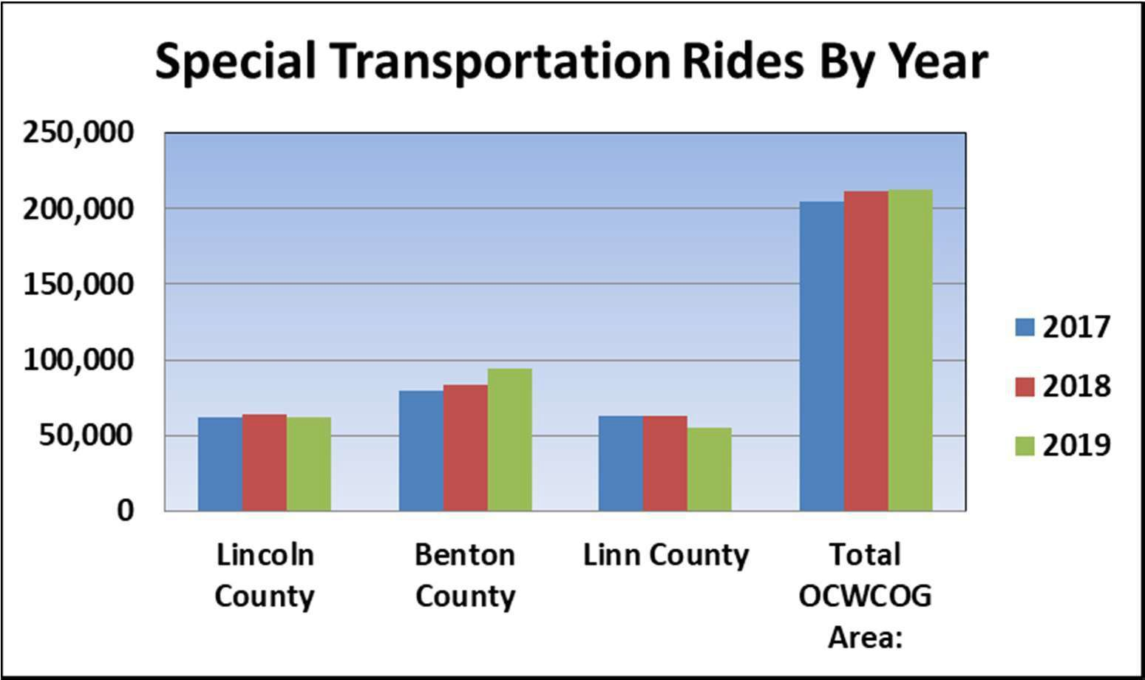

Accessible transportation services are critical for enabling older adults, the frail elderly, and people with disabilities to live independently. Successful community living requires access to medical and other essential services. While the health impact of reduced access to needed medical and life-sustaining services is obvious (missed appointments, emergency hospital visits, lack of food, shopping, and other continual care), social isolation due to lack of transportation, can have an equally negative effect on health and mental health.

One option available for income-qualified medical transportation is the Cascades West RideLine, which contracts with IHNCCO to coordinate non-emergency medical transportation to OHP eligible clients living in Linn, Benton, and Lincoln Counties who have no other way to get to their medical services. Transportation is arranged through locally contracted transportation providers, which can make scheduling last minute rides a problem in areas where there are fewer approved providers such as in Lincoln County, and arranging rides across county lines or to Portland. The RideLine Transportation Reimbursement Program offers an allowance to eligible Oregon Health Plan Plus (OHP+) clients to cover costs of travel to and from a covered Medicaid medical service. Clients requesting transportation reimbursement typically have access to a working vehicle or know a friend or family member that is available to drive them to their medical appointment. While RideLine offers a great service, the benefits are restricted to Medicaid consumers and thus are not available to people who have Medicare only. This unfortunately limits services to a large group of seniors and persons with disabilities.

On-demand “dial-a-ride” services provide a resource for those who are unable to use the fixed route services, and may be ineligible for the RideLine service. Technically known as Demand Response Service, this transportation option provides curb to curb, wheelchair accessible transportation. Demand Response Services operates in Lincoln County (transit district area boundary), Corvallis, greater Benton County (with restriction), Albany, Lebanon, and Sweet Home. However, all of these programs have had State STF funding reductions which have caused them to decrease service bandwidth, making rides from these well-used resources difficult to schedule, especially on short notice. On-demand services are area-specific and generally do not cross jurisdictional boundaries, so medical appointments in other counties require other options, or use of multiple on-demand services.

Smaller community-based programs are trying to fill the gaps in the regional transportation options. Many of these programs rely on volunteers, which can be difficult to recruit and retain even in the easiest of times, and extraordinarily difficult in the time of COVID. Additionally, there is a constant struggle for reliable, ongoing, and sustainable funding. The community- based transportation providers fill a critical role in our communities, and yet from the stakeholder group on transportation one thing we learned is that there is a general lack of coordination in how they serve consumers. For example, on any given day there may be three different service organizations driving to Alsea to provide rides to consumers. Ongoing stakeholder meetings to try to work more collaboratively and efficiently is something we hope will continue.

Goals and Objectives: Transportation

Goal #1: Continue to operate and expand the Senior Companion Program (SCP) to provide transportation to those living in the most rural communities.
MEASURABLE OBJECTIVES | KEY TASKS | LEAD POSITION & ENTITY | TIMEFRAME FOR 2021-2025  START DATE / END DATE
1. 70% of volunteers and 85% clients in OCWCOG’s Senior Companion Program will reside in one of the following rural areas: Benton: Alsea, Monroe, Philomath; Linn: Sweet Home, Halsey, Brownsville, Lebanon; Lincoln County. | A. Complete outreach via rural radio and/or print media at least once a quarter. | CSP Program Manager. | A. – B. 7/1/2021 – 6/30/25  ongoing.  C. Meet this goal with volunteers during SCP Federal 2021-2024 grant cycle.
 | B. Complete one rural outreach event per county each year. | CSP Program Manager.
 | C. Increase mileage caps for volunteers residing in these areas during the SCP Federal 2021- 2024 grant cycle. | CSP Program Manager.
 |  |  | D. Completion based on Federal cycle before 6/30/2025.
 | D. Complete data collection and report out through Federal grant reporting. |  | D. Completion based on Federal cycle before 6/30/2025.
Goal #2: OCWCOG will take the lead in bringing smaller community-based organizations which provide transportation for seniors together to support greater collaboration and efficiency, through development of a virtual forum.

1. Convene a quarterly meeting of stakeholders invested in transportation which supports older adults and people with disabilities. | A. Identify and invite stakeholder who need to be at the table. | Program Director and CSP Program Manager. | First meeting in February 2024.  B. – D. 2/2024 – 6/30/2025
 | B. Assess places where we are duplicating efforts  and work to reduce duplication. | Program Director and CSP Program Manager. | First meeting in February 2024.  B. – D. 2/2024 – 6/30/2025
C. Identify ways we can leverage resources such as volunteers or combined routes
so resources spread further.
D. Create MOUs or systems for supporting each
other in program delivery.
Goal #3: Combine the efforts of all OCWCOG departments in supporting people who are unable to drive.
1. Increase the number of SDS and CSP consumers referred to the Travel Training Program in CED and the transit providers involved. | A. CED staff will regularly attend staff meetings providing other programs about the Travel Training Program. | CED, SDS, and CSP  Program Managers. | Provide education to the teams 11/30/2021 . Track referral numbers starting and place follow up calls beginning 3/1/2023.

 | B. The number of referrals made to the Travel Training program by SDS and CSP staff will be tracked. |  | B. – C. 1/1/2022 – 6/30/2025
 | C. Follow up calls will be made to SDS and CSP consumers who were referred to the Travel Training Program to assess if the referral was helpful. |  | B. – C. 1/1/2022 – 6/30/2025
1. Support the rollout of the “Without a License” project which CED is launching, so that it can become more “older adult friendly”. | A. Work with CED staff to develop tools that are appropriate for older adults and  people with disabilities. | CED Program Manager/ CSP Program Manager. | A. By 4/30/2023.  B. 5/1/2023 – 6/30/2025.
 | B. Use program to support consumers who lose their licenses. | CED Program Manager/ CSP Program Manager. | A. By 4/30/2023.  B. 5/1/2023 – 6/30/2025.

Goal #4: OCWCOG will use special transportation funds to provide transportation to those in need.
1. OCWCOG will apply for STF funds and STIF funds. | A. Staff will complete annual or biannual STF and STIF applications from Linn and Benton Counties. | Director or Program Manager. | A. – C. Annually and ongoing.
1. OCWCOG will apply for STF funds and STIF funds. | B. Staff will distribute STF funds to consumers from Linn and Benton and Counties when needed.  C. Staff will complete all tracking and reporting necessary for contract requirements. | Director or Program Manager. | A. – C. Annually and ongoing.
ACCOMPLISHMENTS- UPDATES 2022 | - STF funds were awarded in Benton and Linn County. We use those funds to support transportation needs. We have applied for funding and been awarded it again this year.  - A pilot project was started that is a partnership between OCWCOG RideLine and IHN CCO where a small number of rides can be provided to Samaritan Advantage membership. This is helpful but still doesn’t meet the need of many Medicare consumers.  - Without a License project is on hold because of staff turnover.  - Bringing together advocates in transportation has been put on hold this year because of continued concerns about COVID.  - All Senior Companion program goals related to transportation have been met for the period.
ACCOMPLISHMENTS- UPDATES 2023 | - Once again OCWCOG applied and was awarded Special Transportation Funds through Linn and Benton counties. The money was used to support older adults and people with disabilities in getting to appointments and social engagement opportunities in their communities.  - All Senior Companion Program goals outlined above are being met.  - Grants were awarded for FY 2023 to support agencies that provide transportation to consumers in need including Grace Center and North End Senior Solutions (NESS), Adult Day Service providers in the area. NESS specifically provides transportation to consumers on the North Coast, a very rural area with few transportation providers.  - Bringing transportation providers to the table continues to be difficult post Covid, but having another Transportation Round Table is something we hope to accomplish in FY 2024.  - Staff shortages, including a Director over the Community and Economic Development Department has caused the pilot programs in that department such as the Without a License project and Travel Training to stall. There have been no participation in those programs this year. Brochures for the Without a License program were sent to local DMV office, but there has not been any response to that outreach.

Section D: OAA/OPI Services and Method of Service Delivery
D. 1 – ADMINISTRATION OF OREGON PROJECT INDEPENDENCE (OPI)
The Oregon Project Independence program provides services and assistance to residents who are between the ages of 19 and 59 with a disability, 60 years or older, or under 60 years and diagnosed as having Alzheimer’s disease. People receiving OPI cannot be receiving Medicaid except for SNAP benefits, Qualified Medicare Beneficiary, or Supplemental Low Income Medicare Beneficiary. Demographic information about all OPI consumers is entered into Oregon ACCESS (OA). OCWCOG has a documented Conflict of Interest Policy and provides annual training to all staff on Conflict of Interest and Maintaining Professional Boundaries.

OPI participants can utilize a suite of services and supports aimed at allowing them to live in their home as independently and safely for as long as possible. These services may include case management, personal care, home care, adult day care services, home delivered meals, assistive technology, and chore services.
Initial screenings are conducted by a Resource Specialist in the ADRC call center who gathers information about the individual or family’s needs and provides referral to internal OCWCOG programs as well as external community resources. Consumers and their families who are not able to or do not want to apply for Medicaid but require more information about resources, benefits, and long term care services are referred to Option Counselors.

Options Counselors make phone contact with potential consumers and/or family members within 5-10 business days of receiving a referral to schedule a home visit and assessment. During the visit Options Counselors take a deeper dive into the needs and desires of the person they are working with and share a wide breadth of programs and resources. If OPI is decided to be the best fit for the individual’s specific needs the case managers perform a functional assessment to determine the participant’s ability to perform Activities of Daily Living (ADL). The assessment is based on observation and a consumer interview. The assessment tool then generates a Service Priority Level (SPL) which is the basis of program eligibility. Consumers with priority levels 1-15 are currently served under OPI in OCWCOG’s service area. (Note: during the COVID pandemic, assessments for services have been done telephonically.)

Once eligible, the consumer plays an active role in determining how many hours per week/month they will need in the areas of personal care, home maker, and chore services to remain independent in their own home. Options of using a Home Care Worker through the Client Employed Provider (CEP) program versus the option of using an in-home care agency (Addus Health Care, Inc.) are discussed as well as the benefits and costs of each option. OCWCOG, Northwest Senior and Disability Services (NWSDS), and Lane Council of Governments (LCOG) have a tri-agency (nine-county) In-Home Services Contract with Addus HealthCare Inc. that began July 1, 1999. Other community resources and supports that will augment the service hours are provided to develop a comprehensive support system. The Case Manager will complete a service plan in OA and process the plan through the appropriate channels for referral and payment of services.

Case Managers follow up with consumers within three to six months of the initial needs assessment to make sure that the plan is working or adjust as needed and a reassessment is done annually to review and reevaluate current services. In addition, consumers can always ask for a reassessment because of a change in condition.

Many consumers enter the Long-Term Services and Supports system through referrals from partner agencies and the local healthcare system when they have experienced a healthcare crisis or their current supports are no longer adequate. Individuals with the greatest risk factors often enter the system through APS. APS workers refer at-risk consumers to the ADRC Call Center and Options Counselors to assess for community resources and services. These cases are often a priority and OPI is regularly used to stabilize the situation.

All other consumers are assessed on a first come, first served basis. Case Managers complete a risk assessment on all consumers in order to survey them for priority of need at the initial assessment. Funding is used to assist as many high-risk consumers as possible. The OPI program at OCWCOG has not had a waitlist for many years, but does have an OPI Waitlist Policy in place. The policy is included in the Appendices section of this document. See Appendix I.
When consumers are determined ineligible at their initial assessment or during their annual review, or if they are going to experience a reduction or closure, the Case Manager will have a conversation to inform the consumer of the action prior to sending out any paperwork. After the conversation, the Case Manager will send a written notice to the consumer along with a copy of the formal complaint process and information on a consumer’s right to grieve adverse eligibility or service determinations. The Program Manager will be made aware of any denials, reduction, or terminations of services prior to the notice(s) being sent, as the complaint process directs consumers to the local Program Manager with questions or concerns. The OPI Case Manager will provide the consumer with information about other available community resources that may meet their ongoing need for assistance. (Following State process guidelines, during COVID no adverse actions such as reducing care plans or closing services have been taken.)

At initial enrollment, the Case Manager informs the consumer of the grievance procedure, they are provided a copy of the Reduction/Closure Grievance Policy. In addition, OPI brochures are given to all new consumers, which provides them of their right to file a complaint and the office contact information.

OPI participants with higher incomes may be required to pay a sliding scale fee which is set based on their income level minus any household medical costs. The sliding scale fees are explained at the screening level, but full explanation and calculation are determined by the Case Manager. This is done by completing an OPI Income/Fee Determination form. The fees are calculated based on the State issued fee schedule and applied for the cost of the OPI service hours.

When the case is opened, the consumer is sent the Service Agreement form confirming the start of the OPI service and confirming the proportion of service cost which the consumer is to pay and the estimated monthly cost. Consumers receiving home care worker services and paying a portion of OPI service costs are billed by administrative staff who enter the fee

percentage(s) into the OA billing system. All fees collected are submitted to OCWCOG on a monthly basis and are applied to the overall budget and billing of OPI services submitted to the State. If housekeeping or personal care services are provided through an in-home care agency, the Case Manager sends a copy of the consumer service plan to the agency contractor to begin service and to inform them of the percentage to be billed to the consumer. The OPI Income/Fee Determination form is reviewed and updated annually at the service assessment review date.

A one-time $25 fee will be applied to all individuals receiving OPI services who have adjusted income levels at, or below, the Federal Poverty Level and have no fee for OPI services. This is billed to the participant when the services are opened.

Administrative Support staff notifies Case Managers of any unpaid fees accumulated by people receiving services provided by home care workers. In-home care agencies notify Case Managers of any unpaid fees accrued by participants using their services. If non-payment occurs, the Case Manager contacts the consumer and discusses the reasons for non-payment, and evaluates the hardship and/or reason, reminding them they must pay the fee within 10 days or risk closure.

Fees are mandatory, no matter how small. However, a Case Manager may request a fee be waived in a situation of undue financial hardship or APS involvement. This would be rare and circumstances would be extenuating. The Program Manager is consulted in each case where a waived payment is requested.

Service providers are monitored through reporting requirements determined in the contracts scope of work. Contract agencies for adult day services and home-delivered meals are monitored annually through site visits. Site visits may entail the review of case files, employee records and practices, fiscal practices, and discussion of any findings or issues that may occur. All contract agencies are monitored through monthly fiscal audits of billings and unit reporting. Additionally, contract agencies administered by a third party, such as Addus Health Care Inc., receive additional monitoring by the administering agency, NWSDS.

Cost of Authorized Services per Unit for OPI as of July 2021:

Personal Care | $ 19.29 per hour
Home Care | $ 19.01 - $ 22.80 per hour
Adult Day Care | $ 92.00 full day, $ 70.40 ½ day
Home Delivered Meals | $ 9.54 per meal
Assistive Technology | $ 68.39 average , price per unit varies
Chore Services | $ 17.15 per hour
Case Management | $ 44.43 average

Attachment C

SERVICE MATRIX and DELIVERY METHOD

Instruction: Indicate all services provided, method of service delivery and funding source. (The list below is sorted numerically by service matrix number.)

 #1 Personal Care (by agency)
Funding Source: OAA  OPI Other Cash Funds  Contracted Self-provided
Contractor name and address (List all if multiple contractors):
Addus Healthcare, 2300 Warrenville Rd, Ste. 100, Downers Grove, IL 60515-1765 “for profit”
New Horizons In Home Care, 3125 Chad Dr., Ste 290, Eugene, OR 97408-for profit, Wellness at Home, 2853 Salem Avenue SE, Albany, OR 97321-for profit

 #1a Personal Care (by HCW) Funding Source: OAA  OPI Other Cash Funds
#2 Homemaker (by agency)
Funding Source: OAA  OPI Other Cash Funds  Contracted Self-provided
Contractor name and address (List all if multiple contractors):
Addus Health Care Inc., 2300 Warrenville Rd., Ste. 100, Downers Grove, IL 60515
New Horizons In Home Care, 3125 Chad Dr., Ste 290, Eugene, OR 97408, Wellness at Home, 2853 Salem Avenue SE, Albany, OR 97321-for profit

#2a Homemaker (by HCW)  Funds | Funding Source: | OAA | OPI | Other Cash
#3 Chore (by agency)
Funding Source: OAA OPI Other Cash Funds  Contracted Self-provided
Contractor name and address (List all if multiple contractors):
#3a Chore (by HCW)  Funds | Funding Source: | OAA | OPI | Other Cash



Trio Community Health, PO Box 7153, Salem, OR 97303 “for profit” OCWCOG operates meal sites.




Grace Center for Adult Day Services, 980 NW Spruce Avenue, Corvallis OR 97330













Trio Community Health, PO Box 7153, Salem, OR 97303, "for profit". Meals Sites managed by OCWCOG
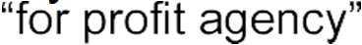








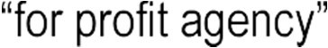
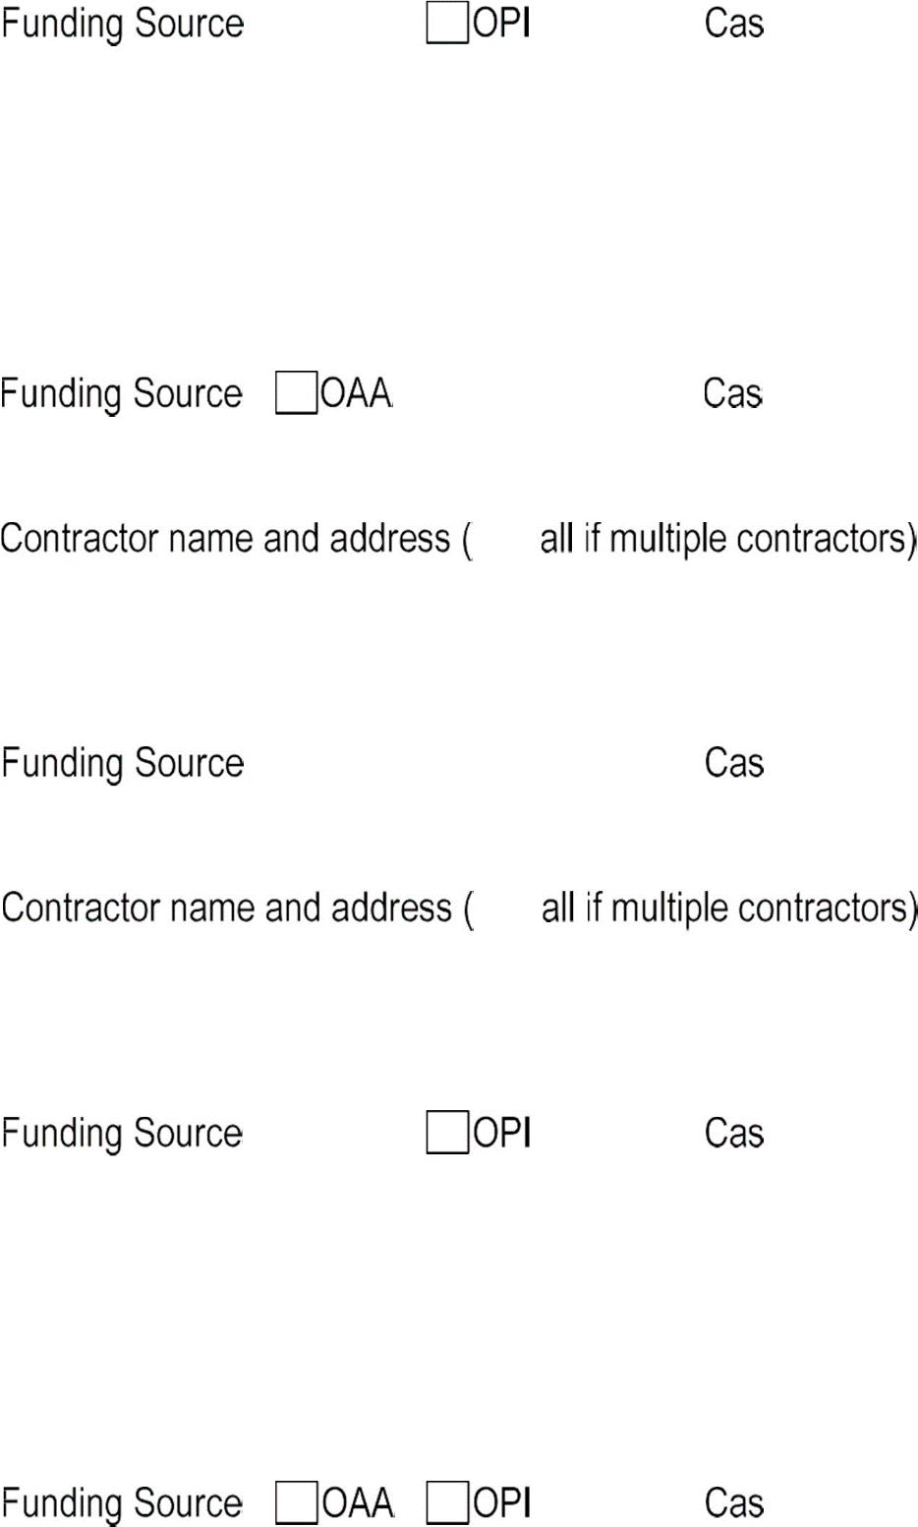



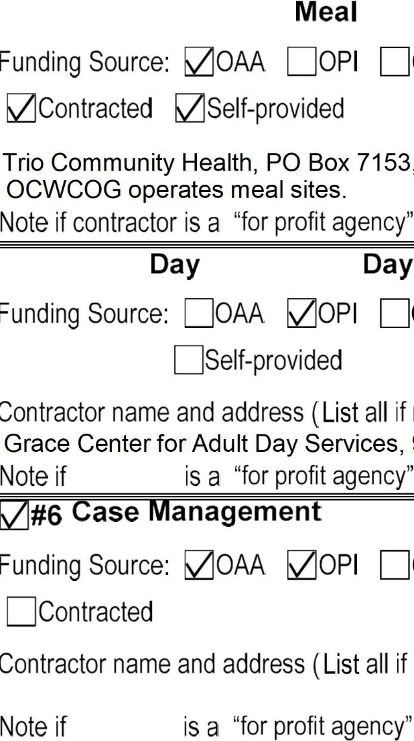





#9 Assisted Transportation
Funding Source: OAA OPI Other Cash Funds  Contracted Self-provided
Contractor name and address (List all if multiple contractors):
#10 Transportation
Funding Source: OAA OPI Other Cash Funds Contracted Self-provided
Contractor name and address (List all if multiple contractors):
 #11 Legal Assistance
Funding Source: OAA OPI Other Cash Funds  Contracted Self-provided
Contractor name and address (List all if multiple contractors):
Legal Aid Services of Oregon, 433 4th Ave SW, Albany, OR 97321
 #12 Nutrition Education
Funding Source: OAA OPI Other Cash Funds Contracted  Self-provided
Contractor name and address (List all if multiple contractors):
 #13 Information & Assistance
Funding Source: OAA OPI Other Cash Funds Contracted  Self-provided
Contractor name and address (List all if multiple contractors):

#14 Outreach
Funding Source: OAA OOPI Other Cash Funds
□c ontracted Self-provided
Contractor name and address (List all if multiple contractors):

#15/1Sa Information for Caregivers
Funding Source: OAA OOPI □Other Cash Funds
□Contracted Self-provided
Contractor name and address (List all if multiple contractors):

#16/16a Caregiver Access Assistance
Funding Source: OAA OOPI □Other Cash Funds
□c ontracted Self-provided
Contractor name and address (List all if multiple contractors):

#20-2 Advocacy
Funding Source: OAA OOPI □Other Cash Funds
□c ontracted Self-provided
Contractor name and address (List all if multiple contractors):

0#20-3 Program Coordination & Development
Funding Source: OOAA OOPI □Other Cash Funds
□c ontracted □Self-provided
Contractor name and address (List all if multiple contractors):

Note if contractor is a "for profit agency"

#30-1 Home Repair/Modification
Funding Source: OAA OPI Other Cash Funds Contracted Self-provided
Contractor name and address (List all if multiple contractors):
 #30-4 Respite Care (IIIB/OPI)
Funding Source: OAA  OPI Other Cash Funds  Contracted Self-provided
Contractor name and address (List all if multiple contractors):
Grace Center for Adult Day Services, 980 NW Spruce Avenue, Corvallis OR 97330
 #30-5/30-5a Caregiver Respite
Funding Source: OAA OPI Other Cash Funds Contracted  Self-provided
Contractor name and address (List all if multiple contractors):
 #30-6/30-6a Caregiver Support Groups Funding Source: OAA OPI Other Cash Funds  Contracted Self-provided
Contractor name and address (List all if multiple contractors):
Lumina Hospice & Palliative Care, 720 SW 4th St., Corvallis, OR 97330
 #30-7/30-7a Caregiver Supplemental Services Funding Source: OAA OPI Other Cash Funds Contracted  Self-provided
Contractor name and address (List all if multiple contractors):

 #40-2 Physical Activity and Falls Prevention Funding Source: OAA OPI Other Cash Funds  Contracted Self-provided
Contractor name and address (List all if multiple contractors): Newport 60+ Activity Center, 20 SE 2nd St., Newport, OR 97365
Mid-Willamette Family YMCA, 3201 Pacific Blvd SW, Albany, OR 97321
 #40-3 Preventive Screening, Counseling and Referral Funding Source: OAA OPI Other Cash Funds Contracted Self-provided
Contractor name and address (List all if multiple contractors):
Lumina Hospice & Palliative Care, 720 SW 4th St., Corvallis, OR 97330
#40-4 Mental Health Screening and Referral Funding Source: OAA OPI Other Cash Funds Contracted Self-provided
Contractor name and address (List all if multiple contractors):
#40-5 Health & Medical Equipment
Funding Source: OAA  OPI Other Cash Funds Contracted Self-provided
Contractor name and address (List all if multiple contractors):
North End Senior Solutions, PO Box 148, Otis, OR 97368 / Lifeline, 815 NW 9th St., Ste. 200, Corvallis, 97330 / Assured Independence,3125 Colby Ave. Ste. B, Everrett, WA 98201
#40-8 Registered Nurse Services
Funding Source: OAA OPI Other Cash Funds Contracted Self-provided
Contractor name and address (List all if multiple contractors):

#40-9 Medication Management
Funding Source: OAA OPI Other Cash Funds Contracted Self-provided
Contractor name and address (List all if multiple contractors):
#50-1 Guardianship/Conservatorship Funding Source: OAA OPI Other Cash Funds Contracted Self-provided
Contractor name and address (List all if multiple contractors):
#50-3 Elder Abuse Awareness and Prevention Funding Source: OAA OPI Other Cash Funds Contracted Self-provided
Contractor name and address (List all if multiple contractors):
#50-4 Crime Prevention/Home Safety Funding Source: OAA OPI Other Cash Funds Contracted Self-provided
Contractor name and address (List all if multiple contractors):
#50-5 Long Term Care Ombudsman Funding Source: OAA OPI Other Cash Funds Contracted Self-provided
Contractor name and address (List all if multiple contractors):





Albany Senior Center, 489 Water Avenue NW, Albany, OR 97321












Certified Languages, 4800 S. Macadam, Ste. 400, Portland, OR 97239, "for profit" JSF Sign Language Interpreting, 1822 NW Whitecliff Dr., Albany, OR 97321 "for profit"






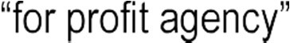
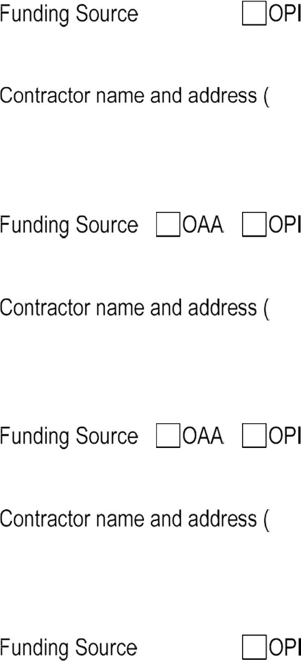
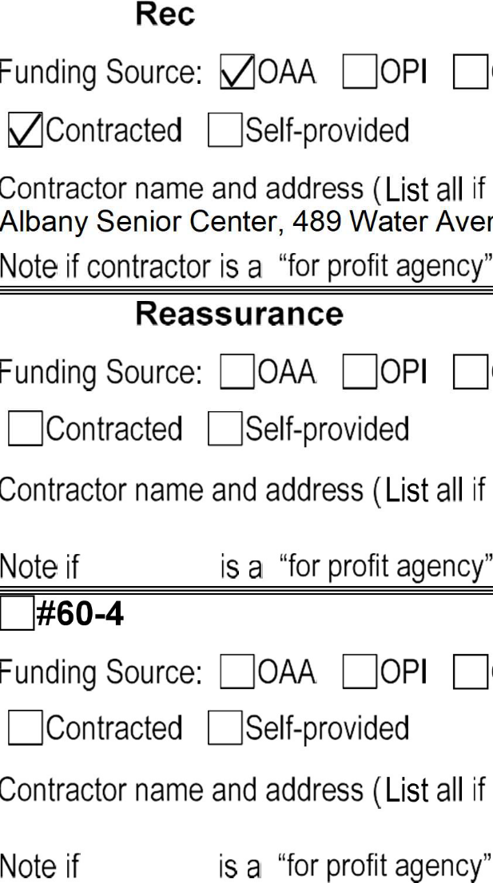














OCWCOG 21-25

#70-2a/70-2b Caregiver Counseling
Funding Source: OAA OPI Other Cash Funds Contracted Self-provided
Contractor name and address (List all if multiple contractors):
#70-5 Newsletter
Funding Source: OAA OPI Other Cash Funds Contracted Self-provided
Contractor name and address (List all if multiple contractors):
#70-8 Fee-based Case Management Funding Source: OAA OPI Other Cash Funds Contracted Self-provided
Contractor name and address (List all if multiple contractors):
#70-9/70-9a Caregiver Training
Funding Source: OAA OPI Other Cash Funds  Contracted  Self-provided
Contractor name and address (List all if multiple contractors):
Lumina Hospice & Palliative Care, 720 SW 4th St., Corvallis, OR 97330
#70-10 Public Outreach/Education
Funding Source: OAA OPI Other Cash Funds Contracted Self-provided
Contractor name and address (List all if multiple contractors):

OCWCOG 21-25 8

#71 Chronic Disease Prevention, Management/Education
Funding Source: OAA OPI Other Cash Funds Contracted Self-provided
Contractor name and address (List all if multiple contractors):
Mid-Willamette Family YMCA, 3201 Pacific Blvd SW, Albany, OR 97321
Samaritan Health Services-Health Ed, 3600 NW Samaritan Dr., Corvallis, OR 97330 “for profit”
#72 Cash and Counseling
Funding Source: OAA OPI Other Cash Funds Contracted Self-provided
Contractor name and address (List all if multiple contractors):

Note if contractor is a “for profit agency”
#73/73a Caregiver Cash and Counseling Funding Source: OAA OPI Other Cash Funds Contracted Self-provided
Contractor name and address (List all if multiple contractors):
#80-1 Senior Center Assistance
Funding Source: OAA OPI Other Cash Funds Contracted Self-provided
Contractor name and address (List all if multiple contractors):
Grace Center for Adult Day Services, 980 NW Spruce Avenue, Corvallis OR 97330
#80-4 Financial Assistance
Funding Source: OAA OPI Other Cash Funds Contracted Self-provided
Contractor name and address (List all if multiple contractors):

#80-5 Money Management
Funding Source: OAA OPI Other Cash Funds Contracted  Self-provided
Contractor name and address (List all if multiple contractors):
#Volunteer Services
Funding Source: OAA OPI Other Cash Funds Contracted Self-provided
Contractor name and address (List all if multiple contractors):

Area Plan Budget, Worksheet 1
Oregon Cascades West Council of Governments Senior & Disabled Srvcs (OCWCOG) BUDGET PERIOD: 7.1.2021 - 6.30.2022 Area Plan Year 1
Budget by Service Category

 |  |  |  |  |  | (9) |  |  |  |  |  | (10)
(3) | (4) |  |  |  |  | OAA |  |  |  |  |  |  | (11) | (12) | (13) | (14) | (15) | (16) | (17)
Matrix | SERVICE NAME | (5) | (6) | (7) | (8) | T III B | T III C-1 | T III C-2 | T III D | T III E | T VII | OAA  Total | NSIP | OPI | Other State provided Funds | Other Cash Funds | Total Funds | Estimated Cost Per Unit | Comments Explanation
ADMINISTRATION |  |  |  |  |  | $40,530 | $0 | $0 | $0 | $11,439 | $0 | $51,969 | $0 | $75,482 | $0 | $0 | $127,451
20-1 | Area Plan Administration | C = Contract  D = Direct Provision | Estimated Units | Unit Definition | Estimated Clients | $30,998 |  |  |  | $11,439 |  | $42,437 |  | $75,482 |  |  | $117,919
20-2 | AAA Advocacy |  |  |  |  | $9,532 |  |  |  |  |  | $9,532 |  |  |  |  | $9,532
20-3 | Program Coordination & Development |  |  |  |  |  |  |  |  |  |  | $0 |  |  |  |  | $0
ACCESS SERVICES - |  |  |  |  |  | $162,740 | $0 | $0 | $0 | $0 | $2,750 | $165,490 | $0 | $323,829 | $0 | $15,000 | $504,319
6 | Case Management | D | 3041 | 1 hour | 341 | $18,082 |  |  |  |  |  | $18,082 |  | $323,829 |  | $15,000 | $356,911 | #DIV/0!
9 | Assisted Transportation |  |  | 1 one-way trip |  |  |  |  |  |  |  | $0 |  |  |  |  | $0 | #DIV/0!
10 | Transportation |  |  | 1 one-way trip |  |  |  |  |  |  |  | $0 |  |  |  |  | $0 | #DIV/0!
13 | Information & Assistance | D | 7890 | 1 contact | 5167 | $139,492 |  |  |  |  |  | $139,492 |  |  |  |  | $139,492 | #DIV/0!
14 | Outreach |  |  | 1 contact |  |  |  |  |  |  |  | $0 |  |  |  |  | $0 | #DIV/0!
40-3 | Preventive Screening, Counseling, and Referral |  |  | 1 session |  |  |  |  |  |  |  | $0 |  |  |  |  | $0 | #DIV/0!
40-4 | Mental Health Screening & Referral |  |  | 1 hour |  |  |  |  |  |  |  | $0 |  |  |  |  | $0 | #DIV/0!
60-5 | Interpreting/Translation |  |  | 1 hour |  |  |  |  |  |  |  | $0 |  |  |  |  | $0 | #DIV/0!
70-2 | Options Counseling |  |  | 1 hour |  |  |  |  |  |  |  | $0 |  |  |  |  | $0 | #DIV/0!
70-5 | Newsletter |  |  | 1 activity |  |  |  |  |  |  |  | $0 |  |  |  |  | $0 | #DIV/0!
70-8 | Fee-Based Case Management |  |  | 1 hour |  |  |  |  |  |  |  | $0 |  |  |  |  | $0 | #DIV/0!
70-10 | Public Outreach/Education | D | 24 | 1 activity | 288 | $5,166 |  |  |  |  | $2,750 | $7,916 |  |  |  |  | $7,916 | #DIV/0!
IN-HOME SERVICES |  |  |  |  |  | $21,507 | $0 | $0 | $0 | $0 | $0 | $21,507 | $0 | $165,385 | $0 | $0 | $186,892
1 | Personal Care | C | 1328 | 1 hour | 28 |  |  |  |  |  |  | $0 |  | $47,735 |  |  | $47,735 | #DIV/0!
1a | Personal Care - HCW |  |  | 1 hour |  |  |  |  |  |  |  | $0 |  |  |  |  | $0 | #DIV/0!
2 | Homemaker/Home Care | C | 920 | 1 hour | 30 |  |  |  |  |  |  | $0 |  | $53,382 |  |  | $53,382 | #DIV/0!
2a | Homemaker/Home Care - HCW | C | 28144 | 1 hour | 199 |  |  |  |  |  |  | $0 |  |  |  |  | $0 | #DIV/0!
3 | Chore |  |  | 1 hour |  |  |  |  |  |  |  | $0 |  | $7,962 |  |  | $7,962 | #DIV/0!
3a | Chore - HCW |  |  | 1 hour |  |  |  |  |  |  |  | $0 |  |  |  |  | $0 | #DIV/0!
5 | Adult Day Care/Adult Day Health | C | 300 | 1 hour | 3 |  |  |  |  |  |  | $0 |  | $19,256 |  |  | $19,256 | #DIV/0!
30-1 | Home Repair/Modification |  |  | 1 payment |  |  |  |  |  |  |  | $0 |  |  |  |  | $0 | #DIV/0!
30-4 | Respite (IIIB or OPI funded) | C | 68 | 1 hour | 5 | $3,425 |  |  |  |  |  | $3,425 |  |  |  |  | $3,425 | #DIV/0!
40-5 | Health, Medical & Technical Assistance Equip. | C | 15 | 1 loan/payment | 90 | $18,082 |  |  |  |  |  | $18,082 |  | $37,050 |  |  | $55,132 | #DIV/0!
40-8 | Registered Nurse Services |  |  | 1 hour |  |  |  |  |  |  |  | $0 |  |  |  |  | $0 | #DIV/0!
60-3 | Reassurance |  |  | 1 contact |  |  |  |  |  |  |  | $0 |  |  |  |  | $0 | #DIV/0!
90-1 | Volunteer Services |  |  | 1 hour |  |  |  |  |  |  |  | $0 |  |  |  |  | $0 | #DIV/0!
LEGAL SERVICES |  |  |  |  |  | $30,998 | $0 | $0 | $0 | $0 | $0 | $30,998 | $0 | $0 | $0 | $0 | $30,998
11 | Legal Assistance | C | 480 | 1 hour | 65 | $30,998 |  |  |  |  |  | $30,998 |  |  |  |  | $30,998 | #DIV/0!
NUTRITION SERVICES |  |  |  |  |  | $0 | $346,870 | $176,213 | $0 | $0 | $0 | $523,083 | $0 | $247,816 | $0 | $0 | $770,899
4 | Home Delivered Meals | D | 195000 | 1 meal | 1222 |  |  | $175,913 |  |  |  | $175,913 |  | $247,816 |  |  | $423,729 | #DIV/0!
7 | Congregate Meals | D | 10960 | 1 meal | 197 |  | $344,870 |  |  |  |  | $344,870 |  |  |  |  | $344,870 | #DIV/0!

8 | Nutrition Counseling |  |  | 1 session |  |  |  |  |  |  |  | $0 |  |  |  |  | $0 | #DIV/0!
12 | Nutrition Education | D |  | 1 session |  |  | $2,000 | $300 |  |  |  | $2,300 |  |  |  |  | $2,300 | #DIV/0!

(3) | (4) |  |  |  |  | OAA |  |  |  |  |  |  | (11) | (12) | (13) | (14) | (15) | (16) | (17)
Matrix | SERVICE NAME | (5) | (6) | (7) | (8) | T III B | T III C-1 | T III C-2 | T III D | T III E | T VII | OAA  Total | NSIP | OPI | Other State provided Funds | Other Cash Funds | Total Funds | Estimated Cost Per Unit | Comments Explanation
 |  | Contract or  Direct  Provide | Estimated Units | Unit Definition | Estimated Clients
FAMILY CAREGIVER SUPPORT |  |  |  |  |  | $0 | $0 | $0 | $0 | $109,483 | $0 | $109,483 | $0 | $0 | $0 | $0 | $109,483
15 | Information for Caregivers | D | 5 | 1 activity | 93 |  |  |  |  | $859 |  | $859 |  |  |  |  | $859 | #DIV/0!
15a | Information for CGs serving Children |  |  | 1 activity |  |  |  |  |  |  |  | $0 |  |  |  |  | $0 | #DIV/0!
16 | Caregiver Access Assistance | D | 402 | 1 contact | 108 |  |  |  |  | $46,857 |  | $46,857 |  |  |  |  | $46,857 | #DIV/0!
16-a | Caregiver Access Assistance-Serving Children | D |  | 1 contact |  |  |  |  |  |  |  | $0 |  |  |  |  | $0 | #DIV/0!
30-5 | Caregiver Respite | D | 2170 | 1 hour | 57 |  |  |  |  | $37,655 |  | $37,655 |  |  |  |  | $37,655 | #DIV/0!
30-5a | Caregiver Respite for Caregivers Serving Children | D | 61 | 1 hour | 10 |  |  |  |  | $1,524 |  | $1,524 |  |  |  |  | $1,524 | #DIV/0!
30-6 | Caregiver Support Groups | C |  | 1 session |  |  |  |  |  |  |  | $0 |  |  |  |  | $0 | #DIV/0!
30-6a | Caregiver Support Groups Serving Children | C |  | 1 session |  |  |  |  |  |  |  | $0 |  |  |  |  | $0 | #DIV/0!
30-7 | Caregiver Supplemental Services | D | 1107 | 1 payment | 96 |  |  |  |  | $9,275 |  | $9,275 |  |  |  |  | $9,275 | #DIV/0!
30-7a | Caregiver Supplemental Services-Serving Children | D | 25 | 1 payment | 20 |  |  |  |  | $5,030 |  | $5,030 |  |  |  |  | $5,030 | #DIV/0!
70-2a | Caregiver Counseling |  |  | 1 session |  |  |  |  |  |  |  | $0 |  |  |  |  | $0 | #DIV/0!
70-2b | Caregiver Counseling-Serving Children |  |  | 1 session |  |  |  |  |  |  |  | $0 |  |  |  |  | $0 | #DIV/0!
70-9 | Caregiver Training | D/C | 18 | 1 session | 36 |  |  |  |  | $8,283 |  | $8,283 |  |  |  |  | $8,283 | #DIV/0!
70-9a | Caregiver Training - Serving Children |  |  | 1 session |  |  |  |  |  |  |  | $0 |  |  |  |  | $0 | #DIV/0!
73 | Caregiver Self-Directed Care |  |  | 1 client served |  |  |  |  |  |  |  | $0 |  |  |  |  | $0 | #DIV/0!
73a | Caregiver Self-Directed Care-Serving Children |  |  | 1 client served |  |  |  |  |  |  |  | $0 |  |  |  |  | $0 | #DIV/0!
SOCIAL & HEALTH SERVICES |  |  |  |  |  | $5,970 | $0 | $0 | $21,000 | $0 | $0 | $26,970 | $0 | $0 | $0 | $0 | $26,970
40-2 | Physical Activity & Falls Prevention | C | 150 | 1 session | 30 |  |  |  | $12,000 |  |  | $12,000 |  |  |  |  | $12,000 | #DIV/0!
40-9 | Medication Management |  |  | 1 session |  |  |  |  |  |  |  | $0 |  |  |  |  | $0 | #DIV/0!
50-1 | Guardianship/Conservatorship |  |  | 1 hour |  |  |  |  |  |  |  | $0 |  |  |  |  | $0 | #DIV/0!
50-3 | Elder Abuse Awareness and Prevention |  |  | 1 activity |  |  |  |  |  |  |  | $0 |  |  |  |  | $0 | #DIV/0!
50-4 | Crime Pervention/Home Safety |  |  | 1 activity |  |  |  |  |  |  |  | $0 |  |  |  |  | $0 | #DIV/0!
50-5 | LTC Ombudsman |  |  | 1 payment |  |  |  |  |  |  |  | $0 |  |  |  |  | $0 | #DIV/0!
60-4 | Volunteer Recruitment |  |  | 1 placement |  |  |  |  |  |  |  | $0 |  |  |  |  | $0 | #DIV/0!
60-10 | Recreation |  |  | 1 hour |  |  |  |  |  |  |  | $0 |  |  |  |  | $0 | #DIV/0!
71 | Chronic Disease Prevention, Management & Ed | C | 180 | 1 session | 42 |  |  |  | $9,000 |  |  | $9,000 |  |  |  |  | $9,000 | #DIV/0!
72 | Self-Directed Care |  |  | 1 client served |  |  |  |  |  |  |  | $0 |  |  |  |  | $0 | #DIV/0!
80-1 | Senior Center Assistance |  |  | 1 center served |  |  |  |  |  |  |  | $0 |  |  |  |  | $0 | #DIV/0!
80-4 | Financial Assistance |  |  | 1 contact |  |  |  |  |  |  |  | $0 |  |  |  |  | $0 | #DIV/0!
80-5 | Money Management |  |  | 1 hour |  |  |  |  |  |  |  | $0 |  |  |  |  | $0 | #DIV/0!
80-6 | Center Renovation/Acquisition |  |  | 1 center acqrd/renovated |  |  |  |  |  |  |  | $0 |  |  |  |  | $0 | #DIV/0!
900 | Other - Computer Repair & IT |  | 3 |  |  | $5,970 |  |  |  |  |  | $5,970 |  |  |  |  | $5,970 | #DIV/0!
900 | Other (specify) |  |  |  |  |  |  |  |  |  |  | $0 |  |  |  |  | $0 | #DIV/0!
900 | Other (specify) |  |  |  |  |  |  |  |  |  |  | $0 |  |  |  |  | $0 | #DIV/0!

900 | Other (specify) |  |  |  |  |  |  |  |  |  |  | $0 |  |  |  |  | $0 | #DIV/0!
GRAND TOTAL |  |  |  |  |  | $261,745 | $346,870 | $176,213 | $21,000 | $120,922 | $2,750 | $929,500 | $0 | $812,512 | $0 | $15,000 | $1,757,012

Area Plan Budget, Worksheet 2
Oregon Cascades West Council of Governments Senior & Disabled Srvcs (OCWCOG)
BUDGET PERIOD: 7.1.2021 - 6.30.2022 Area Plan Year 1 Cash Match/In-kind Match
(3) | (4) | (5) | (6) | (7) | (8) | (9) | (10) | (11)
SOURCE OF OAA CASH & INKIND MATCH FUNDS  Be descriptive (e.g. Donated dining space @ SC) | Admin. Cash Match | Admin. Inkind Match | III B & C Cash Match | III B & C  Inkind Match | OAA III E  Cash Match | III E Inkind Match | TOTAL Cash Match | TOTAL Inkind Match
Money Management Contract |  |  | $96,000 |  |  |  | $96,000 | $0
OPI Pay In | $15,000 |  |  |  |  |  | $15,000 | $0
MOW Volunteer Hours |  |  |  | $100,000 |  |  | $0 | $100,000
Legal Aid Contract Match |  |  |  | $8,600 |  |  | $0 | $8,600
Powerful Tools Community Trainers Hours |  |  |  |  |  | $15,000 | $0 | $15,000
Meals on Wheels Volunteer Mileage Donation |  |  |  |  |  |  | $0 | $0
Donated Space, Door Prizes and Food for FCSP Celebration |  |  |  |  |  |  | $0 | $0
SSAC and DSAC Volunteer Hours |  | $11,700 |  |  |  |  | $0 | $11,700
Older Adult Behavioral Health Contract w/ Linn County |  |  | $15,000 |  |  |  | $15,000 | $0
Donated Grace Center Attendence for FCG Participants |  |  |  |  |  | $20,000 | $0 | $20,000
 |  |  |  |  |  |  | $0 | $0
 |  |  |  |  |  |  | $0 | $0
Column Totals: | $15,000 | $11,700 | $111,000 | $108,600 | $0 | $35,000 | $126,000 | $155,300

Notes/Comments
(12) | (13)
SOURCE OF MEDICAID LOCAL MATCH FUNDS | TOTAL
Dues, Donations, Fees | $187,000
Benton County Veterans Contract | $190,000
Contract with Lincoln County Hospitals | $57,600
Column Totals: | $434,600

135160

min of 25% of total Admin expenditures IIIB, C1 & C2
=SSAC/DSAC Vol hours
min of 15% of program expenditures IIIB, C1 & C2
=MOW volunteer hours (C1&C2)
=IIIB $15k OPI, $8600 Legal Aid, $15k Older Adult
min match of 25% for Administration and program expenditures IIIE

Area Plan Budget, Worksheet 3
Oregon Cascades West Council of Governments Senior & BUDGET PERIOD: 7.1.2021 - 6.30.2022 Area Plan Year 1 UPDATED BY SUE 1/4/2021

Medicaid/OAA/OPI Staffing Plan

ADMINISTRATIVE POSITIONS Breakout of funding sources
(3) | (4) | (5) | (6) | (7) | (8) | (9) | (10) | (11) | (12) | (13) | (14)
Position Title | FTE  Worked | Annual  Salary (excludes OPE) | Annual OPE | Total Salary  + OPE | OAA Funds | OPI Funds | Other Funds | Medicaid  Funds Regular Allocation | Medicaid Funds Local Match | Medicaid  Matched by Local Funds | Total
Program Director | 1.00 | $105,938 | $71,348 | $177,286 | $17,747 | $12,320 | $43,868 | $103,351 |  |  | $177,286
Contracts Coordinator | 0.65 | $34,745 | $18,850 | $53,595 | $7,789 | $7,789 | $8,605 | $29,412 |  |  | $53,595
Program Manager | 1.00 | $75,938 | $59,665 | $135,603 | $6,531 | $12,320 |  | $116,752 |  |  | $135,603
Program Supervisor | 10.00 | $731,706 | $441,570 | $1,173,276 | $32,664 |  |  | $1,140,612 |  |  | $1,173,276
Program Supervisor RSVP | 1.00 | $76,825 | $56,386 | $133,211 |  |  | $133,211 |  |  |  | $133,211
Veterans Service Officer | 1.00 | $61,483 | $50,811 | $112,294 |  |  | $112,294 |  |  |  | $112,294
 |  |  |  | $0 |  |  |  |  |  |  | $0
 |  |  |  | $0 |  |  |  |  |  |  | $0
 |  |  |  | $0 |  |  |  |  |  |  | $0
 |  |  |  | $0 |  |  |  |  |  |  | $0
 |  |  |  | $0 |  |  |  |  |  |  | $0
 |  |  |  | $0 |  |  |  |  |  |  | $0
 |  |  |  | $0 |  |  |  |  |  |  | $0
 |  |  |  | $0 |  |  |  |  |  |  | $0
ADMINISTRATIVE TOTAL | 14.65 | $1,086,635 | $698,630 | $1,785,265 | $64,731 | $32,429 | $297,978 | $1,390,127 | $0 | $0 | $1,785,265

DIRECT SERVICES POSITIONS Breakout of funding sources
Position Title | FTE  Worked | Annual  Salary (excludes OPE) | Annual OPE | Total Salary  + OPE | OAA Funds | OPI Funds | Other Funds | Medicaid  Funds Regular Allocation | Medicaid Funds Local Match | Medicaid  Matched by Local Funds | Total
Administrative Assistant | 5 | $215,217 | $156,581 | $371,798 |  |  | $23,433 | $348,365 |  |  | $371,798
ADRC Specialist | 5 | $236,917 | $171,241 | $408,158 | $136,723 |  |  | $271,435 |  |  | $408,158
AFH Licensors | 2 | $113,907 | $85,002 | $198,909 |  |  |  | $198,909 |  |  | $198,909
APS Case Managers | 10 | $648,119 | $443,129 | $1,091,248 |  |  |  | $1,091,248 |  |  | $1,091,248
Case Aide | 9 | $330,820 | $257,722 | $588,542 |  |  |  | $588,542 |  |  | $588,542
Case Manager | 47.65 | $2,753,297 | $1,849,303 | $4,602,600 | $160,808 | $127,618 |  | $4,314,174 |  |  | $4,602,600
Clerical Specialist | 10.5 | $377,325 | $257,550 | $634,875 |  |  | $39,047 | $595,828 |  |  | $634,875
Diversion Transition | 3 | $207,251 | $140,602 | $347,853 |  |  |  | $347,853 |  |  | $347,853
Eligibility Specialist | 24 | $1,200,141 | $921,456 | $2,121,597 |  |  |  | $2,121,597 |  |  | $2,121,597
ERC Coordinator (STEPS) | 1 | $53,209 | $45,713 | $98,922 |  |  |  | $98,922 |  |  | $98,922
Executive Assistant | 1 | $49,702 | $45,164 | $94,866 | $47,433 |  |  | $47,433 |  |  | $94,866
In Home Assistants | 3 | $132,968 | $98,815 | $231,783 |  |  |  | $231,783 |  |  | $231,783
Meal Site Managers | 5.25 | $201,954 | $138,328 | $340,282 |  |  | $340,282 |  |  |  | $340,282
Meals Coordinator | 1.5 | $47,916 | $38,255 | $86,171 |  |  | $86,171 |  |  |  | $86,171
Money Management Program | 1 | $47,146 | $46,150 | $93,296 |  |  | $93,296 |  |  |  | $93,296
Senior Corp - Admin Assistants | 2 | $80,927 | $54,931 | $135,858 |  |  | $135,858 |  |  |  | $135,858
Trainer | 4 | $248,942 | $140,617 | $389,559 |  |  | $389,559 |  |  |  | $389,559

Veterans Services Eligibility | 1.81 | $46,546 | $26,560 | $73,106 |  |  | $73,106 |  |  |  | $73,106
Extra Hire | 3.75 | $164,978 | $54,726 | $219,704 |  |  | $28,750 | $190,954 |  |  | $219,704

DIRECT SERVICES POSITIONS Breakout of funding sources
Position Title | FTE  Worked | Annual  Salary (excludes OPE) | Annual OPE | Total Salary  + OPE | OAA Funds | OPI Funds | Other Funds | Medicaid  Funds Regular Allocation | Medicaid Funds Local Match | Medicaid  Matched by Local Funds | Total
Tech Support Spec | 1 | $42,790 | $24,549 | $67,339 | $18,615 | $14,775 | $33,949 |  |  |  | $67,339
 |  |  |  | $0 |  |  |  |  |  |  | $0
 |  |  |  | $0 |  |  |  |  |  |  | $0
 |  |  |  | $0 |  |  |  |  |  |  | $0
 |  |  |  | $0 |  |  |  |  |  |  | $0
 |  |  |  | $0 |  |  |  |  |  |  | $0
 |  |  |  | $0 |  |  |  |  |  |  | $0
 |  |  |  | $0 |  |  |  |  |  |  | $0
 |  |  |  | $0 |  |  |  |  |  |  | $0
 |  |  |  | $0 |  |  |  |  |  |  | $0
 |  |  |  | $0 |  |  |  |  |  |  | $0
 |  |  |  | $0 |  |  |  |  |  |  | $0
 |  |  |  | $0 |  |  |  |  |  |  | $0
 |  |  |  | $0 |  |  |  |  |  |  | $0
 |  |  |  | $0 |  |  |  |  |  |  | $0
 |  |  |  | $0 |  |  |  |  |  |  | $0
 |  |  |  | $0 |  |  |  |  |  |  | $0
 |  |  |  | $0 |  |  |  |  |  |  | $0
 |  |  |  | $0 |  |  |  |  |  |  | $0
 |  |  |  | $0 |  |  |  |  |  |  | $0
 |  |  |  | $0 |  |  |  |  |  |  | $0
 |  |  |  | $0 |  |  |  |  |  |  | $0
 |  |  |  | $0 |  |  |  |  |  |  | $0
 |  |  |  | $0 |  |  |  |  |  |  | $0
 |  |  |  | $0 |  |  |  |  |  |  | $0
 |  |  |  | $0 |  |  |  |  |  |  | $0
 |  |  |  | $0 |  |  |  |  |  |  | $0
 |  |  |  | $0 |  |  |  |  |  |  | $0
 |  |  |  | $0 |  |  |  |  |  |  | $0
 |  |  |  | $0 |  |  |  |  |  |  | $0
 |  |  |  | $0 |  |  |  |  |  |  | $0
 |  |  |  | $0 |  |  |  |  |  |  | $0
 |  |  |  | $0 |  |  |  |  |  |  | $0
 |  |  |  | $0 |  |  |  |  |  |  | $0
 |  |  |  | $0 |  |  |  |  |  |  | $0
 |  |  |  | $0 |  |  |  |  |  |  | $0
 |  |  |  | $0 |  |  |  |  |  |  | $0
DIRECT SERVICES TOTAL | 141.46 | $7,200,072 | $4,996,394 | $12,196,466 | $363,579 | $142,393 | $1,243,451 | $10,447,043 | $0 | $0 | $12,196,466
GRAND TOTAL | 156.11 | $8,286,707 | $5,695,024 | $13,981,731 | $428,310 | $174,822 | $1,541,429 | $11,837,170 | $0 | $0 | $13,981,731

Area Plan Budget, Worksheet 4
Oregon Cascades West Council of Governments Senior & Disabled Srvcs (OCWCOG)
BUDGET PERIOD: 7.1.2021 - 6.30.2022 Area Pla
(3) (4) (5) (6)
APD Position Titles | Number  of FTE  Employed | Area Agency on Aging Position Title (if applicable)
Admin Specialist 1 | 5.00 | Administrative Assistant
Adult Protective Services Specialist | 10.00 | APS Case Manager
Compliance Specialist 2 (AFH Licen.) | 2.00 | AFH Licensor
Diversion Case Manager | 3.00 | Diversion Transition Case Manager
Human Services Assistant 2 | 3.00 | In Home Assistant
Human Services Case Manager | 47.65 | Case Manager
Human Services Specialist 3 | 24.00 | Eligibility Speciailist
Office Specialist 2 | 10.50 | Clerical Specialist
Pre-Admission Screening
Principal Executive Manager C | 10.00 | Program Supervisors
Principal Executive Manager D
Principal Executive Manager E | 1.00 | Program Manager
Principal Executive Manager F | 1.00 | Program Director
Transition Case Manager

Medicaid Positions  and Title  (in addition to APD allocated positions) | Number  of FTE  Employed
Trainer | 4.00
Clerical Supervisor | 0.00
ADRC Specialist | 5.00
Contract Coordinator | 0.65
Council Liaison
Case Aide | 9.00
Lead Eligibility | 1.00
Executive Assistant | 1.00

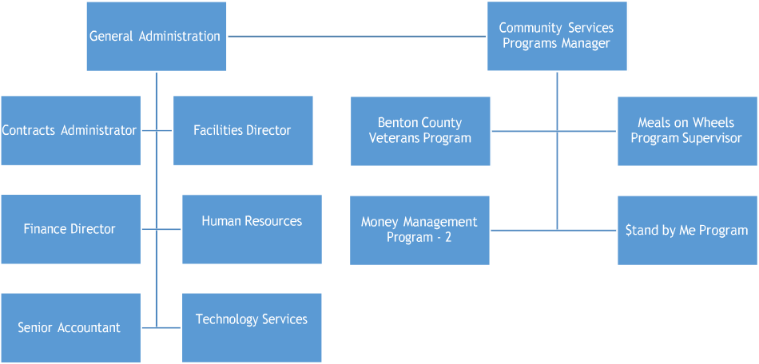
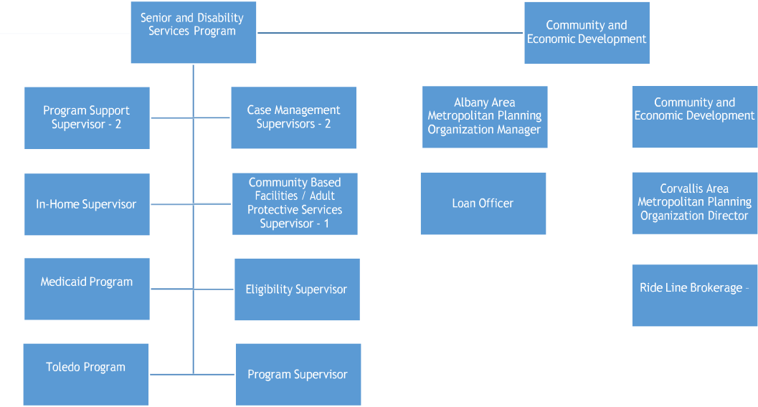
Appendix A: Oregon Cascades West Council of Governments Organization Chart
Director
Planner
Manager
Director
Manager
12
Supervisor

APPENDIX B

2021 OCWCOG
Board of Directors
LINN COUNTY
*Sherrie Sprenger Commissioner, Linn County  Term Ends: 12/31/2024 | Alex Johnson, II Mayor, Albany  Term Ends: 12/31/2024 | Don Ware  Mayor, Brownsville Term Ends: 12/31/2022
Jerry Gillson  Councilor, City of Halsey Term Ends: 12/31/2020 | Mike Caughey  Councilor, City of Harrisburg Term Ends: 12/31/2024 | Wayne Rieskamp Councilor, City of Lebanon Term Ends: 12/31/2022
*Jim Lepin (VICE-CHAIR) Mayor, Millersburg  Term Ends: 12/31/2021 | Debbie Nuber Councilor, Scio  Term Ends: 12/31/2022 | Angelita Sanchez  Councilor-Elect, Sweet Home Term Ends: 12/31/2022
Carol Korn Councilor, Tangent
Term Ends: 12/31/2024
BENTON COUNTY
*Pat Malone (Treasurer)  Commissioner, Benton County Term Ends: 12/31/2022 | *Alan Rowe  Councilor, Adair Village Term Ends: 12/31/2022 | Biff Traber Mayor, Corvallis  Term Ends: 12/31/2022
Vacant  City of Monroe | Chas Jones Mayor, Philomath  Term Ends: 12/31/2024
(*indicates Executive Committee)
OCWCOG 21-25

APPENDIX B

LINCOLN COUNTY
*Claire Hall (CHAIR) Commissioner, Lincoln County Term Ends: 12/31/2024 | Robert Kentta  Treasurer, Confederated Tribes of Siletz Indians  Term Ends: 12/31/2022 | Joyce King Councilor  City of Depoe Bay Term Ends:
Riley Hoagland Councilor, Lincoln City Term Ends: 12/31/2024 | *Dean Sawyer Mayor, Newport  Term Ends: 12/31/2022 | Gil Sylvia  Commissioner, Port of Newport Term Ends: 06/30/2023
Vacant  City of Siletz | Rod Cross Mayor, Toledo  Term Ends: 12/31/2022 | Greg Holland  Mayor, City of Waldport Term Ends: 12/31/2024
Leslie Vaaler
Mayor, City of Yachats Term Ends: 12/31/2023

OCWCOG 21-25

APPENDIX B

2023 OCWCOG
Disability Services Advisory Council (DSAC)
LINN COUNTY
Richard Montgomery
BENTON COUNTY
Suzanne Lazaro |  | Allison Hobgood
LINCOLN COUNTY
Jan Molnar-Fitzgerald, Chair | Joanne Cvar | Michelle Giammona
2023 OCWCOG
Senior Services Advisory Council (SSAC)
LINN COUNTY
Mitzi Naucler, Chair | Kay MacDonald
BENTON COUNTY
Dennis Epstein | Lee Strandberg | Terri Fackrell
Holly Bollman | Robynn Pease
LINCOLN COUNTY
 | Bill Turner
98

APPENDIX B

OCWCOG - SSAC / DSAC Demographics:

SSAC:
Total number age 60 or over = 6 Total number minority = 2
Total number rural = 2
Total number self-indicating having a disability = 0

DSAC:
Total number age 60 or over = 2 Total number minority = 0
Total number rural = 2
Total number self-indicating having a disability = 2

Appendix C – Public Planning Process
Area Plan Committee: Our Area Plan review committee consisted of staff and advisory council members. Planning, development and review meetings were held monthly. Community needs assessments included, surveys, forums, and a public hearing.
Elder Rights Protection Roundtable: Senior and Disability Services conducted a roundtable discussion held on February 4th, 2020 with advisory council members, Adult Protective Services and community partners. Service gaps and issues identified were used in structuring the Area Plan goals and objectives.
Transportation Roundtable: A roundtable listening session was held on February 24th, 2020 to discuss deficiencies consumers experience around transportation. Representatives at the table included Community and Economic Development (CED), Samaritan Health Services, Senior Corps Program, City of Albany, City of Corvallis, Linn County, and Lebanon, Albany and Newport Senior Centers. Priorities identified were servicing rural clients, program funding, RideLine transportation, and utilization of volunteer programs. Goals and objectives identified are included in the 2021-2025 Area Plan.
Nutrition Roundtable: On March 5th, 2020, SDS held a roundtable discussion at the Meals on Wheels meal site in Corvallis. Community partners from around the region gathered to collaborate and identity gaps around nutrition within our communities. Priorities identified are included in the Nutrition goals and objectives. Stakeholders agreed to a continuum of quarterly meetings addressing the goals, objectives and future needs. Due to COVID these in-person meeting were cancelled.
Public Hearing: Senior and Disability Services conducted an online Zoom, Public Hearing on January 14th, 2021 to introduce the 2021-2025 Area Plan recommendations to the community. Public announcements were published in four newspapers across the tri-county area along with Facebook announcements and e-invites to community partners and surrounding agencies. Five committee members attended.
See Attachments F, G, and H for public hearing publications.

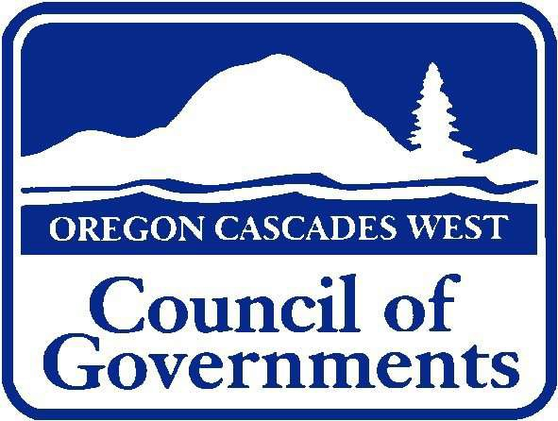
Senior and Disability Services
1400 Queen Ave SE • Suite 206 • Albany, OR 97322 (541) 967-8630 TTY/Voice • 1-800-638-0510 TTY/Voice

203 N Main St • Toledo, OR 97391
(541) 336-2289 • (541) 336-8103 TTY/Voice • (800) 282-6194

Appendix D Final Update from 2017-2020 Area Plan

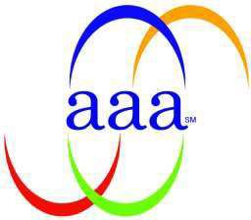
Area Agency on Aging

With the support of the Oregon Cascades West Senior and Disability Services Advisory Councils, the Senior and Disability Services (SDS) department was successful in meeting many of the goals and objectives outlined in its 2017- 2020 Area Plan. As part of our preparation for the 2021-2025 Area Plan, SDS is reflecting back on those accomplishments as well as identifying areas where improvement could have been made or we fell short of our goals.

Family Caregiver
Family Caregiver Program recipient numbers continue to grow in all three counties with funding provided toward caregiver support and recognition increasing as well. The goal of increasing the number of family caregivers that are raising grandkids who access supports has increased slightly, with hopes that trend will continue as we build relationships with school systems. Harder, has been increasing the number of caregivers for LGBTQ people who are accessing support. This is an area we would like to continue to focus on.

Elder Rights and Legal Assistance
Despite a 28% increase in the number of investigations assigned to the Adult Protective Services (APS) team over the last four years, investigations continue to happen in a thorough and timely way, with 99% of reports being submitted within State required timelines. The increased number of calls received by the APS screeners is a sign of the success of the team in meeting the goal of increasing outreach and bringing more awareness about abuse and neglect to our communities.

Health Promotion
Over the last four years we have continued to provide financial support for several Evidence Based Health Promotion Programs operated by a variety of community partners across the three county region. These include the addition of Wisdom Warriors, provided through a contract with the Confederated Tribes of the Siletz Indians, and the Better Bones and Balance Class through the Mid-Willamette Valley YMCA.

Launching Evidence Based programs related to isolation and loneliness or dementia related diseases did not happen, but other courses of action took place in the form of increased referrals to other resources such as the Senior Loneliness Line and the Alzheimer Association.

Native American Elders
Much progress has been made in more fully developing our relationships with the Tribes and supporting Native American Elders. Highlights of this work over the last year include:
- SDS involvement and attendance at quarterly Meet and Greet events between Area Agency on Aging and Title VII staff.
- Regular participation of two Siletz staff members in our Advisory Council meetings.
- Financial support provided for Tribal Elder events such as the Elder Days conference.
- Supporting staff from the Coos, Lower Umpqua, and Siuslaw Tribes in Lane County in providing food for homebound Elders during the COVID 19 pandemic.

Gaining a more frequent audience with tribal Elders remains difficult, but continues to be something we strive for.

Nutrition Services
We have exceeded the goal of maintaining current service levels for the Meals on Wheels program over the last four years and actually are serving larger numbers every year. Most significant is the jump in numbers this spring because of COVID 19. We do not have a waiting list for receiving meals. Ongoing sustainable funding of the program is always a concern, but more importantly the aging out of our volunteer base will need to be addressed in the next Area Plan.

Areas Outside of the identified Goals and Objectives
A media campaign for Older Americans Month was completed with ads placed in local newspapers highlighting the Older Americans Act and the programs it supports in the community. These ads will be put into poster form for posting in locations around the region such as doctor offices and senior centers.
We continue to gather data and input for the next Area Plan, including info collected through these four surveys:
- Medicaid Participant Survey – developed by the Care Planning Committee
- Consumer Survey - Oregon Project Independence
- Survey of Family Caregivers
- Survey to community partners who work with underserved minorities, specifically, Tribal members, Latino, and LGBTQ populations.

Three well attended roundtable discussions were hosted by SDS, inviting community partners and stakeholders to discuss the topics of food security, transportation, and Elder Justice as they relate to the creation of the next Area Plan.
Advocates attended events at the Capitol and appealed to Legislators resulting in significant funding increases ($5 million locally) aimed at reducing caseloads.
The first ever summit bringing SSAC and DSAC members together was held with representatives of all regional Senior/60+ facilities attending. We plan on this being an annual event where we can have conversations on how to work more collaboratively and adapt programs so to better align with the needs of today’s aging adult.

Continuity of Operations (COOP)
and

Emergency Protocols

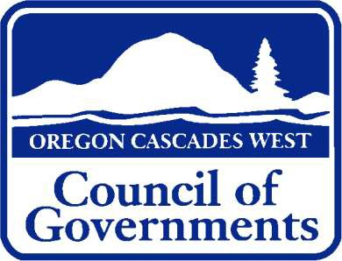

Oregon Cascades West Council of Governments 1400 Queen Ave., SE
Albany, OR 97322

Updated: 11/2020

Introduction
This document contains the Continuity of Operations (COOP) plan for Oregon Cascades West Council of Governments (OCWCOG). It is the document containing the information needed to post-interruption decision- making and the agency’s response to any disruptive or extended interruption of the organization’s normal operations and services. This plan outlines an action plan appropriate for our clients, employees, and visitors in the event of an emergency. This plan identifies natural and man-made emergencies that may impact our operations as well as the community. It details the response procedures that should be followed in case of an emergency.
Purpose
The COOP plan is to be used as a guide whenever an event results in prolonged disruption of services provided by OCWCOG. Some examples include but are not limited to:
- Fire or other damage to the building
- Natural disasters such as earthquakes, flood or volcano
- Chemical Event
- Temporary loss of significant number of staff
- Damage or interruption to utilities, computer or telephone systems
Applicability and Scope
This Plan is based on a short-term (less than five business days) closure. If closure is for an extended period of time, all functions will resume operation as quickly as possible at a new and previously identified temporary long term location.
A copy of this Plan is to be maintained by all OCWCOG managers and at each worksite. A backup copy of this Plan will be kept offsite by the Executive Director, the Deputy Director, and the Program Directors.

All OCWCOG employees have received a copy of the OCWCOG Employee Office Safety and Protection Guide. This guide is to assist employees in dealing with the emergency at-hand and the safety of building occupants. If the building cannot be used, the OCWCOG Business Continuity Plan will be used.
The succession of events in an emergency are not predictable, hence, published support of operational plans will serve only as a guide and checklist, and will require modification during an event to meet the requirements of the emergency. Flexibility and rationality are keys to successfully managing and emergency. Our organization stresses human safety above material loss at all times.
The following people have been designation as the OCWCOG Continuity Planning Team.

Continuity Planning Team
TBD | Toledo
Curtis Nelson | Corvallis
Ryan Schulze | Albany
Randi Moore | Albany
John Haytas | Albany
Sue Forty | Albany
Ryan Vogt | Albany
Guiding Principles and Assumptions
  - Every incident will be different, both in severity and in length of impact. The response needs to be flexible and meet the needs of the incident.

  - Safety of staff and clients is the first goal, though efforts will be made to minimize damage to property.
  - Responses will be made in cooperation with local emergency authorities and organizations according to the Linn-Benton Vulnerable Populations Emergency Plan. Assistance will be available from outside our tri-county area through mutual aid agreements with County, State and Federal emergency services.
  - Documentation of the event and all steps taken, decisions made, and funds expended are very important.
  - Every event is stressful on all employees. If the response is likely to last more than a couple of days, plans should be made to rotate staff to allow for periods of rest.
  - A major disaster event will likely affect the lives of many Linn, Benton and Lincoln County agency employees limiting, or preventing, them from performing shelter and care activities.
  - A major disaster will likely result in loss of utilities, communication systems, and transportation systems making evacuation to mass care facilities difficult and may limit which mass care facilities can be used.
  - Experince has shown that a high percentage of evacuees will seek lodging from friends or relatives rather than go to facilities during minor events or localized conditions.
  - Additional services, including the care of special needs groups and crisis counceling, will be required from our agency.
  - Many residents, especially those with special medical needs, may asssume there will be local resources available to rescue them. Medically-fragile clinets may not have access or transporation to regular services such as dialysis, oxygen or chemotherapy.
  - Patients who normally receive home helathcare services may need to be accompanied by a caregiver to a shelter. In such cases, the

caregiver should be transferred with the evacuee and permitted to remain with that person as the caregiver is able.

SECTION
1
Activation of Plan

Decision Process
The Executive Director, or successor if the Executive Director is not available, will make the decision whether or not to implement the COOP. Communication of decisions will flow from the Executive Director to the Program Directors. Program Directors will be responsible for communicating to their unit Managers or designated staff and on down to their assigned staff. Section 2 of this Plan further describes the agency communication protocol.

Orders of Succession
Succession for the Agency will take place in the event the Executive Director is unavailable, debilitated, or incapable of performing their legally authorized duties, roles, and responsibilities.

Successors
Sue Forty, Finance Director
Randi Moore, Senior and Disability Services Director
Ryan Schulze, Human Resources

Succession of each Department for the purpose of continuing operations is as follows:

PROGRAM | PRIMARY STAFF PERSON | FIRST BACK UP PERSON | SECOND BACK UP PERSON
Senior & Disability Service | Randi Moore | Amy Peer | Rachel Nowak
CED | Ryan Vogt | Nick Meltzer | Danny Magana
Tech Services | John Haytas | Laura South | Jacob Blinn
Human Resources | Ryan Schulze | Rebecca Gibbons-Yardley | Tiffani Baker
Finance | Sue Forty | Janet Cline | Kristi Nofziger

Each Program Director will also have a succession plan for each office. The Program Directors will communicate this plan with their Unit Management Team.
Employees are encouraged to have individual and family emergency plans. Being prepared themselves will keep them better equipped to help others in the event of an emergency. It is recommended to keep a five-day kit, stocked with food, water, blankets and other supplies.

Communications
SECTION
2
Oregon Cascades West Council of Governments is registered with the Linn-Benton ALERT Emergency Notification System and with the Reverse 9-1-1 alert system in Lincoln County. If an event has been reported, the Executive Director will contact the appropriate county’s Emergency Management program through the Sheriff’s office to verify. A list of Emergency Resources can be found in the Appendices of this document.
Once the event has been verified, the following communications plan will be used:

Employees
During an event, we will assess which means of communication are still available to us, and use the means closest in speed and form to the means that we have used in the past to communicate with the staff.
All OCWCOG managers, including the Facilities Maintenance Coordinator and the Network Operations Specialist, are required to maintain a cell phone for emergency contact purposes. Human Resources (HR) provides an updated emergency after-hours contact list to each person required to maintain a cell phone.
The Human Resources Manager will also provide an updated employee contact list to unit managers on a monthly basis.
Communication decisions will flow from the Executive Director to the Program Directors. Program Directors will be responsible for communicating to their unit Managers or designated staff and on down to their assigned staff.
The Executive Director will serve as the Public Relations Officer at an emergency scene. Only the Public Relations Officer (or a representative designated by the Executive Director) will provide statement to media

personnel. Not all employees will have all of the pertinent information; therefore, employees will be instructed not to release any information to media personnel, and to provide “no comment” when approached for information by any member of the media.
The on-site Supervisors have been designated as Building Evacuation Supervisors. The Evacuation Supervisors will assist employees as needed during an evacuation, and will take a head count of all employees in the building at the time.
External internet based communications will be posted by HR or Technology Services staff. OCWCOG is registered with FlashAlert News Wire, which notifies all television, radio stations, and newspapers within the Albany/Corvallis, Eugene/Roseburg, and Portland/Salem (includes Lincoln City and Newport) of any business continuity information that needs to be communicated to OCWCOG employees. The HR Manager is responsible for providing the necessary information to FlashAlert News Wire. If the HR Manager is not available, another assigned OCWCOG Continuity Planning Team member will contact FlashAlert.
If phone service to the affected worksite has not been obstructed, voicemail instructions will be recorded on the following Staff Information Lines:

Albany/Corvallis Staff Line | 541-924-8434
 | 1-888-777-5960
Toledo Staff Line | 541-336-2289
 | 1-800-354-1095

If an event should result in a building closure, the following chart illustrates the agency flow of communication.

Agency Flow of Communication

The Executive Director is notified of an event that would result in building closure and event is verified

Executive Director contacts all Program Directors and the Board Chair of building closure
Executive Director crafts message to communicate (may coordinate with directors) and records voice mail message for staff phone line



Program Directors notify their managers and/or their direct staff of building closure
Program Directors and/or assigned staff notify others who may have immediate business with CWCOG, e.g. meeting attendees

Human Resources Manager posts message on web page

Executive Director provides message to local media

Managers contact their direct staff of building closure

Staff keep updated via news media, COG website and staff line voice mail

Communications to OCWCOG clients/customers and other people we do business with is as follows:

Clients/Customers
In the event that any of the OCWCOG buildings are closed to the public, information will be posted on the external website by HR or Technology Services staff. Information will also be communicated to the public via FlashAlert News Wire, which notifies all television, radio stations, and newspapers within the OCWCOG service areas. The HR Manager, in coordination with appropriate department Directors will be responsible for posting information on FlashAlert News Wire.
If feasible, information and instructions for our consumers will be posted by the OCWCOG Primary Responders on the outside doors of each affected worksite.

Shared Resource Organizations
In the event that any of the OCWCOG buildings are closed to the public and/or business services suffer interruption, other agencies should be notified and kept informed. The appropriate Program Directors, or assigned staff, will be responsible for communicating the status of OCWCOG operations with them. Shared resource organizations are found in the Appendices of this document.

Disaster Detection and Determination
SECTION
3
Should there be an event that would potentially cause any of the COG buildings to be inaccessible, a primary responder will be responsible for assessing the building and reporting to the Executive Director. Designated Primary Responders are as follows:
Albany Building: Facilities Maintenance Coordinator and/or assigned back-up
Toledo Building: Senior & Disability Services Program Manager and/or assigned back-up
Corvallis Building: Senior and Disability Services Director and/or assigned back-up
Each Primary Responder will have an assigned backup should they be unavailable to assess their assigned building.
Each building has a Vendor Reference Manual that will provide contact information of building contractors. A list of primary vendor contacts is provided in the Appendices of this document.
Should an event happen that could potentially compromise any of the OCWCOG facilities, the Executive Director will verify the event and then contact the appropriate Primary Responder for that building. The Primary Responder will assess the building using an assessment check-off list to determine damage and/or safety concerns and report back to the Executive Director.
If the building is found safe to occupy, staff will follow the Communication Plan outlined in Section 1 of this manual.
If the building is not safe to occupy, staff and tenants will be notified per the Communication Plan. The Primary Responder and/or the Facilities Maintenance Coordinator will confer with the Finance Director regarding

insurance coverage. The Facilities Maintenance Coordinator will contact the insurance company to formulate a plan of action to mobilize cleanup and detail. A copy of City County Insurance Services’ Claim Procedure can be found in the Appendices of this document. The Facilities Maintenance Coordinator will notify the appropriate vendors, and employees and building tenants who have the expertise needed to regain building operations.
The following flow chart illustrates detection and determination.
















Building IS safe
to occupy
1st Responder assesses
building and reports
findings back to the Executive Director
Building is NOT
safe to occupy
Follow
Communication Plan
Follow
Communication
Plan
Confer with Finance
Director regarding
insurance coverage
Call insurance and
formulate a plan of action
Mobilize cleanup
and detail assessment including employees or tenants with special
knowledge

DISASTER DETECTION AND DETERMINATION FLOW CHART






Executive Director
verifies an event
Executive Director
notifies 1st responder

Types of Hazards

Electrial Fire Hazards
Electrical system failures and the misuse of electrical equipment are the leading causes of workplace fires. Fires can result from loose ground connections, wiring with frayed insulation, or overloaded fuses, circuits, motors or outlets.
To prevent electrical fires, employees should:
  - Replace worn wires.
  - Use appropriately rated fuses.
  - Do not use extension cords as substitue for wiring improvements.
  - Use only aproved esxtension cords.
  - Check wiring in hazardous locations where the risk of fire is especially high.
  - Check electrical equiptment to ensure it is properly grounded or double insulated.
  - Ensure adequate spacing while performing maintenance.
  - Do not overload curcuits with office equiptment.
  - Turn off nonessential electrical equiptment at the end of each workday.
  - Keep storage areas and walkways clear.
  - Do not let trash and recycling accumulate.

General Fire Prevention and Procedures
Fire prevention is everyone’s responsibility. Unsafe practices shall not be tolerated. The following safe practices are required of all staff members.

  - Flammables and combustibles will not be stored near heaters, electrical appliances or other potential sources of ignition.
  - Smoking is prohibited in public places and places of employent, which means smoking is prohibited in all OCWCOG buidings and within fifty (50) feet of a service line that extends out of doors.
  - Do not block potential escape routes.
  - Any gasoline, kerosene or cleaning solvents which must be stored inside, must be stored in an approved container with identifying information readily visible.
Administrators shall present basic fire prevention training to all employees upon employment, and shall maintain documetation of the training.
Portable extinguishers shall be maintained in fully charged and operable condition. Maintenance staff will provide upkeep of fire alarms and sprinkler systems throughout our facilites. All persons in their respective buildings need to know how to get out of the building in the event of a fire or other emergency. Fire exits should be clearly marked, identifiable and continually up kept by maintenance staff. In the event of an emergency, stairs should be used as preference to elevators.

Medical Emergencies
Major mecial emergencies can include an array of conditions such as a fall, burns, choking, heart attack, poisoning, severe bleeding or stroke.
How to respond:
  - Quickly assess emergency situation.
  - Check for any additional immediate danger.
  - Seek professional medical help as soon as possible.
  - Avoid moving an injured person unless absolutely necessary.
  - Wait until medical help arrives.

  - Do not provide first aid or CPR unless you have been trained.

Natural Disasters Hurricane
High winds, flooding and flying debris resulting from hurricanes can be extremely dangerous. Hurricanes typically affect coastal areas such as Lincoln County, but can also inflict damage far inland. A hurricane watch is issued when threat hurricane conditions are expected within 24-36 hours. A hurricane warning is issued when hurricane conditions are expected within 24 hours or less. The hurricane season typically lasts from July through November.
How to Respond:
- It is essential that all employees stay indoors throughout the entire hurricane. During the peak of the storm for maximun protection, it is suggested that employees close doors and remain In hallways and/or spaces farthest from windows.
- Employees should remain away from dangerous areas, such as glass windows.
- Do not attempt to open windows or doors to see what is happening outside.
- Employees should report all accidents, inuuries, broken windows, or excessive water to a supervisor.
- Telephone calls should be made only in case of emergency.
- Keep in mind that everything is calm when the eye of the strom passes overhead. Do not venture outside, as the second half of the storm will follow shortly.
- Do not use fire stairs to go to an adjacent floor where the elevator will be shut off. Do not go outside.

Tsunami
A tsunami can cause major damage and loss of life along coastal areas, such as Lincoln County. Traveling at speeds of up to 500 miles per hour, a tsunami wave can be among the most powerful destructive forces on Earth. These waves typically occur as a result of earthquakes giving little or no warning for nearby shorelines.
How to Respond:
- Listen to broadcasts that keep citizens up to date of potential tsunami situations. National Oceanic and Atmospheric Administration weather radios are especailly helpful in sending out immediate warnings and instructions. Local news stations are typically quick to respond and get the message out to the people in their listening area.
- Listen carefully to instructions and follow them in order to remain as safe as possible until the all clear has been issued for your area.
- Move away from the shoreline and seek higher ground and stay there. Tsunamis are not a single wave, but are instead a series of waves that are unpredictable. Do not return to low ground until the all clear signal has been given.

Earthquake
One of the most destructive phenomena of nature is an earthquake. An earthquake is a sudden, rapid shaking of the Earth, caused by the breaking and shifting of subterranean rock as it relases strain that has accumulated over a long period. This is followed by aftershocks.
How to Respond:
- React quickly, but stay calm.
- Move away from windows. Duck and cover or stand securely in a doorway to avoid falling debris.
- Do not use elevators or stairs until identified as safe.

- Expect fire alarms and sprinklers to activate.

Flood
Floods are the most common hazard for our tri-county area. Flooding can happen gradually or in an instant. Flash floods usually occur within a few minutes or hours of excessive rainfall or sudden rush of water held by an ice jam. Flash floods often have a dangerous wall of roaring water carrying rocks, mud and other debris. Overland flooding, the most common type of flooding, typically occurs when waterways such as rivers or streams overflow their banks as a result of rainwater. It can also occur when rainfall or snowmelt exceeds the capacity of underground pipes, or the capacity of streets and drains designed to carry flood water away from urban areas.
How to Respond:
- Turn off main switches or valves if instructed to do so. Disconnect electrical appliances. Do not touch electrical equipment if you are wet or standing in water.
- Keep a safe distance from flooded water. Avoid walking through moving water. Any amount of flooded water can cause a fall. If you have to walk through water, walk where the water is not moving. Use a stick to check the firmness of the ground in front of you.
- Do not drive into flooded areas. If floodwaters rise around your car, abandon the car and move to higher ground if you can do so safely. You and the vehicle can be swept away quickly.
- Do not camp or park your vehicle along streams, rivers, or creeks, particularly during threatening conditions.

Severe Winter Storm
A winder storm watch means severe weather is possible. A winter storm warning signals that severe winter weather is expected. A blizzrd warning signals severe weather with substantial winds is expected. A Travelor’s Advisory means that conditions may make driving unsafe. In some instances during extreme weather or other emergency conditions

OCWCOG may close operations. SDS will notify employees if evacuation is necessary.

Bomb Threat
Anyone who recieves a bomb threat should adhere to the following procedures in the order shown.
- The person receiving the threat should remain calm and attempt to obtain as much information as possible from the caller.
- Call 911. Give your name, location and telephone number. Inform the responder of the situation, reporting the exact words of the threat including information you may have as to the location of the threat, time of the threat and time you received the call. Emergency personnel will handle the evacuation if necessary upon their arrival.
- Do not evacuate the building and do not sound the alarm, but wait for further instruction. Authorities will be responsible for necessary evacuation of buildings.
- If you should spot something our of the normal that appears suspicious, report it to your supervisor. Under no circumstances should you touch, tamper with, or move objects that look out of place or confront persons acting suspicious.
- Immedicately cease the use of all wireless transmission equipment.
- Record conversation if at all possible.
- If the buiding is evacuated, move as far from the building as possible.
- Keep the street, fire landings, hydrants and walkways clear to emergency vehicles and crews.
- Do not return to the building until told to do so by emergency personell.

Essential functions
SECTION
4
Essential functions are those organizational functions and activities that must be continued under any and all circumstances.
OCWCOG has identified the following functions as essential and are those that cannot suffer interruption for more than 12 hours.

Priority | Essential Functions
1 | Case Management
2 | Meals on Wheels
3 | In-home client health and safety check
4 | Medical transportation through RideLine
5 | Adult Protective Services

Each program has established protocols for emergency situations.

Technology Services
In the event the network has been compromised, the following protocol will be used in order to retain network services as quickly as possible:
- If the Albany building is not accessible, Technology personnel are to report to the Corvallis office in order to carry out their assigned functions to get the network operational.
- Should the Corvallis office also be inaccessible, the Technology Services Director will contact the Philomath Police Department in order to set up an offsite office. The Network Operations Specialist will report to the Toledo office.

- The first priority for Technology Services is to establish phone communications followed by remote access to the agency network through an operational office. Secondary tasks will involve restoring agency data and critical services such as the Transportation Brokerage, Springbrook, and Oregon Access.
- Photos of the server room equipment and its location are included as a part of this Plan. Should emergency personnel be able to access the building, the Technology Services Director, or designee, will remove critical equipment, such as hard drives and backup tapes, if feasible.
- The State Department of Human Services (DHS) will be contacted to allow staff to access Oregon Access and other State programs from alternate locations.
A list of pertinent Technology Services Vendor information is provided in the Appendices of this document.

Telephones/Voice Mail
All phone and fax lines can be forwarded to locations where a telephone line exists. This includes forwarding to cell phone numbers. Phone lines can be forwarded immediately through an Internet control interface that Technology Services staff has access to or by calling the phone provider. In the event the Internet is no functioning and a phone provider has to be called, expect up to 72 hours before the forwarding takes effect, although the published agency numbers can typically be forwarded within 4 hours. The published numbers are:
Albany: 541-967-8720 (GA), 541-967-8630 (SDS), 541-967-8551 (CED)
Corvallis: 541-758-1595
Toledo: 541-336-2289
In addition, toll-free numbers can be forwarded to different phone numbers by calling the phone provider. Agency voicemail is provided by one server located in the Albany office. In the event this server is inoperable, the phone provider can provide voicemail service on the published phone lines within 72 hours.

Computer and Remote Access
The majority of the OCWCOG management team has been set up through Technology Services with remote access to the agency network. In the event the building(s) is not accessible, and the network has not been compromised, the Program Directors and Managers with remote access, can access emails and critical files and information stored on the network from their home or another location.
Computer connectivity priorities have been established as follows:

Priority | Program
1 | OBBS (Brokerage)
2 | Senior and Disability Services
3 | ADRC
4 | Veteran’s Services
5 | General Administration
6 | LMS (Lending)

SECTION
5
VITAL RECORDS MANAGEMENT
Critical records of the agency have been identified in order for the continuation of business. Records required for business success, legal reasons, regulatory agency, and/or to support recovery efforts are listed to the extent possible. How records are stored and how they may be accessed are as follows:
Federal Records

Vital File, Record or Database | Form of Record (e.g., hardcopy,  electronic) | Pre- positioned at Alternate Location | Hand Carried to Alternate Location | Backed up at Third Location
Program
Management
Receipt of Fed
Funds
Federal Grants | Electronic | Feds
CFDA Numbers | Electronic
SBA Loans |  | CWFS
USDA/RDF
133&4
EDA/RLF |  | LMS &  Auditors
EEOC Reports | Electronic | Department  of Labor
I-9’s | Hard copy

Emergency Operations Records

Vital File, Record or Database | Form of Record (e.g., hardcopy,  electronic) | Pre- positioned at Alternate Location | Hand Carried to Alternate Location | Backed up at Third Location
Emergency Continuity of Operations Plan  (COOP) | Hard copy and electronic | All Program Directors
Staff contact and assignment information | Hard copy and electronic | Program Directors and Management  Team |  | X
Orders of succession and delegations of  authority | Hard copy and electronic | Included in COOP
Agency  Insurance Information | Hard copy | Barker  Uerlings & CIS
Policy, procedural and systems  manuals | Hard copy and electronic
List of credit card holders to purchase  needed supplies | Electronic | US Bank

Rights and Interest Records

Vital File, Record or Database | Form of Record (e.g., hardcopy,  electronic) | Pre- positioned at Alternate Location | Hand Carried to Alternate Location | Backed up at Third Location
Agency Bylaws | Hard copy &  electronic
Articles of Agreement | Hard copy  and electronic
Articles of Incorporation | Hard copy in  fire proof file cabinet
Board Resolutions | Hard copy  and electronic
State & Federal Employer Identification Number  Authorization | Hard copy in fireproof safe
Audit Reports | Hard copy and DVD in fire proof  safe
Adopted  Budgets | Electronic
Payroll and  Accounts Receivable | Electronic | Springbrook

Vital File, Record or Database | Form of Record (e.g., hardcopy,  electronic) | Pre- positioned at Alternate Location | Hand Carried to Alternate Location | Backed up at Third Location
Personnel Files | Hard Copies
Client Records | Electronic | State of  Oregon DHS
COG Inventory | Hard copy  and electronic
Titles, deeds, and contracts | Hard copies  in fire proof safe

COOP Planning Responsibilities
SECTION
6
All OCWCOG managers are designated as Emergency Relocation Team (ERT) personnel. The team members are responsible for ensuring that the elements of this Plan are activated and followed by providing leadership in a calm manner to enable the continuation of mission critical functions.
OCWCOG recognizes the importance of taking care of family first in order to be available to then serve the agency. Employees must be sure that their family is safe and secure prior to reporting to work. Employees should develop a personal “go kit” that includes the items their families will need if they have to evacuate or shelter in place. As well, employees should have an office “go kit” that includes the employee’s contact information.
The following table reflects COOP responsibilities for the agency:

Responsibility | Position
Update COOP plan  annually. | Executive Director, Program Directors, and  HR Manager
Update telephone rosters  monthly. | HR Manager
Review status of vital files, records, and databases. | Tech Services and Operations Director,  Finance Director, other Program Directors as appropriate
Conduct alert and  notification tests. | HR Manager in coordination with the  Program Directors
Develop and lead COOP  training. | HR Manager
Plan COOP exercises. | HR Manager in coordination with the  Program Directors

SECTION
7

Test, Training, and Exercises
Training will be provided to all OCWCOG managers, and key personnel, in order to ensure consistent application of the Plan, when a crisis occurs, for continuity of operations.
- The Continuity Planning Team and key personnel will test the Plan to confirm whether or not procedures, processes, and systems function as intended.
- Managers will train their staff to ensure that all personnel know what to do, how to do it, and when it should be done during an emergency.

Designated managers will complete an After-Action Report regarding any emergency incidents. The Continuity Planning Team will review and analyze the data from the After-Action Reports to determine if there are any areas of improvement needed for the OCWCOG Business Continuity Plan.
COOP Plan Maintenance
Our Continuity Planning Team will meet annually to review this document, Continuity of Operations and Emergency Protocol, for necessary updates and revisions. Key evacuation routes, roster and telephone information, as well as maps and room/building designations of alternate locations will be updated as changes occur.

EMERGENCY RESOURCES

Linn and Benton County

AGENCY | PHONE
Linn Co. Sheriff  Emergency Management | 541-967-3901
Benton C. Sheriff  Emergency Management | 541-766-6864
Linn County Public Health
Albany | 541-967-3888
Lebanon | 541-451-5932
Sweet Home | 541-367-3888
American Red Cross | 541-926-1543

Lincoln County

AGENCY | CONTACT PERSON
Lincoln Co. Sheriff  Emergency Management | 541-265-0651
American Red Cross | 541-265-7182
Reverse 9-1-1 | 9-1-1

State of Oregon
CONTACT PERSON

AGENCY
OHA Public Health Division | 971-673-1222

Radio Stations

STATION | PHONE NUMBER | CITY | RADIO DIAL
KRKT | 541-917-0212 early am  541-926-8628 office  FAX 541-928-1261 | Albany | 990AM/1240AM  1340AM  106.3FM/99.9FM
KSHO  KGAL | 541-926-8683  FAX 541-451-5429 | Albany | 920AM  1580AM
KHPE  KWIL | 541-926-2431  FAX 541-926-3925 | Albany | 107.9FM  790AM
KLCC | 800-922-3682  541-463-6000 | Eugene | 89.7FM
KBCH | 541-994-2181 | Lincoln City | 1400 AM
KNPT  KYTE | 541-265-2266 | South Lincoln Co. | 1310 AM  102.7 FM
KFIR | 541-367-5115–Steve  (after 4:30am) | Sweet Home | 720 AM
KORC | 541-563-5100  FAX 541-563-5116  Email: bet8@korcam820.com | Waldport | 820 AM

Appendix F - List of Designated Focal Points

Serving Linn and Benton Counties Serving Lincoln County
Senior and Disability Services Senior and Disability Services
1400 Queen Avenue SE, Suite 206 203 N Main Street
Albany, OR 97322 Toledo, OR 97391
Phone: 541-967-8630 Phone: 541-336-2289
Toll Free: 800-638-0510 Toll Free: 800-282-6194

Linn County Meal Site Locations
- Albany Senior Center, 489 Water Avenue NW, Albany, OR 97321
- Lebanon Senior Center, 80 Tangent Street, Lebanon, OR 97355
- Mill City First Presbyterian Church, 236 SW Broadway Street, Mill City OR 97360
- Sweet Home Community Center, 880 18th Avenue, Sweet Home, OR 97386
- Brownsville Community Church, 198 Washburn Street, Brownsville, OR 97327

Benton County Meal Site Locations
- Corvallis Elks Lodge, 1400 NW 9th Street, Corvallis, OR 97330

Lincoln County Meal Site Locations
- Lincoln City Community Center, 2150 NE Oar Place, Lincoln City, OR 97367
- Newport Senior Activity Center, 20 SE 2nd Street, Newport, OR 97365
- Siletz Tribal Community Center, 201 SE Swan Avenue, Siletz, OR 97380
- Toledo Trinity Methodist Church, 383 NE Beech Street, Toledo, OR 97391
- Waldport South County Community Center, NW Hemlock Street, Waldport, OR 97394

Appendix G
Oregon Cascades West Council of Governments is a type B Medicaid Transfer Agency foregoing appendix G, Partner Memorandum of Understanding.

Appendix H Statement of Assurances and Verification of Intent
For the period of July 1, 2021 through June 30, 2025, Oregon Cascades West Council of Governments (OCWCOG), Senior and Disability Services (SOS) accepts the responsibility to administer this Area Plan in accordance with all requirements of the Older Americans Act (OAA) (P.L. 114-144) and related state law and policy. Through the Area Plan, OCWCOG, Senior and Disability Services shall promote the development of a comprehensive and coordinated system of services to meet the needs of older individuals and individuals with disabilities and serve as the advocacy and focal point for these groups in the Planning and Service Area. OCWCOG, Senior and Disability Services assures that it will:
  - Comply with all applicable state and federal laws, regulations, policies and contract requirements relating to activities carried out under the Area Plan.

  - Conduct outreach, provide services in a comprehensive and coordinated system, and establish goals and objectives with emphasis on: a) older individuals who have the greatest social and economic need, with particular attention to low income minority individuals and older individuals residing in rural areas; b) older individuals with significant disabilities; c) older individuals at risk for institutional placement; d) older Native Americans; and e) older individuals with limited English proficiency.

  - All agreements with providers of OAA services shall require the provider to specify how it intends to satisfy the service needs of low-income minority individuals and older individuals residing in rural areas and meet specific objectives established by OCWCOG, Senior and Disability Services for providing services to low income minority individuals and older individuals residing in rural areas within the Planning and Service Area.

  - Provide assurances that the Area Agency on Aging will coordinate planning, identification, assessment of needs, and provision of services for older individuals with disabilities, with particular attention to individuals with significant disabilities, with agencies that develop or provide services for individuals with disabilities.

Provide information and assurances concerning services to older individuals who are Native Americans, including:
  - Information concerning whether there is a significant population of older Native Americans in the planning and service area, and if so, an assurance that the Area Agency on Aging will pursue activities, including outreach, to increase access of those older Native Americans to programs and benefits provided under the Area Plan;

  - An assurance that the Area Agency on Aging will, to the maximum extent practicable, coordinate the services the agency provides with services provided under Title VI of the Older Americans Act; and
  - An assurance that the Area Agency on Aging will make services under the Area Plan available, to the same extent as such services are available to older individuals within the planning and service area, to older Native Americans.
Provide assurances that the Area Agency on Aging, in funding the State Long Term Care Ombudsman program under section 307(a)(9), will expend not less than the total amount of Title Ill funds expended by the agency in fiscal year 2000 on the State Long Term Care Ombudsman Program.
Obtain input from the public and approval from the AAA Advisory Council on the development, implementation and administration of the Area Plan through a public process, which should include, at a minimum, a public hearing prior to submission of the Area Plan to OHS. OCWCOG, Senior and Disability Services shall publicize the hearing(s) through legal notice, mailings, advertisements in newspapers, and other methods determined by the AAA to be most effective in informing the public, service providers, advocacy groups, etc.

Apr 1, 2021
Date

Randi Moore

Director, OCWCOG, SOS

04/19/2021
Date

Legal Contractor Authority
rzl

Executive Director OCWCOG Title

Signature: Ra11ti/;1/oore
Randi Moore (Apr 1, 202109:03 PDT)
Email: rmoore@ocwcog.org

Appendix I
OCWCOG Procedure for OPI Client Waitlist In the event of the OPI Program being waitlisted:
- ADRC call center staff will identify callers who are potentially eligible for the OPI program.
- Call center staff will explain there is a waiting list, BUT…
- Refer to Options Counseling (OC) and enter client on OPI waitlist spreadsheet.
- Case Manager will call and offer home visit (on hold during COVID) and some level of OC, offering other resources and supports that will meet client need.
- Case Managers will complete an OPI Risk Assessment.
- Case Manager will enter Risk Assessment score in OPI waitlist spreadsheet.
- Case Manager will consider urgent needs, high risk scores, natural supports, other resources, OPI openings, etc.
- Case managers will triage waitlist participants based on risk assessment results.
- When client is opened on OPI, Case Manager will delete client off OPI waitlist spreadsheet.

OPI WAITLIST POLICY - RM 9/2013

Attachment A
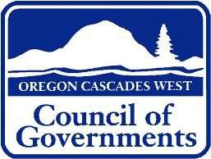

Oregon Cascades West Council of Governments Community Partner Survey
(ELDER LATINO COMMUNITY)

- Do the Latino community members you work with know about programs and supports provided by Senior and Disability Services?
Yes, no, other fill in
- What would be the most effective way to outreach to the aging and disabled Latino community that don’t know about our services?
Community events, radio, printed advertising, brochures, other fill in
- What are the biggest unmet needs faced by the aging and disabled Latino people you work with? Fill in
- How can Senior and Disability Services change the way we do business that would make the experience of applying for assistance more culturally comfortable for Latino community members? Fill in
- Senior and Disability Services hopes to be a resource for Latinos in our communities. If Latinos are not coming to our agency for support, why is that? Fill in
- Is there a way that Senior and Disability Services can partner with your organization to better meet the needs of the people you serve? Fill in

This survey was administered through Survey Monkey to community partner agencies that work with LATINO individuals and families.

Attachment A

Oregon Cascades West Council of Governments Community Partner Survey
(Tribal Community)

- Do Tribal families you work with know about programs and supports provided by Senior and Disability Services? Yes, no, other fill in
- What would be the most effective way to outreach to the aging and disabled Tribal community that don’t know about our services? Community events, radio, printed advertising, brochures, other fill in
- In your opinion, what are the biggest unmet needs faced by aging and disabled Tribal members in your community? Fill in
- Do you feel that Tribal families applying for assistance from Senior and Disability Services find our processes culturally and linguistically competent? Why or why not? Fill in
- How might Senior and Disability Services be better viewed as a trusted resource for the local Tribal community?
- Is there a way that Senior and Disability Services can partner with your organization to better meet the needs of the Tribal community you serve? Fill in

This survey was administered through Survey Monkey to community partner agencies that work with Native American Elders.

Attachment A

Oregon Cascades West Council of Governments Community Partner Survey
(LGBTQ Community)

- Do LGBTQ individuals and/or families you work with know about programs and supports provided by Senior and Disability Services? Yes, No, other fill in
- What would be the most effective way to outreach to the aging and disabled LGBTQ community that don’t know about our services? Community events, radio, printed advertising, brochures, other fill in
- In your opinion, what are the biggest unmet needs faced by aging and disabled LGBTQ’s in our community? Fill in
- Do you feel that LGBTQ individuals or families applying for assistance from Senior and Disability Services find our processes culturally and linguistically competent? Why or why not? Fill in
- How might Senior and Disability Services be better viewed as a trusted resource for the local LBGTQ community? Fill in
- Is there a way that Senior and Disability Services can partner with your organization to better meet the needs of the people you serve? Fill in

This survey was administered through Survey Monkey to community partner agencies that work with LGBTQ individuals and families.

Attachment B

Service | Linn County | Benton County | Lincoln County
Hospitals | 1 | 1 | 2
Clinics | 5 | 6 | 5
Tribal Clinics |  |  | 1
Housing Authority | 2 | 2 | 1
Food Banks | 12 | 9 | 8
Title VI Nutrition Sites | 5 Emergency Meal Sites | 4 Emergency Meal Sites | 9 Emergency Meal Sites

Attachment D

We want to hear from you!
Senior and Disability Services (SDS) manages services and programs that help older adults and people with disabilities in Linn, Benton, and Lincoln counties. Our goal is to provide exceptional customer service while working to help people stay healthy, safe, and independent. As one of our consumers, this is an opportunity for you to tell us how we are doing. Providing your feedback is voluntary and your responses will be kept confidential. Surveys can be completed and returned in the enclosed postage paid envelope OR electronically by visiting our website at: www.ocwcog.org and click the button “SDS Consumer Survey”.

Please know that questions regarding staff apply to your SDS case manager, eligibility worker or support staff. We are not seeking feedback on your homecare worker, facility staff or anyone else that provides assistance in your home.

Please begin the survey by selecting the answer that best meets your experience. If you have any questions about the survey, please contact xxx.

How long have you been a consumer with Senior and Disability Services?
  - Less than 6 months
  - Six months, up to 1 year
  - More than 1 year, but less than 5 years
  - Five years or more

Which of the following statements best describes your relationship with us?
  - Receive medical and/or food benefits and work with an eligibility worker.
  - Receive services for physical care needs and have a case manager.
  - Both a. and b.
  - None of the above

What type of residence do you live in?
  - House or Apartment
  - Assisted Living Facility
  - Adult Foster Home
  - Skilled Nursing Facility
  - Other:

How would you like to communicate with us? Select all that apply. Please note that not all of the options are available but may be offered, based on your feedback.
  - Phone
  - Email
  - Text
  - In-person
  - Other:

In your experience, what is the hardest part about applying or reapplying for benefits? Select all that apply.
  - Understanding the paperwork.
  - Gathering the documentation.
  - The process taking too long.
  - Sharing personal information and details.
  - None of the above.
  - Other:

6. TheOCoWffiCcOe Glo2c1a-t2io5ns that you have visited are: | Agree | Disagree

Conveniently located.
Open the hours needed for your schedule.
Safe and comfortable.
Physically accessible.
Have never been to any of the office locations.

7. Do you find the staff you work with: | Agree | Disagree
Understand the programs.
Are able to explain the programs to me in a way I understand.
Take the time to listen.
Respond to questions and concerns within 24 hours.
Allow you to feel in control of the services received.
Maintain confidentiality.
Are friendly, courteous and respectful.

8. When you need help: | Agree | Disagree
Staff are available and easy to contact.
If staff are not able to help, they provide an explanation as to why
they cannot.
Staff provide suggestions for other agencies and services that provide assistance, if staff are not able to help you.

Have you experienced any of the frustrations listed below? Select all that apply.
O Not clear what you’re eligible for. O Programs don’t meet your needs.
O Staff take too long to get back to you. O It’s hard to understand the process. O None of the above.

Have the services you received from Senior and Disability Services: Select all that apply.
O Allowed you to continue living in your home. O Improved your quality of life.
O Given you the opportunity to better your health and well-being. O None of the above.
O Other:

- Please share any additional information or concerns that were not addressed in the survey.

Thank you for your feedback!

Please return the completed survey in the enclosed postage paid envelope to: c/o Senior and Disability Services, Oregon Cascades West Council of Governments,
1400 Queen Ave SE #201, Albany, OR 97322

If you would like to be contacted to share your experience working with Senior and Disability Services, please provide your contact information below.

Name: Phone: Email:

Attachment E
We want to hear from you!
Oregon Project Independence (OPI) provides in-home assistance to older adults and people with physical disabilities in Linn, Benton, and Lincoln Counties as an alternative to Medicaid. Our goal is to provide exceptional customer service while working to help you stay in your home. As a valued consumer, we want to hear from you on how we are doing. Your feedback is voluntary and confidential. Surveys can be completed and returned in the enclosed postage paid envelope.

The following questions ask about your experiences with Oregon Project Independence (OPI) and your Case Manager. These questions are not about your Homecare Worker.
Please select the answers that best matches your experience with OPI. If you have any questions about the survey, please contact Kim Cooper at 541-812-1917.

How long have you been a consumer with OPI?
O Less than 6 months
O Six months, up to 1 year
O More than 1 year, but less than 5 years
O Five years or more

Which of the following statements best describes your relationship with us?
O Consumer receiving services.
O Family member of consumer receiving services. O None of the above.

What is the age of the consumer that receives OPI services?
O Sixty years of age or older O Less than 60 years of age

How would you like to communicate with us? Select all that apply. Not all of the options are available currently, but may be offered, based on consumer feedback.
O Phone O Email O Text
O In-person O Mail
O Other:

How many hours of in-home assistance do you receive each week through OPI?
O Less than 4 hours per week
O Four hours, up to 8 hours per week O More than 8 hours per week

Does the amount of in-home assistance provided by OPI meet your care needs?
O Yes O No
O Other:

The services you receive from OPI include in-home assistance with: (Select all that apply.)
O Personal care, such as dressing, toileting, showering or grooming. O Transfer to bed, chair, toilet, or wheelchair.
O Light housekeeping, such as dusting, vacuuming or laundry.
O Transportation to and from medical appointments, shopping or errands. O Meal preparation and/or eating.
O Respite care.
O Other:

What equipment has OPI provided to meet your care needs? Select all that apply.
O Emergency pendant, such as Lifeline.
O Meal delivery service, such as Meals on Wheels. O Medication management.
O Home modifications, such as grab bags, shower chairs or raised toilet seats. O None of the above.
O Other:

What services or equipment do you need to meet your care needs that has not been provided?

  - In your experience, what is the hardest part about applying or reapplying for benefits? Select all that apply.
O Understanding the paperwork O Gathering the documentation O The process taking too long
O Sharing personal information and details O None of the above
O Other:

Are you eligible to apply for Medicaid?
O Yes O No
O Don’t Know
O Other:

12.Have you chosen not to apply for Medicaid because: | Agree | Disagree
Application process is too complicated.
The stigma of receiving government assistance.
I don’t think my care needs qualify for Medicaid.
I want to leave my estate to my family.

13. The office locations that you have visited are: | Agree | Disagree
Conveniently located.
Open the hours needed for your schedule.
Safe and comfortable.
Physically accessible.
Have never been to any of the office locations.

14.The staff you work with: | Agree | Disagree
Take the time to listen.
Respond to questions and concerns within 48 hours.
Allow you to feel in control of the services received.
Maintain confidentiality.
Are friendly, courteous, and respectful

15. When you applied for benefits: | Agree | Disagree
They were explained in a way that you understood.
You were not eligible, but understood why.
You were eligible, but the benefit was not enough.
You were given other ideas and suggestions to meet your needs.

Have you experienced any of the frustrations listed below? Select all that apply.
O Not clear what you’re eligible for O Programs don’t meet your needs
O Staff take too long to get back to you O The process is hard to understand O None of the above

The services you received from OPI have: (Select all that apply.)
O Allowed you to continue living in your home O Improved your quality of life
O Given you the opportunity to better your health and well-being O None of the above
O Other:
- Please share any additional information or concerns that were not addressed in the survey.

Thank you for your feedback!
Please return the completed survey in the enclosed postage paid envelope to: c/o Oregon Project Independence, Oregon Cascades West Council of Governments,
1400 Queen Ave SE, Suite 206, Albany, OR 97322
Please provide your contact information below, if you would like to share more of your experiences with Oregon Project Independence.
Name:
Phone: Email:

Attachment F – Public Process

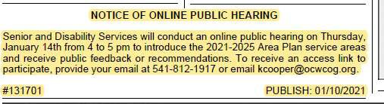

Attachment G

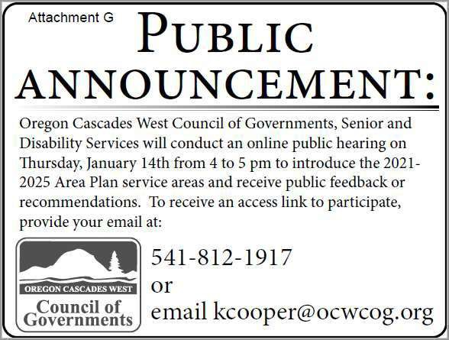

Attachment H

